






Maintain financial standards and records
D1.HFI.CL8.02
D1.HFA.CL7.03
Trainer Guide

Maintain financial standards and records

D1.HFI.CL8.02
D1.HFA.CL7.03

Trainer Guide




Project Base
William Angliss Institute of TAFE
555 La Trobe Street
Melbourne 3000 Victoria
Telephone: | (03) 9606 2111
Facsimile: | (03) 9670 1330
Acknowledgements
Project Director: | Wayne Crosbie
Chief Writer: | Alan Hickman
Subject Writer: | Emma Gronow
Project Manager/Editor: | Alan Maguire
DTP/Production: | Daniel Chee, Mai Vu, Riny Yasin, Kaly Quach

The Association of Southeast Asian Nations (ASEAN) was established on 8 August 1967. The Member States of the Association are Brunei Darussalam, Cambodia, Indonesia, Lao PDR, Malaysia, Myanmar, Philippines, Singapore, Thailand and Viet Nam.
The ASEAN Secretariat is based in Jakarta, Indonesia.
General Information on ASEAN appears online at the ASEAN Website: www.asean.org.
All text is produced by William Angliss Institute of TAFE for the ASEAN Project on “Toolbox Development for Front Office, Food and Beverage Services and Food Production Divisions”.
This publication is supported by the Australian Government’s aid program through the ASEAN-Australia Development Cooperation Program Phase II (AADCP II).
Copyright: Association of Southeast Asian Nations (ASEAN) 2013.
All rights reserved.
Disclaimer
Every effort has been made to ensure that this publication is free from errors or omissions. However, you should conduct your own enquiries and seek professional advice before relying on any fact, statement or matter contained in this book. The ASEAN Secretariat and William Angliss Institute of TAFE are not responsible for any injury, loss or damage as a result of material included or omitted from this course. Information in this module is current at the time of publication. Time of publication is indicated in the date stamp at the bottom of each page.
Some images appearing in this resource have been purchased from stock photography suppliers Shutterstock and iStockphoto and other third party copyright owners and as such are non-transferable and non-exclusive. Clip arts, font images and illustrations used are from the Microsoft Office Clip Art and Media Library. Some images have been provided by and are the property of William Angliss Institute.
Additional images have been sourced from Flickr and SXC and are used under Creative Commons licence: http://creativecommons.org/licenses/by/2.0/deed.en

File name: TG_Maintain_financial_standards_&_records_refined





Table of contents
Competency Based Training (CBT) and assessment - An introduction for trainers 1
Competency standard 11
Notes and PowerPoint slides 19
Recommended training equipment 127
Instructions for Trainers for using PowerPoint – Presenter View 129
Appendix – ASEAN acronyms 131

Competency Based Training (CBT) and assessment - An introduction for trainers

Competency
Competency refers to the ability to perform particular tasks and duties to the standard of performance expected in the workplace.
Competency requires the application of specified knowledge, skills and attitudes relevant to effective participation, consistently over time and in the workplace environment.
The essential skills and knowledge are either identified separately or combined.
Knowledge identifies what a person needs to know to perform the work in an informed and effective manner.
Skills describe the application of knowledge to situations where understanding is converted into a workplace outcome.
Attitude describes the founding reasons behind the need for certain knowledge or why skills are performed in a specified manner.
Competency covers all aspects of workplace performance and involves:
- Performing individual tasks
- Managing a range of different tasks
- Responding to contingencies or breakdowns
- Dealing with the responsibilities of the workplace
- Working with others.

Unit of Competency
Like with any training qualification or program, a range of subject topics are identified that focus on the ability in a certain work area, responsibility or function.
Each manual focuses on a specific unit of competency that applies in the hospitality workplace.
In this manual a unit of competency is identified as a ‘unit’.
Each unit of competency identifies a discrete workplace requirement and includes:
- Knowledge and skills that underpin competency
- Language, literacy and numeracy
- Occupational safety and health requirements.
Each unit of competency must be adhered to in training and assessment to ensure consistency of outcomes.

Element of Competency
An element of competency describes the essential outcomes within a unit of competency.
The elements of competency are the basic building blocks of the unit of competency. They describe in terms of outcomes the significant functions and tasks that make up the competency.
In this manual elements of competency are identified as an ‘element’.

Performance criteria
Performance criteria indicate the standard of performance that is required to demonstrate achievement within an element of competency. The standards reflect identified industry skill needs.
Performance criteria will be made up of certain specified skills, knowledge and attitudes.

Learning
For the purpose of this manual learning incorporates two key activities:
- Training
- Assessment.
Both of these activities will be discussed in detail in this introduction.
Today training and assessment can be delivered in a variety of ways. It may be provided to participants:
- On-the-job – in the workplace
- Off-the-job – at an educational institution or dedicated training environment
- As a combination of these two options.
No longer is it necessary for learners to be absent from the workplace for long periods of time in order to obtain recognised and accredited qualifications.

Learning Approaches
This manual will identify two avenues to facilitate learning:
Competency Based Training (CBT)
This is the strategy of developing a participant’s competency.
Educational institutions utilise a range of training strategies to ensure that participants are able to gain the knowledge and skills required for successful:
- Completion of the training program or qualification
- Implementation in the workplace.
The strategies selected should be chosen based on suitability and the learning styles of participants.

Competency Based Assessment (CBA)
This is the strategy of assessing competency of a participant.
Educational institutions utilise a range of assessment strategies to ensure that participants are assessed in a manner that demonstrates validity, fairness, reliability, flexibility and fairness of assessment processes.

Flexibility in Learning
It is important to note that flexibility in training and assessment strategies is required to meet the needs of participants who may have learning difficulties. The strategies used will vary, taking into account the needs of individual participants with learning difficulties. However they will be applied in a manner which does not discriminate against the participant or the participant body as a whole.
Catering for Participant Diversity
Participants have diverse backgrounds, needs and interests. When planning training and assessment activities to cater for individual differences, trainers and assessors should:
- Consider individuals’ experiences, learning styles and interests
- Develop questions and activities that are aimed at different levels of ability
- Modify the expectations for some participants
- Provide opportunities for a variety of forms of participation, such as individual, pair and small group activities
- Assess participants based on individual progress and outcomes.
The diversity among participants also provides a good reason for building up a learning community in which participants support each other’s learning.
Participant Centred Learning
This involves taking into account structuring training and assessment that:
- Builds on strengths – Training environments need to demonstrate the many positive features of local participants (such as the attribution of academic success to effort, and the social nature of achievement motivation) and of their trainers (such as a strong emphasis on subject disciplines and moral responsibility). These strengths and uniqueness of local participants and trainers should be acknowledged and treasured
- Acknowledges prior knowledge and experience – The learning activities should be planned with participants’ prior knowledge and experience in mind
- Understands learning objectives – Each learning activity should have clear learning objectives and participants should be informed of them at the outset. Trainers should also be clear about the purpose of assignments and explain their significance to participants
- Teaches for understanding – The pedagogies chosen should aim at enabling participants to act and think flexibly with what they know
- Teaches for independent learning – Generic skills and reflection should be nurtured through learning activities in appropriate contexts of the curriculum. Participants should be encouraged to take responsibility for their own learning
- Enhances motivation – Learning is most effective when participants are motivated. Various strategies should be used to arouse the interest of participants
- Makes effective use of resources – A variety of teaching resources can be employed as tools for learning
- Maximises engagement – In conducting learning activities, it is important for the minds of participants to be actively engaged
- Aligns assessment with learning and teaching – Feedback and assessment should be an integral part of learning and teaching
- Caters for learner diversity – Trainers should be aware that participants have different characteristics and strengths and try to nurture these rather than impose a standard set of expectations.
Active Learning
The goal of nurturing independent learning in participants does not imply that they always have to work in isolation or solely in a classroom. On the contrary, the construction of knowledge in tourism and hospitality studies can often best be carried out in collaboration with others in the field. Sharing experiences, insights and views on issues of common concern, and working together to collect information through conducting investigative studies in the field (active learning) can contribute a lot to their eventual success.
Active learning has an important part to play in fostering a sense of community in the class. First, to operate successfully, a learning community requires an ethos of acceptance and a sense of trust among participants, and between them and their trainers. Trainers can help to foster acceptance and trust through encouragement and personal example, and by allowing participants to take risks as they explore and articulate their views, however immature these may appear to be. Participants also come to realise that their classmates (and their trainers) are partners in learning and solving.
Trainers can also encourage cooperative learning by designing appropriate group learning tasks, which include, for example, collecting background information, conducting small-scale surveys, or producing media presentations on certain issues and themes. Participants need to be reminded that, while they should work towards successful completion of the field tasks, developing positive peer relationships in the process is an important objective of all group work.

Competency Based Training (CBT)
Principle of Competency Based Training
Competency based training is aimed at developing the knowledge, skills and attitudes of participants, through a variety of training tools.
Training Strategies
The aims of this curriculum are to enable participants to:
- Undertake a variety of subject courses that are relevant to industry in the current environment
- Learn current industry skills, information and trends relevant to industry
- Learn through a range of practical and theoretical approaches
- Be able to identify, explore and solve issues in a productive manner
- Be able to become confident, equipped and flexible managers of the future
- Be ‘job ready’ and a valuable employee in the industry upon graduation of any qualification level.
To ensure participants are able to gain the knowledge and skills required to meet competency in each unit of competency in the qualification, a range of training delivery modes are used.
Types of Training
In choosing learning and teaching strategies, trainers should take into account the practical, complex and multi-disciplinary nature of the subject area, as well as their participant’s prior knowledge, learning styles and abilities.
Training outcomes can be attained by utilising one or more delivery methods:
Lecture/Tutorial
This is a common method of training involving transfer of information from the trainer to the participants. It is an effective approach to introduce new concepts or information to the learners and also to build upon the existing knowledge. The listener is expected to reflect on the subject and seek clarifications on the doubts.
Demonstration
Demonstration is a very effective training method that involves a trainer showing a participant how to perform a task or activity. Through a visual demonstration, trainers may also explain reasoning behind certain actions or provide supplementary information to help facilitate understanding.
Group Discussions
Brainstorming in which all the members in a group express their ideas, views and opinions on a given topic, is a free flow and exchange of knowledge among the participants and the trainer. The discussion is carried out by the group on the basis of their own experience, perceptions and values. This will facilitate acquiring new knowledge. When everybody is expected to participate in the group discussion, even the introverted persons will also get stimulated and try to articulate their feelings.
The ideas that emerge in the discussions should be noted down and presentations are to be made by the groups. Sometimes consensus needs to be arrived at on a given topic. Group discussions are to be held under the moderation of a leader guided by the trainer. Group discussion technique triggers thinking process, encourages interactions and enhances communication skills.
Role Play
This is a common and very effective method of bringing into the classroom real life situations, which may not otherwise be possible. Participants are made to enact a particular role so as to give a real feel of the roles they may be called upon to play. This enables participants to understand the behaviour of others as well as their own emotions and feelings. The instructor must brief the role players on what is expected of them. The role player may either be given a ready-made script, which they can memorise and enact, or they may be required to develop their own scripts around a given situation. This technique is extremely useful in understanding creative selling techniques and human relations. It can be entertaining and energising and it helps the reserved and less literate to express their feelings.

Simulation Games
When trainees need to become aware of something that they have not been conscious of, simulations can be a useful mechanism. Simulation games are a method based on "here and now" experience shared by all the participants. The games focus on the participation of the trainees and their willingness to share their ideas with others. A "near real life" situation is created providing an opportunity to which they apply themselves by adopting certain behaviour. They then experience the impact of their behaviour on the situation. It is carried out to generate responses and reactions based on the real feelings of the participants, which are subsequently analysed by the trainer.
While use of simulation games can result in very effective learning, it needs considerable trainer competence to analyse the situations.
Individual /Group Exercises
Exercises are often introduced to find out how much the participant has assimilated. This method involves imparting instructions to participants on a particular subject through use of written exercises. In the group exercises, the entire class is divided into small groups, and members are asked to collaborate to arrive at a consensus or solution to a problem.
Case Study
This is a training method that enables the trainer and the participant to experience a real life situation. It may be on account of events in the past or situations in the present, in which there may be one or more problems to be solved and decisions to be taken. The basic objective of a case study is to help participants diagnose, analyse and/or solve a particular problem and to make them internalise the critical inputs delivered in the training. Questions are generally given at the end of the case study to direct the participants and to stimulate their thinking towards possible solutions. Studies may be presented in written or verbal form.
Field Visit
This involves a carefully planned visit or tour to a place of learning or interest. The idea is to give first-hand knowledge by personal observation of field situations, and to relate theory with practice. The emphasis is on observing, exploring, asking questions and understanding. The trainer should remember to brief the participants about what they should observe and about the customs and norms that need to be respected.
Group Presentation
The participants are asked to work in groups and produce the results and findings of their group work to the members of another sub-group. By this method participants get a good picture of each other's views and perceptions on the topic and they are able to compare them with their own point of view. The pooling and sharing of findings enriches the discussion and learning process.
Practice Sessions
This method is of paramount importance for skills training. Participants are provided with an opportunity to practice in a controlled situation what they have learnt. It could be real life or through a make-believe situation.

Games
This is a group process and includes those methods that involve usually fun-based activity, aimed at conveying feelings and experiences, which are everyday in nature, and applying them within the game being played. A game has set rules and regulations, and may or may not include a competitive element. After the game is played, it is essential that the participants be debriefed and their lessons and experiences consolidated by the trainer.
Research
Trainers may require learners to undertake research activities, including online research, to gather information or further understanding about a specific subject area.

Competency Based Assessment (CBA)
Principle of Competency Based Assessment
Competency based assessment is aimed at compiling a list of evidence that shows that a person is competent in a particular unit of competency.
Competencies are gained through a multitude of ways including:
- Training and development programs
- Formal education
- Life experience
- Apprenticeships
- On-the-job experience
- Self-help programs.
All of these together contribute to job competence in a person. Ultimately, assessors and participants work together, through the ‘collection of evidence’ in determining overall competence.
This evidence can be collected:
- Using different formats
- Using different people
- Collected over a period of time.
The assessor, who is ideally someone with considerable experience in the area being assessed, reviews the evidence and verifies the person as being competent or not.
Flexibility in Assessment
Whilst allocated assessment tools have been identified for this subject, all attempts are made to determine competency and suitable alternate assessment tools may be used, according to the requirements of the participant.
The assessment needs to be equitable for all participants, taking into account their cultural and linguistic needs.
Competency must be proven regardless of:
- Language
- Delivery Method
- Assessment Method.
Assessment Objectives
The assessment tools used for subjects are designed to determine competency against the ‘elements of competency’ and their associated ‘performance criteria’.
The assessment tools are used to identify sufficient:
- Knowledge, including underpinning knowledge
- Skills
- Attitudes
Assessment tools are activities that trainees are required to undertake to prove participant competency in this subject.
All assessments must be completed satisfactorily for participants to obtain competence in this subject. There are no exceptions to this requirement, however, it is possible that in some cases several assessment items may be combined and assessed together.
Types of Assessment
Allocated Assessment Tools
There are a number of assessment tools that are used to determine competency in this subject:
- Work projects
- Written questions
- Oral questions
- Third Party Report
- Observation Checklist.
Instructions on how assessors should conduct these assessment methods are explained in the Assessment Manuals.
Alternative Assessment Tools
Whilst this subject has identified assessment tools, as indicated above, this does not restrict the assessor from using different assessment methods to measure the competency of a participant.
Evidence is simply proof that the assessor gathers to show participants can actually do what they are required to do.
Whilst there is a distinct requirement for participants to demonstrate competency, there are many and diverse sources of evidence available to the assessor.
Ongoing performance at work, as verified by a supervisor or physical evidence, can count towards assessment. Additionally, the assessor can talk to customers or work colleagues to gather evidence about performance.
A range of assessment methods to assess competency include:
- Practical demonstrations
- Practical demonstrations in simulated work conditions
- Problem solving
- Portfolios of evidence
- Critical incident reports
- Journals
- Oral presentations
- Interviews
- Videos
- Visuals: slides, audio tapes
- Case studies
- Log books
- Projects
- Role plays
- Group projects
- Group discussions
- Examinations.
Recognition of Prior Learning
Recognition of Prior Learning is the process that gives current industry professionals who do not have a formal qualification, the opportunity to benchmark their extensive skills and experience against the standards set out in each unit of competency/subject.
Also known as a Skills Recognition Audit (SRA), this process is a learning and assessment pathway which encompasses:
- Recognition of Current Competencies (RCC)
- Skills auditing
- Gap analysis and training
- Credit transfer.
Assessing competency
As mentioned, assessment is the process of identifying a participant’s current knowledge, skills and attitudes sets against all elements of competency within a unit of competency. Traditionally in education, grades or marks were given to participants, dependent on how many questions the participant successfully answered in an assessment tool.
Competency based assessment does not award grades, but simply identifies if the participant has the knowledge, skills and attitudes to undertake the required task to the specified standard.
Therefore, when assessing competency, an assessor has two possible results that can be awarded:
- Pass Competent (PC)
- Not Yet Competent (NYC).
Pass Competent (PC)
If the participant is able to successfully answer or demonstrate what is required, to the expected standards of the performance criteria, they will be deemed as ‘Pass Competent’ (PC).
The assessor will award a ‘Pass Competent’ (PC) if they feel the participant has the necessary knowledge, skills and attitudes in all assessment tasks for a unit.
Not Yet Competent’ (NYC)
If the participant is unable to answer or demonstrate competency to the desired standard, they will be deemed to be ‘Not Yet Competent’ (NYC).
This does not mean the participant will need to complete all the assessment tasks again. The focus will be on the specific assessment tasks that were not performed to the expected standards.
The participant may be required to:
a) Undertake further training or instruction
b) Undertake the assessment task again until they are deemed to be ‘Pass Competent’.

Competency standard
UNIT TITLE: MAINTAIN FINANCIAL STANDARDS AND RECORDS |  |  |  | NOMINAL HOURS: 65
UNIT NUMBER: D1.HFI.CL8.02 D1.HFA.CL7.03
UNIT DESCRIPTOR: This unit deals with the skills and knowledge required to maintain financial standards and records in a range of settings within the hotel and travel industries
ELEMENTS AND PERFORMANCE CRITERIA | UNIT VARIABLE AND ASSESSMENT GUIDE
Element 1. Monitor financial procedures  1.1 Check transactions accordance with enterprise procedures  1.2 Balance transactions accurately  1.3 Check balances prepared by others in accordance with enterprise procedures  1.4 Implement and control financial systems in accordance with enterprise procedures  1.5 Monitor financial systems and provide input on possible improvements to appropriate personnel  1.6 Identify and resolve discrepancies or errors according to level of responsibility and in consultation with designated persons  Element 2. Complete financial reports  2.1 Complete routine financial/statistical reports accurately within designated timelines  2.2 Forward financial/statistical reports promptly to the appropriate person/department | Unit Variables  The Unit Variables provide advice to interpret the scope and context of this unit of competence, allowing for differences between enterprises and workplaces. It relates to the unit as a whole and facilitates holistic assessment  This unit applies to maintaining financial standards and records within the labour divisions of the hotel and travel industries and may include:  Front Office  Housekeeping  Food and Beverage Service  Food Production  Travel Agencies  Tour Operation  Transactions may include:  Purchasing a fixed asset on credit  Selling a fixed asset on credit  Correcting posting errors
Writing off a bad debt
Interest expense
Interest receivable
Commencing business entries
Withdrawal of stock/assets by owner
Non-cash transactions, e.g. Writing off depreciation, stock losses
Foreign currency.
Check balances may include:
checking accuracy of debtor account balances, e.g. cash receipts journal, sales return journal, general journal
Checking accuracy of creditor account balances, e.g. Cash payments journal, purchases journal, purchases returns journal, general journal
Checking the total of the debtor's schedule equals the balance of the debtor's control account
Checking the total of the creditor's schedule equals the balance of the creditor's control account.
Financial systems should relate to:
Sales and sales returns
Purchases and purchase returns
Cash receipts
Cash payments
Asset acquisition
Stock control
Debtor control
Creditor control
Petty cash
Banking procedures
Cash control, e.g. Security, floats.
Discrepancies or errors may relate to:
Data entry errors
Sales that should have had an invoice raised but by error did not
Goods not delivered but charged for
Posting errors including:
- Posting of the wrong amount
- Omitting a posting
- Posting in the wrong column
- Posting more than once.
Designated persons may include:
Supervisor
Bank
Organisation's authorisations department
Line management
Statutory body.
Financial/statistical reports may relate to:
Daily, weekly, monthly transactions and reports
Break up by department
Occupancy
Sales performance
Commission earnings
Sales returns
Commercial account activity
Foreign currency activities
All types of payment.
Designated timelines may relate to:
Within agreed period
Monthly
By month end
Within organisational deadline.
Assessment Guide
The following skills and knowledge must be assessed as part of this unit:
Understanding of the processes to identify and respond to discrepancies and errors
Understanding of the processes to identify and comply with organisational requirements
Understanding of the principles of double entry bookkeeping and accrual accounting.
Linkages To Other Units
Develop and implement business plans
Develop and implement operational plans
Plan and establish systems and procedures
Prepare business documents
Maintain financial performance within a budget
Manage legal requirements for business compliance
Manage physical assets and infrastructure
Lead and manage people.
Critical Aspects of Assessment
Evidence of the following is essential:
Demonstrated ability to audit financial procedures within a travel and hotel industry context
Consistency of performance across a range of situations that demonstrates knowledge, understanding and skill in implementing the principles of double entry bookkeeping and accrual accounting.
Resource Implications
Training and assessment to include access to a real or simulated commercial workplace environment in which financial procedures can be audited; and access to workplace standards, procedures, policies, guidelines, tools and equipment.
Context of Assessment
This unit may be assessed on or off the job:
Assessment should include practical demonstration of the ability to maintain financial standards and records in the workplace or through a simulation activity, supported by a range of methods to assess underpinning knowledge
Assessment must relate to the individual’s work area, job role and area of responsibility
Assessment must include project or work activities that allow the candidate to respond to multiple and varying workplace issues relevant to work area, job role and area of responsibility that allow the candidate to demonstrate knowledge and skill in maintaining financial standards and records.
Assessment Methods
The following methods may be used to assess competency for this unit:
Case studies
Observation of practical candidate performance
Oral and written questions
Portfolio evidence
Problem solving
Role plays
Third party reports completed by a supervisor
Project and assignment work.
Key Competencies in this Unit
Level 1 = competence to undertake tasks effectively
Level 2 = competence to manage tasks
Level 3 = competence to use concepts for evaluating
 | Key Competencies | Level | Examples
 | Collecting, organising and analysing information | 3 | Analyse financial information
 | Communicating ideas and information | 3 | Express complex strategies in a clear and concise format
 | Planning and organising activities | 3 | Perform activities in line with business requirements
 | Working with others and in teams | 3 | Devise strategies to ensure team commitment to maintaining financial standards and records
 | Using mathematical ideas and techniques | 2 | Calculate deviations and reverse errors
 | Solving problems | 3 | Identify discrepancies and errors
 | Using technology | 2 | Identify and analyse the optimum use of technology to achieve business objectives; use accounting software

Notes and PowerPoint slides
Slide

Slide No | Trainer Notes
 | Trainer and trainees to introduce themselves.

Slide
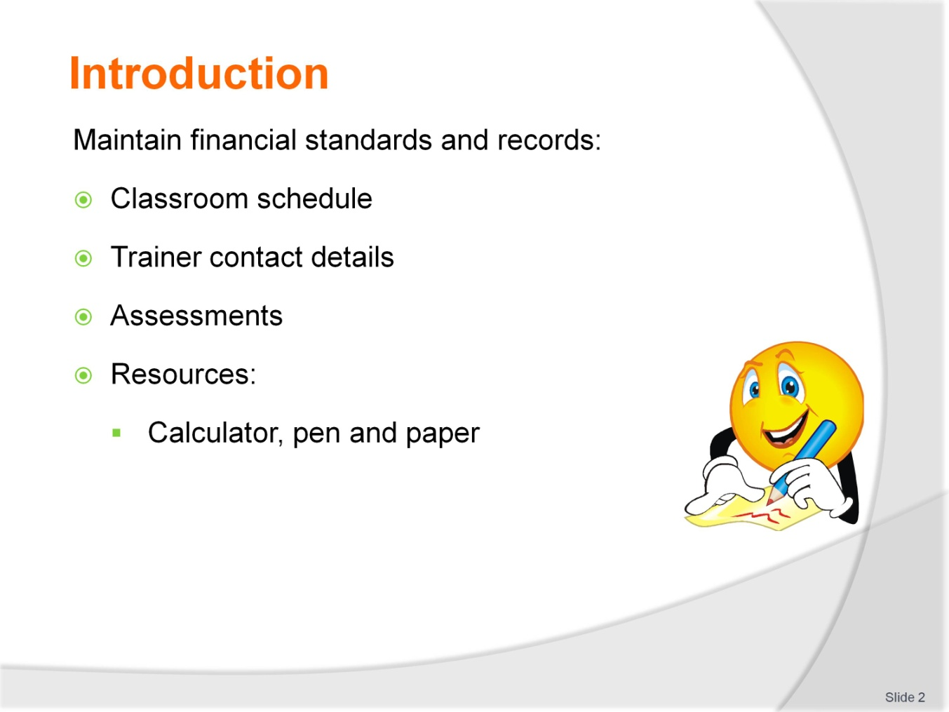
Slide No | Trainer Notes
Session Introduction
Welcome trainees and introduce the classroom schedule
Discuss housekeeping issues such as times of attendance, expected classroom behaviour, contact details, resources required such as a calculator
Explain that the trainees will be assessed and the requirements of those assessments.
Trainers will find it beneficial to have access to the following training equipment:
Whiteboard
Butchers paper
Spreadsheet software is optional but may assist in the demonstration of calculations
Internet access is optional but will assist with using relevant, local examples to illustrate concepts.
Get to know you activity on next slide.

Slide
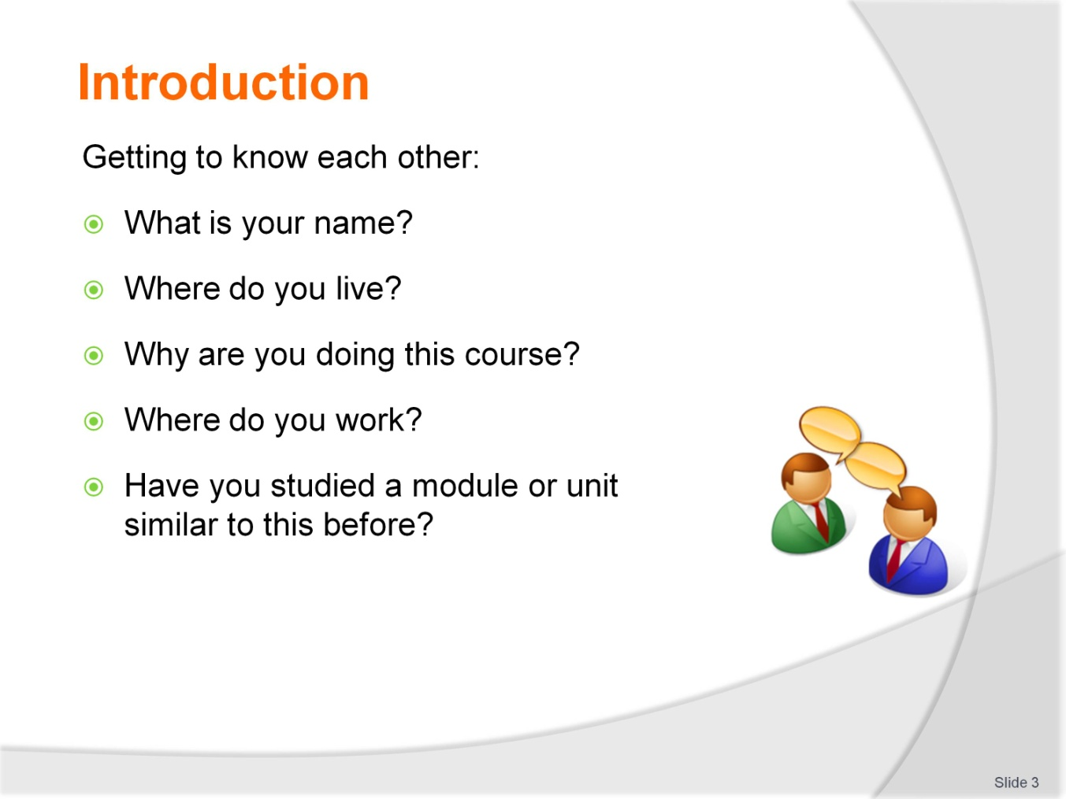
Slide No | Trainer Notes
Ice-breaker (10 minutes)
If the trainees haven’t met before ask them to break into pairs. Each person in the pair should introduce himself to the other and ask key questions as above.
After the trainees have had some time to talk, ask them to introduce their partner using the information they have learnt about them.
If the trainees have met you may prefer to ask them to introduce themselves to you, the trainer, using the questions above as a basis for discussion.
The trainer will now have a better idea of the composition of the group and the group will feel more comfortable with each other. It is sometimes helpful to make a brief note next to the trainee’s name regarding their experience or knowledge as you may be able to draw on this throughout the module.

Slide
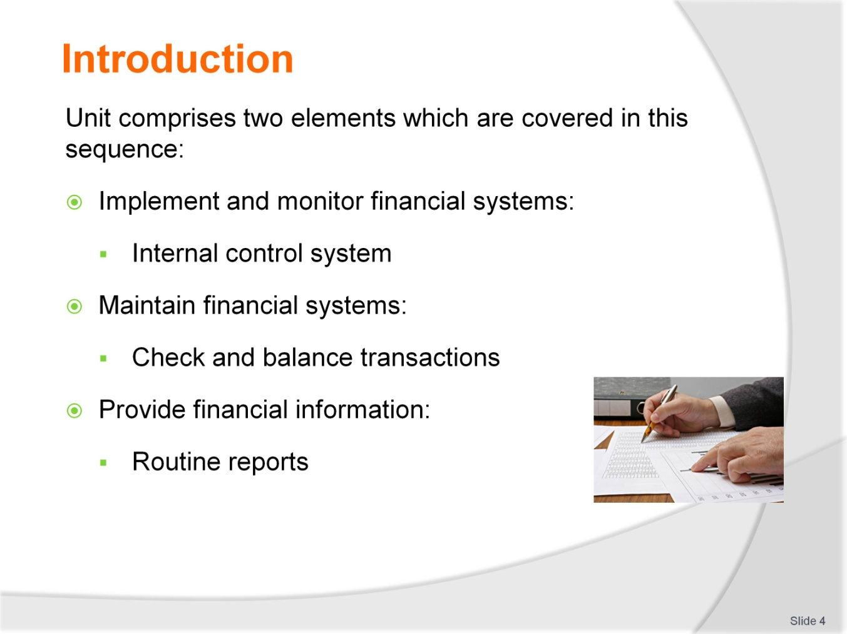
Slide No | Trainer Notes
 | Trainers please note that the sequence of materials in the slides is different to the training manual. The slides begin with an overview of the system, the controls the system needs and then the various procedures and processes to maintain the integrity of the system. Finally, examples of the products of the system, the financial reports are discussed.

Slide
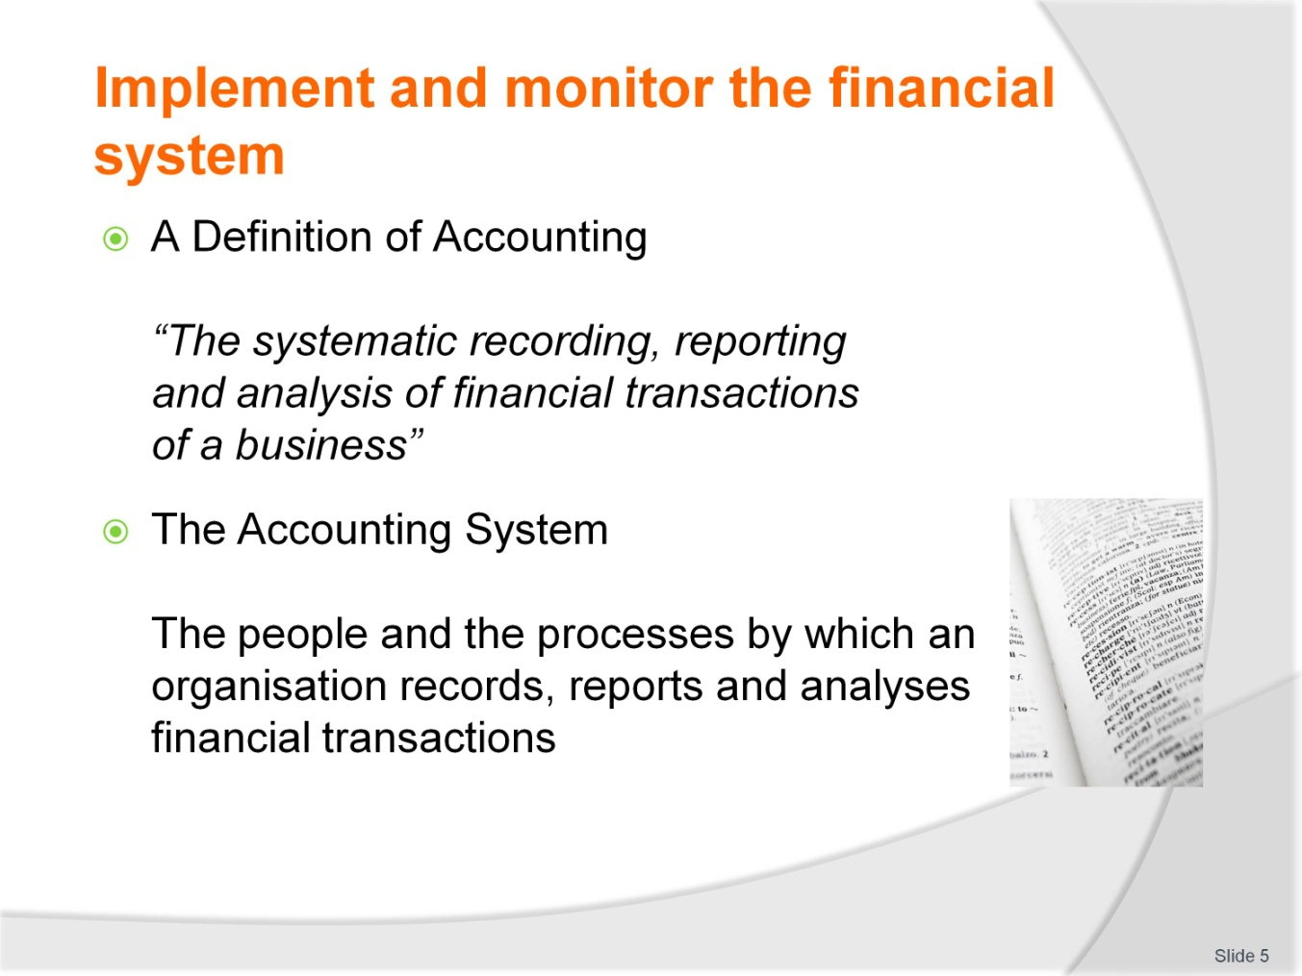
Slide No | Trainer Notes
Trainer: Before we begin there are some concepts to explain first.
To assist trainees to contextualise the definition of accounting, ask them for examples of financial transactions in their day to day lives. Your objective is to illustrate that this is any transaction where goods or services are exchanged for payment. You may like to begin with some examples of your own such as:
Purchases of goods and services
Use of their mobile phones
Payment of wages for work performed
Payment of tuition fees for this course.
The terms financial and accounting system are used throughout this unit to explain the process of recording transactions. In the strictest sense, the financial system encompasses more than just the accounting system but for the purposes of this unit, the terms are used interchangeably.

Slide
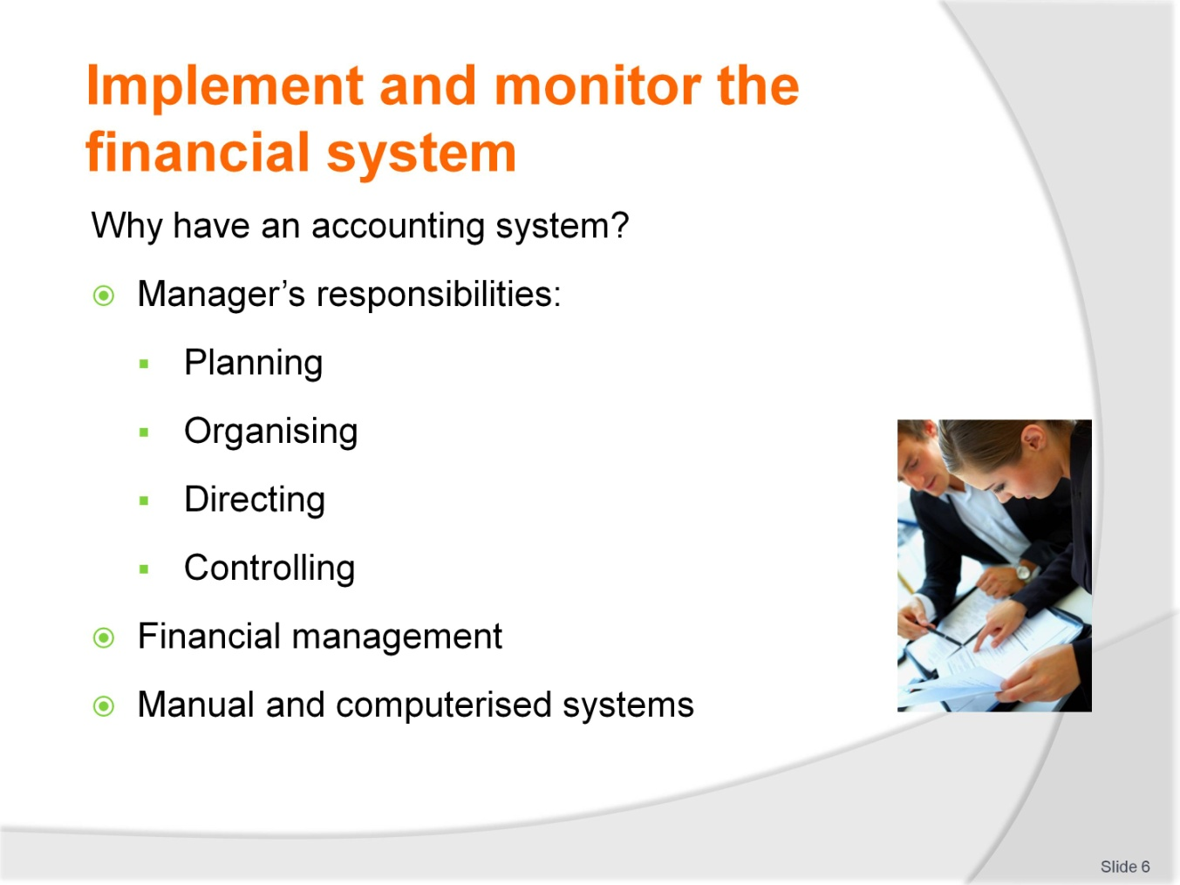
Slide No | Trainer Notes
Trainers: Explain the key responsibilities of managers and the support the financial or accounting system can provide. It may be possible to illustrate through practical examples from personal or trainee’s experience. It is necessary that adequate time is taken to do this as this discussion will highlight the purpose and importance of financial information.
Trainers also need to explain that although may organisations use computerised systems, this unit will explain a manual system as all computerised accounting systems are based on manual processes and procedures.

Slide
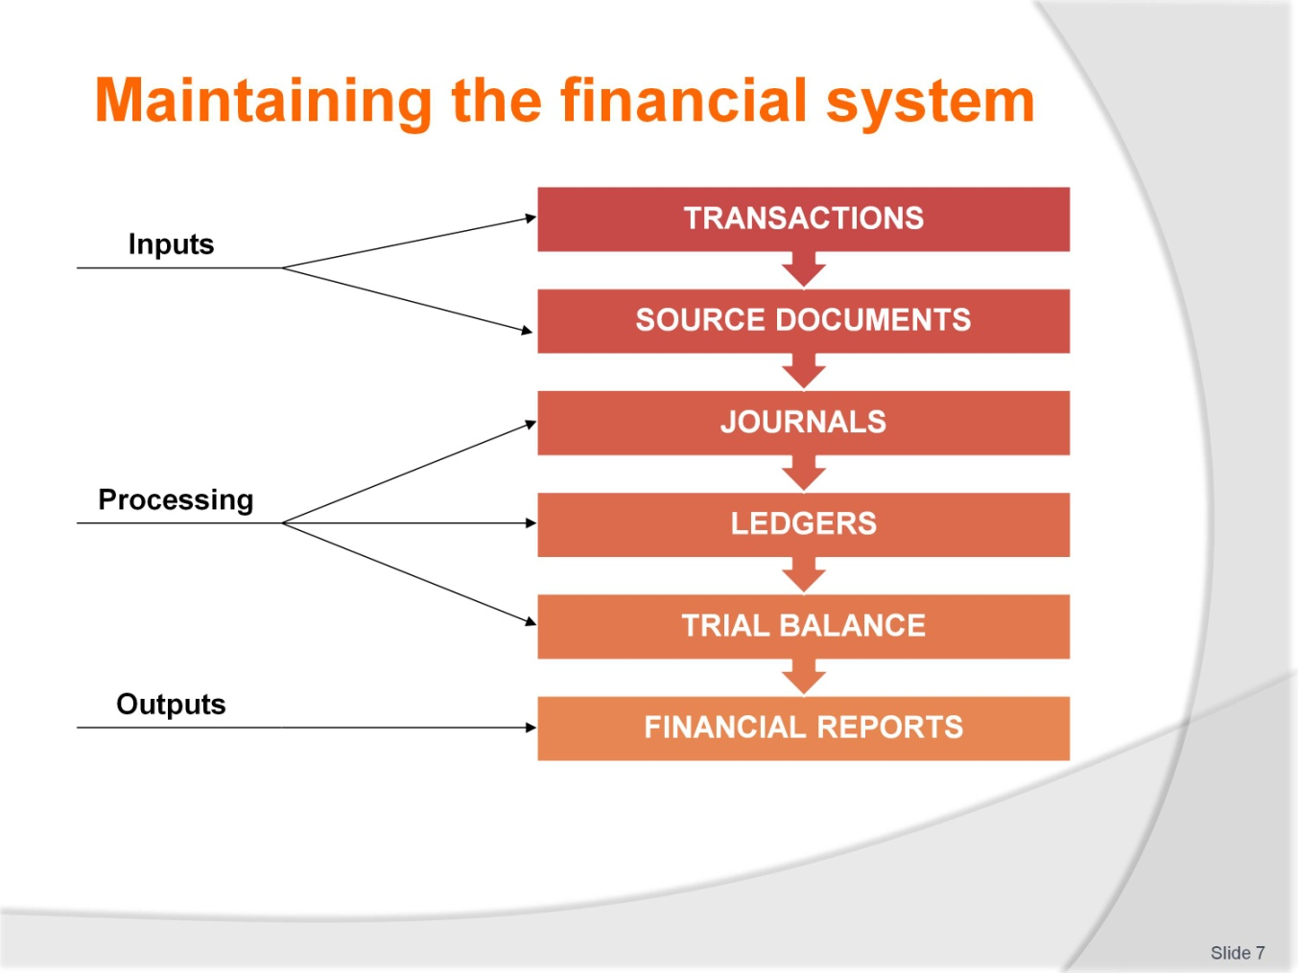
Slide No | Trainer Notes
Trainers are now introducing trainees to the flow of financial transactions and how an accounting system is structured so that financial transactions are ultimately summarised and reported. This is discussed in terms of illustrating inputs, outputs and processing as this is the manner in which the system is discussed throughout the manual.
The design of the accounting or financial system is continued on the next slide.

Slide
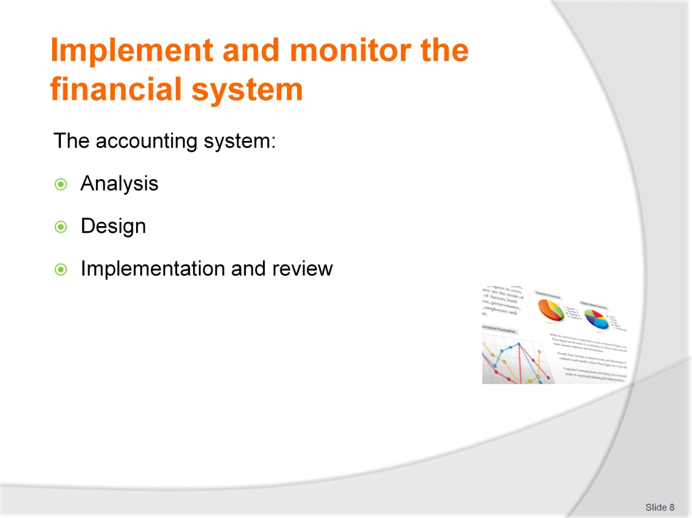
Slide No | Trainer Notes
 | Trainers work through the process for developing an accounting system with trainees. The exercise o the next slide can be completed first, if the trainees have been asked to read the training manual or trainers can explain concepts and then trainees work through the exercise. This should be completed in small groups.

Slide
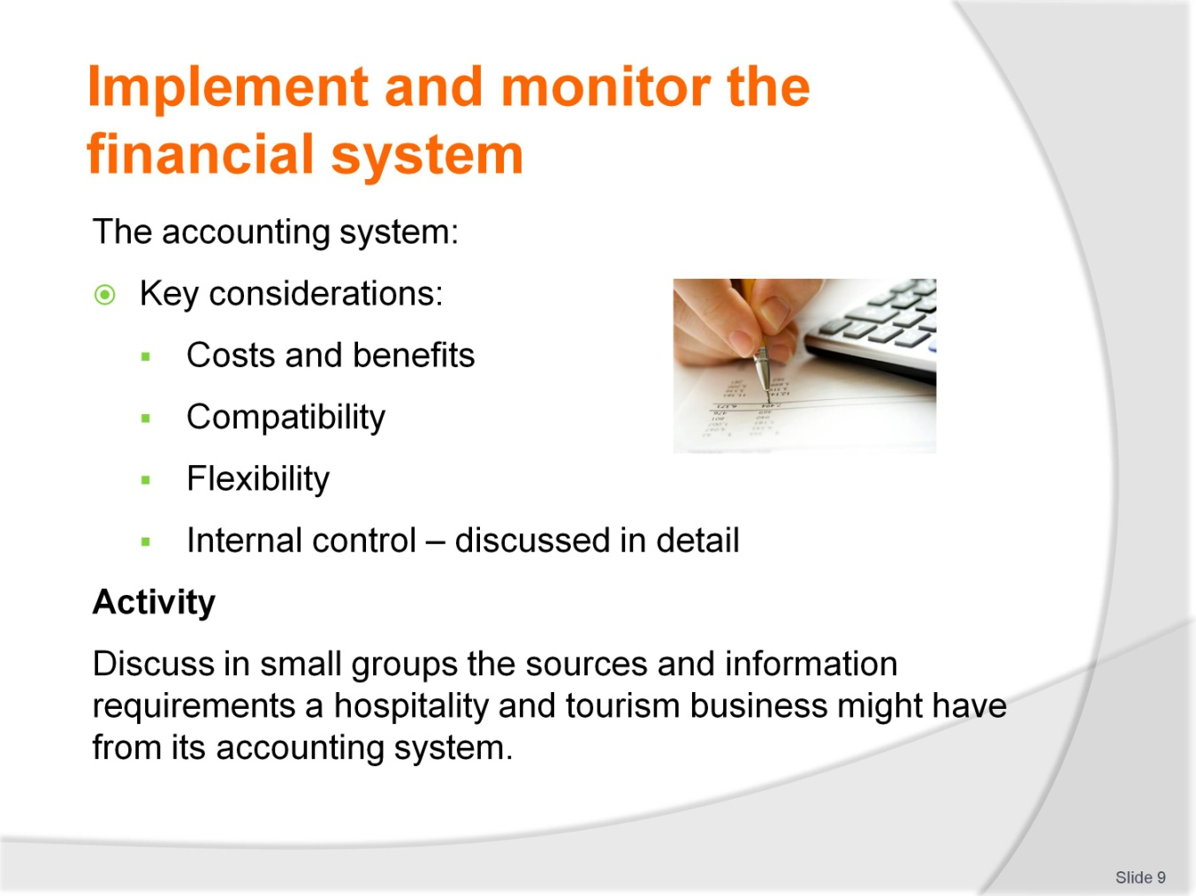
Slide No | Trainer Notes
 | Trainers note that Internal control considerations are discussed in detail over the next series of slides so discussion for the activity should merely focus on information requirements.

Slide
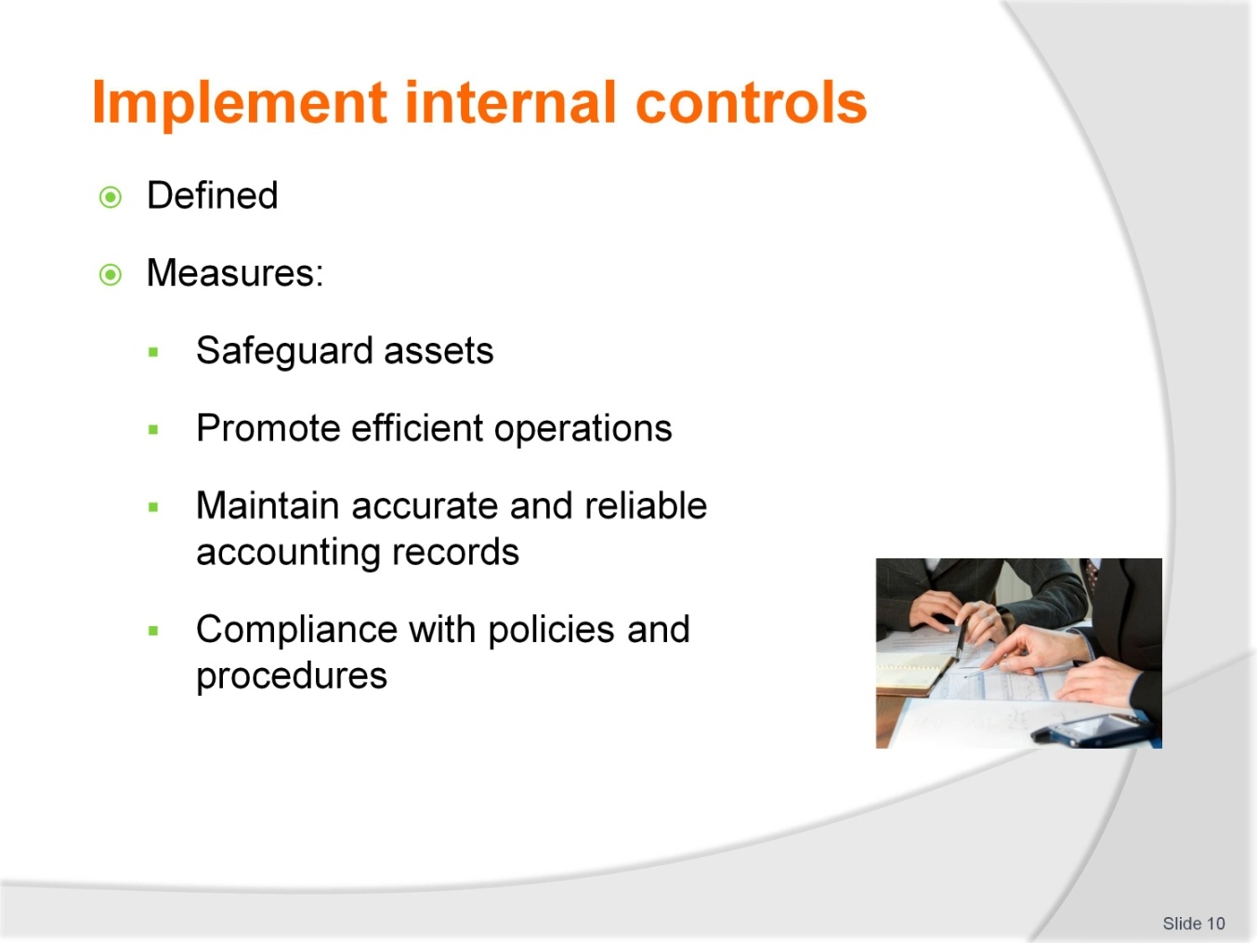
Slide No | Trainer Notes
 | Trainers: The internal control system encompasses and protects the accounting system. It is important that trainees are clear on the need for internal controls and can identify internal control measures in the workplace. The next series of slides includes activities that should illustrate this. Refer to the training manual to ensure all internal control measures are discussed.

Slide
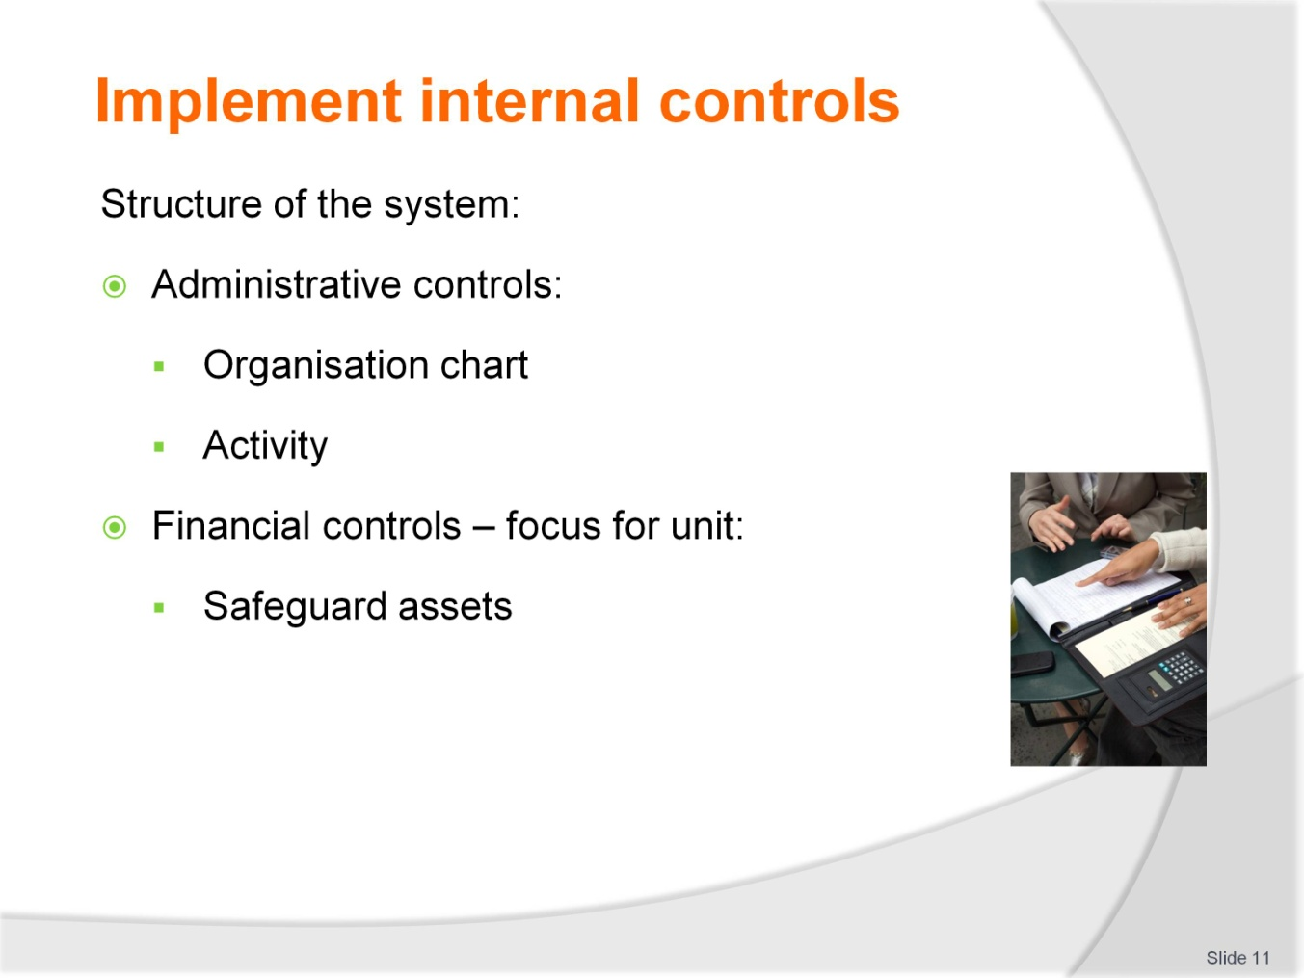
Slide No | Trainer Notes
Trainer: The training manual includes two organisational charts. Trainees use these examples to create an organisational chart for their workplace or a local example provided by the trainer. This activity can be completed individually or in small groups. The purpose is to highlight that the organisation chart defines responsibilities and supervision in an organisation.
Financial controls are continued on the next number of slides.

Slide
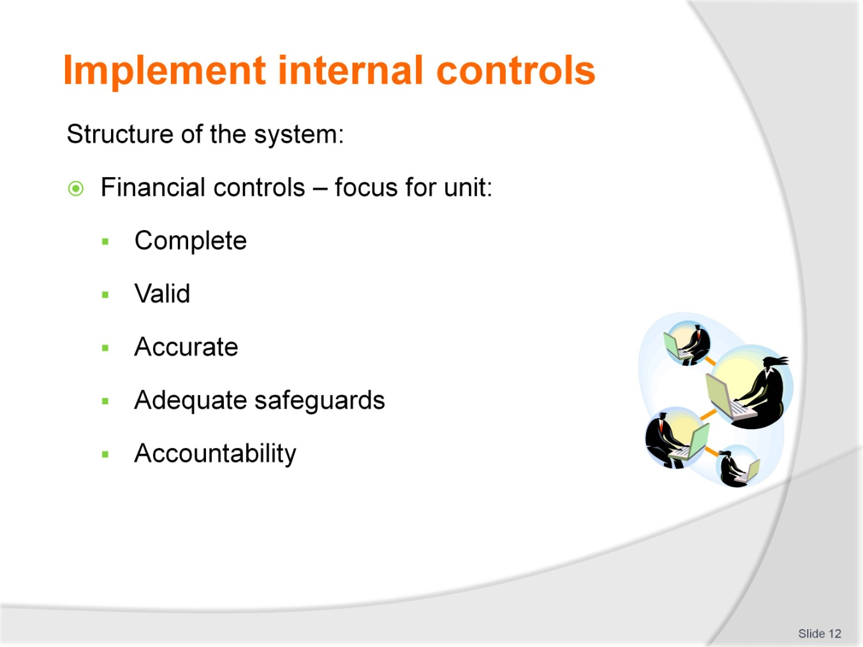
Slide No | Trainer Notes
 | Trainers: Financial controls address these objectives for financial or accounting information. They shape the reasons or purpose behind many of the internal control processes and procedures. Trainees should be reminded to keep these objectives in mind. It can help to display them on a piece of butcher’s paper or whiteboard when discussing internal controls.

Slide
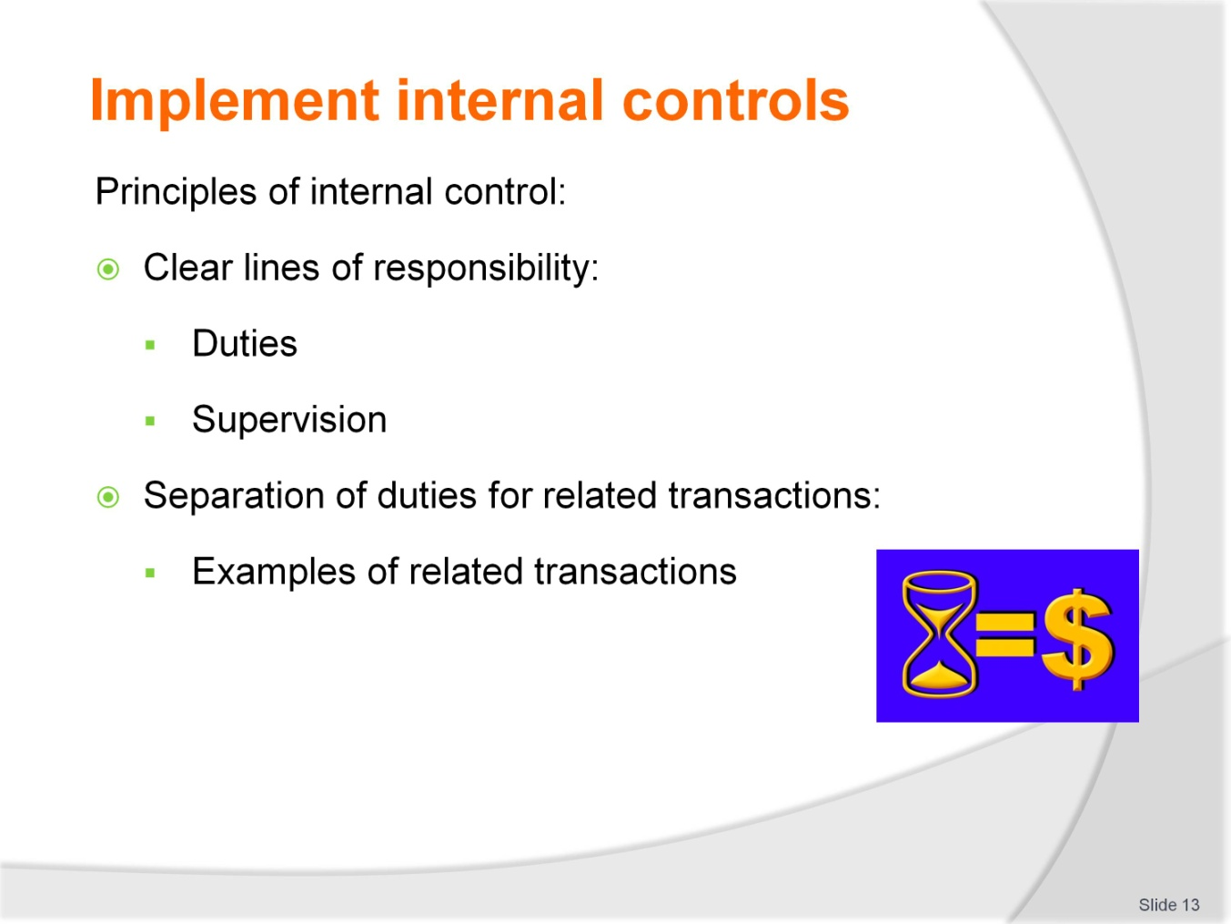
Slide No | Trainer Notes
 | Trainer: Trainees to appreciate that when employees understand the reasons for internal controls as well as the principles, they are more likely to follow the processes and procedures to maintain an effective system. You may choose to start with the activity on slide 16 and illustrate the principles or introduce all the principles to trainees first.

Slide
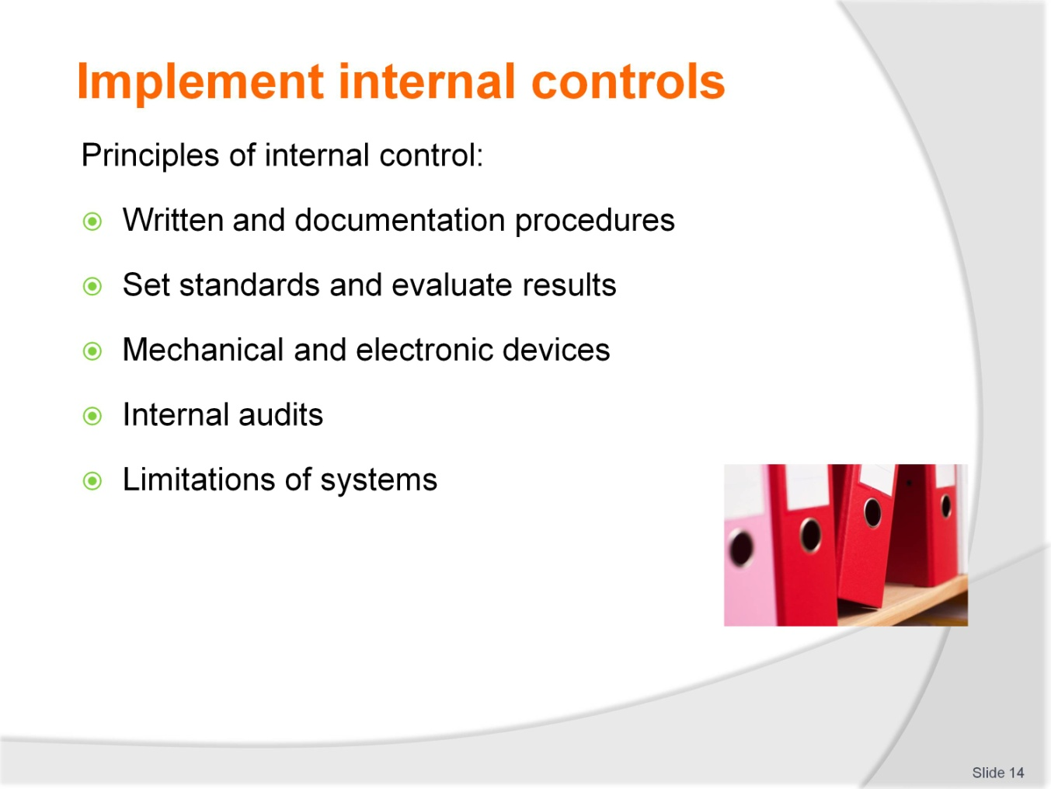
Slide No | Trainer Notes
 | Continued from the previous slide.

Slide
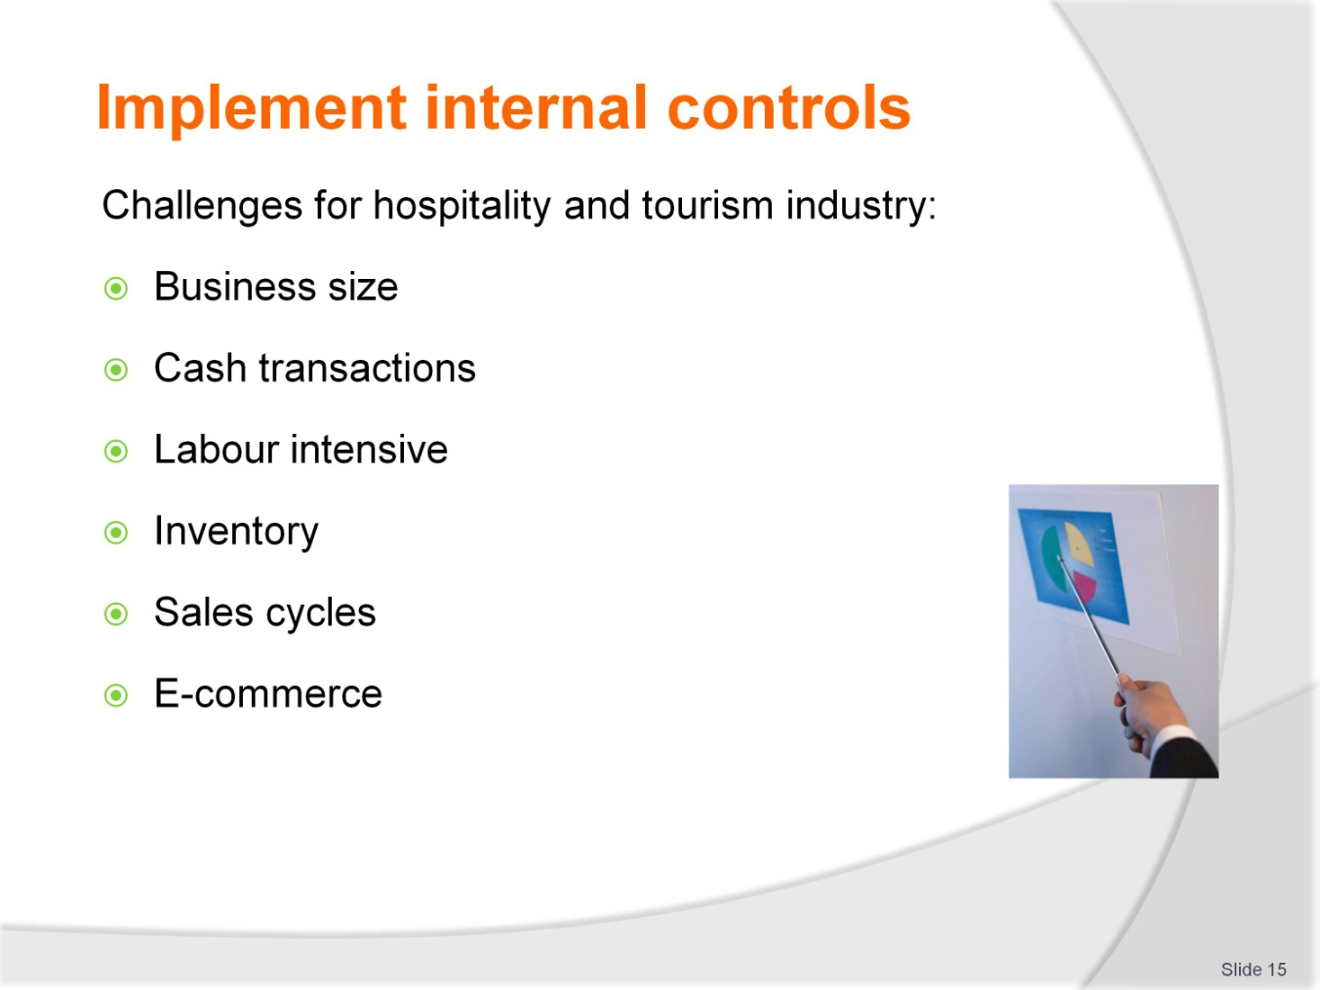
Slide No | Trainer Notes
 | Continued from the previous slide.

Slide
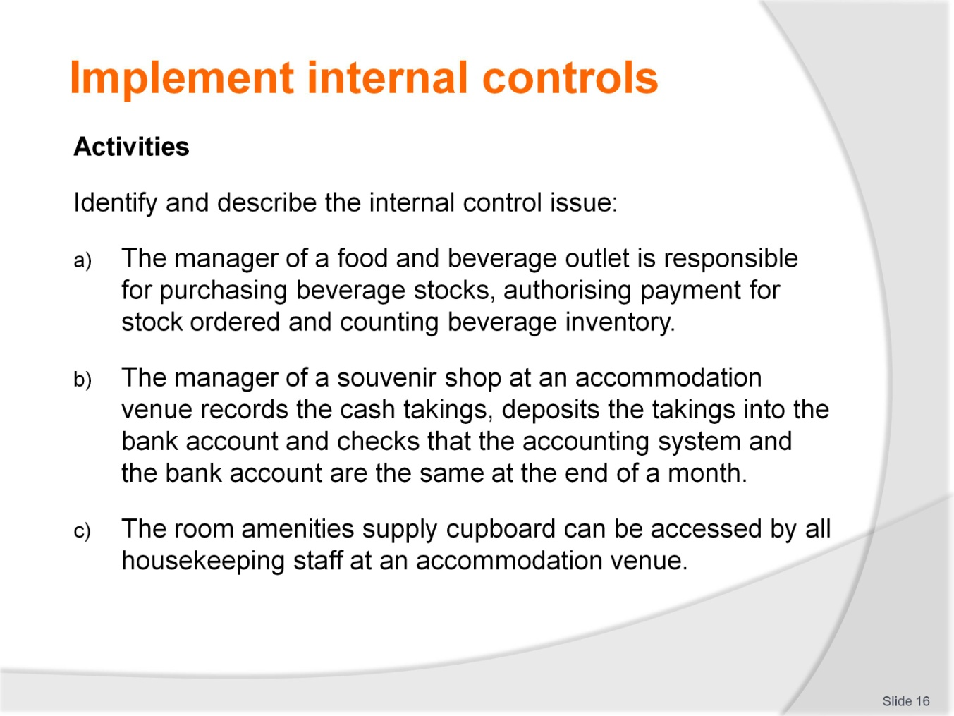
Slide No | Trainer Notes
 | Continued from the previous slide.

Slide
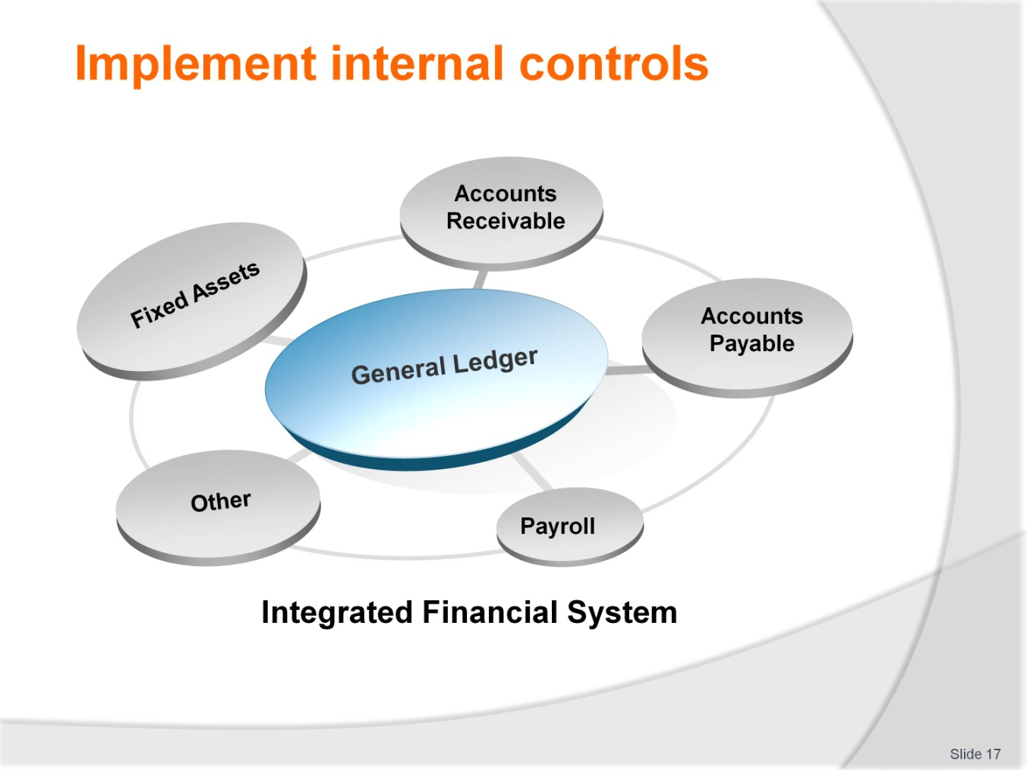
Slide No | Trainer Notes
 | Trainer: the activity has highlighted internal control issues in certain functional areas in an establishment. Internal control processes and procedures are discussed over the next slides in terms of each area of a financial system.

Slide
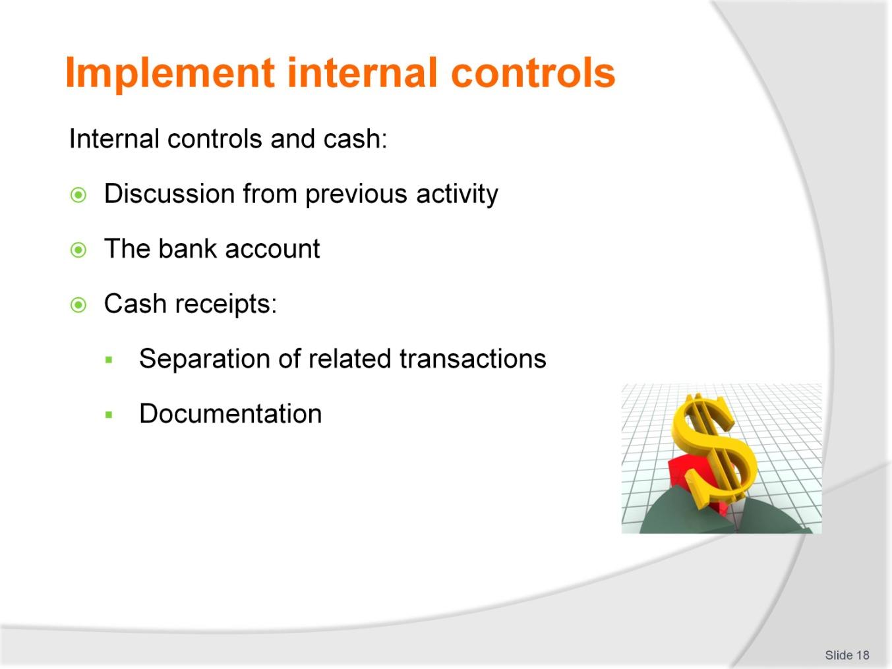
Slide No | Trainer Notes
 | Trainees must understand that the definition of cash includes all local legal forms of payment. The earlier activity would have prompted discussions surrounding internal controls for cash and this slide and the next expand that discussion.

Slide
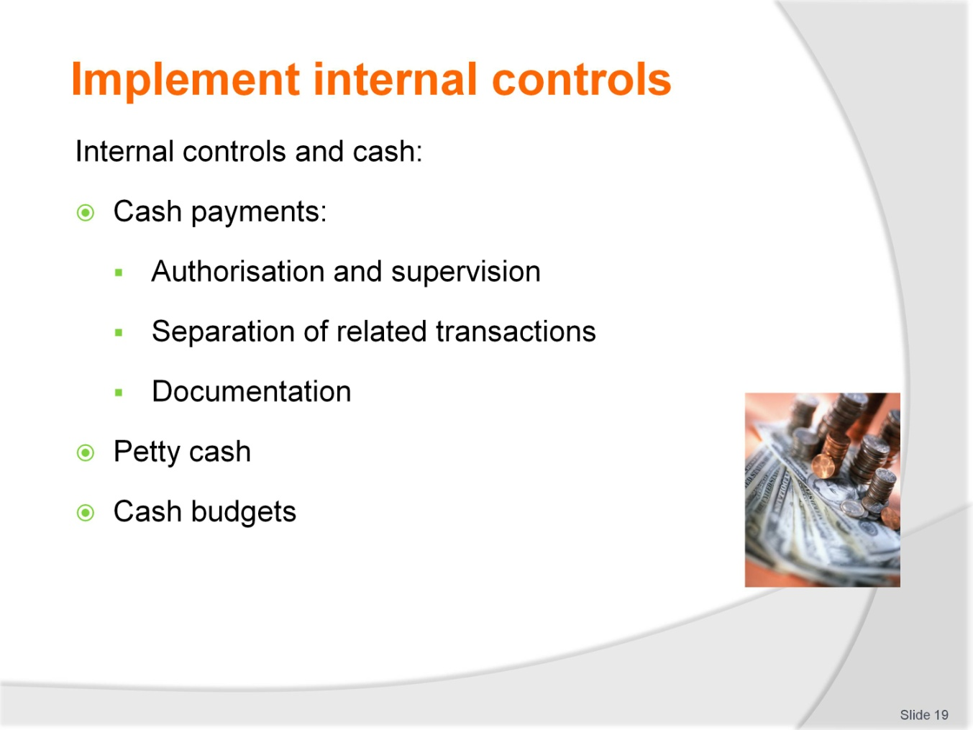
Slide No | Trainer Notes
 | Continued from previous slide.

Slide
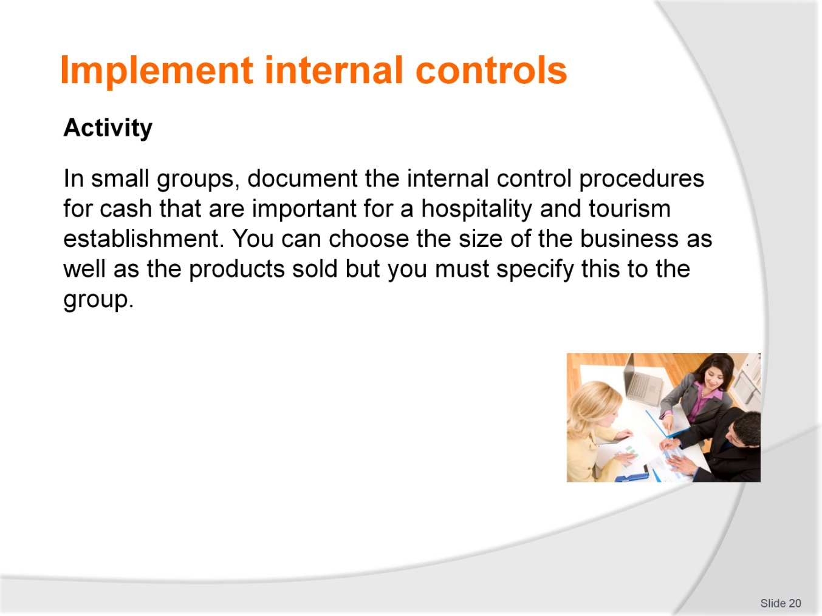
Slide No | Trainer Notes
 | Trainer: Trainees can refer to the training manual for details and must cover controls for cash receipts and payments, petty cash and discuss cash budgets.

Slide
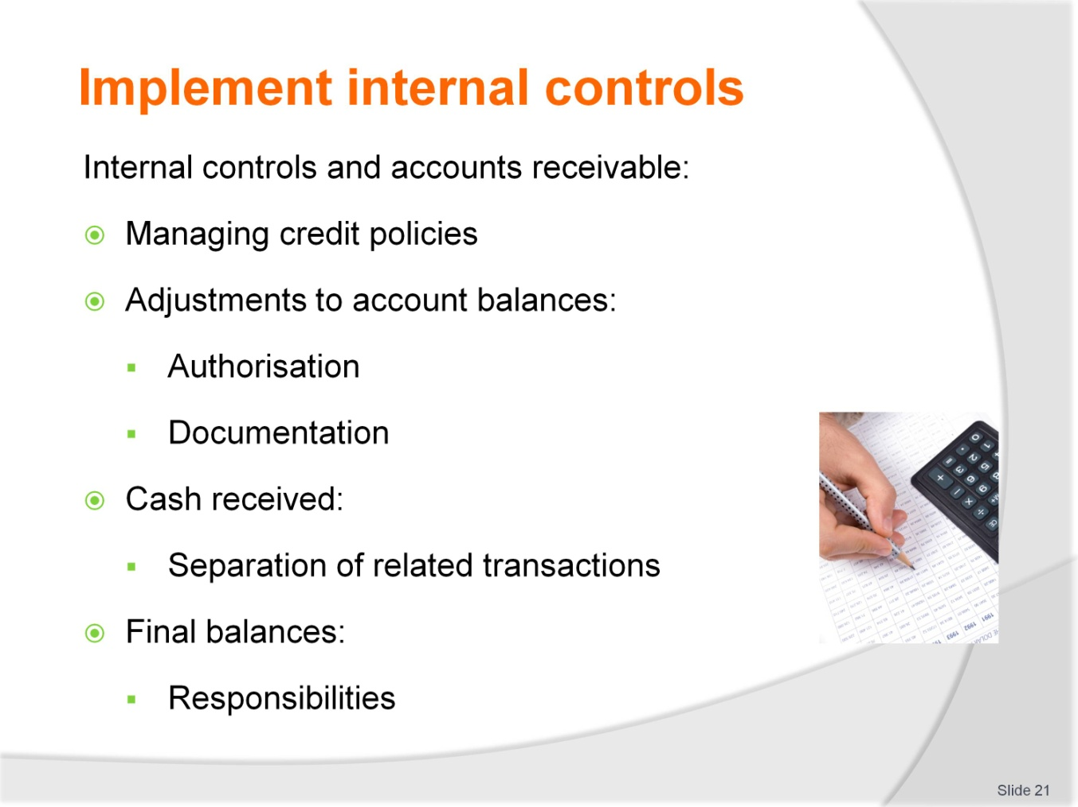
Slide No | Trainer Notes
 | Trainer: Explain the nature of accounts receivable in the hospitality and tourism industry and that credit may not always be extended to customers, guests or clients. Compare a small restaurant to a large accommodation venue to illustrate for example.

Slide
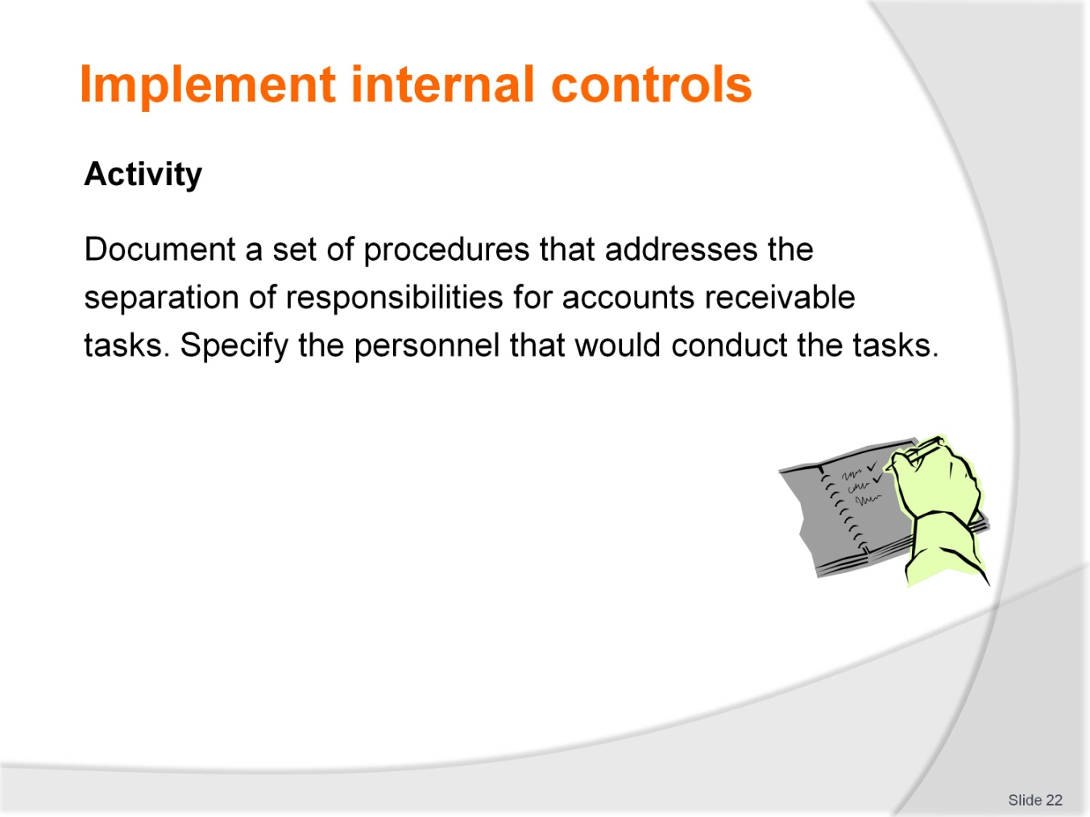
Slide No | Trainer Notes
 | Trainer: Trainees can refer to the training manual for details and must cover controls for cash receipts, adjustments and the reconciliation of final balances.

Slide
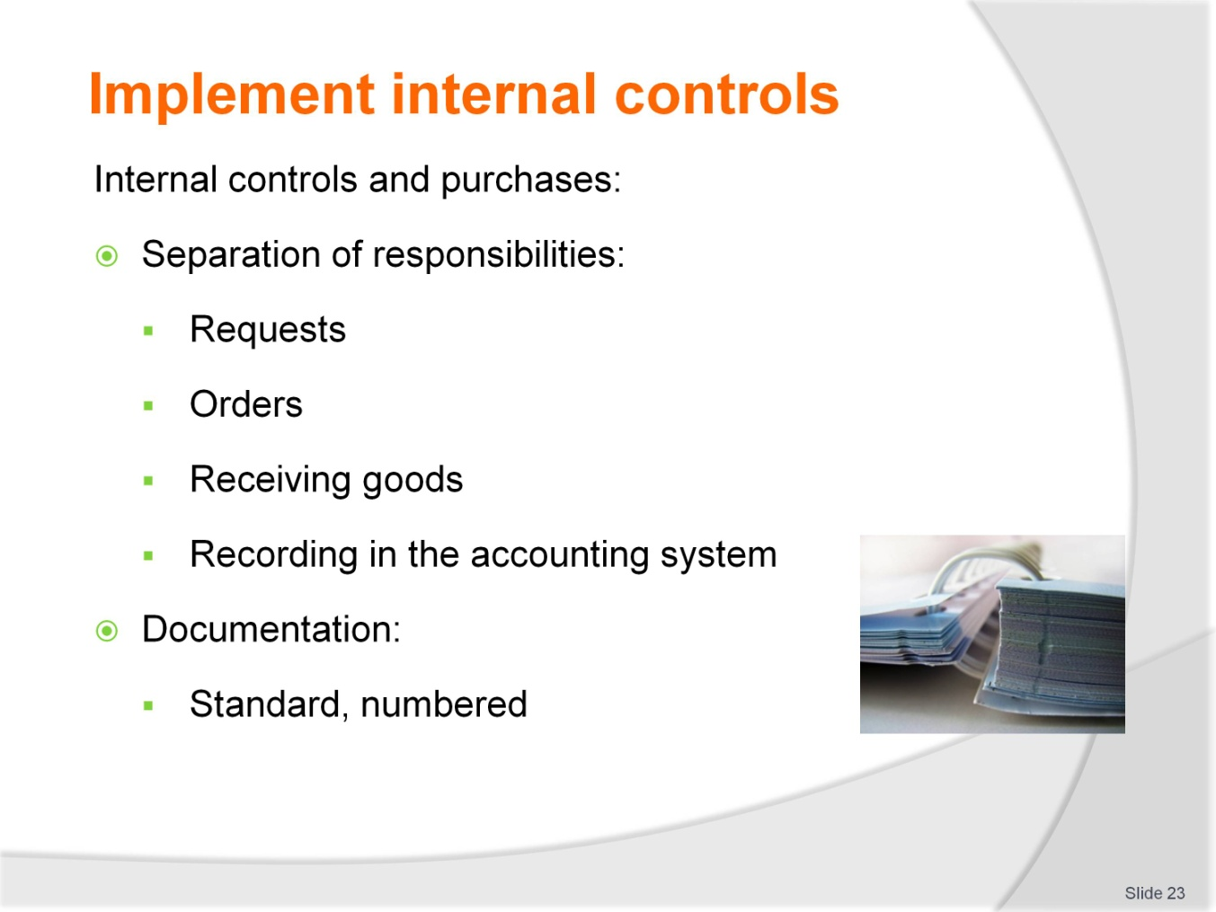
Slide No | Trainer Notes
 | Trainer: Purchases refers to the purchase of supplies that are converted to goods and services for re-sale. An activity follows on the next slide.

Slide
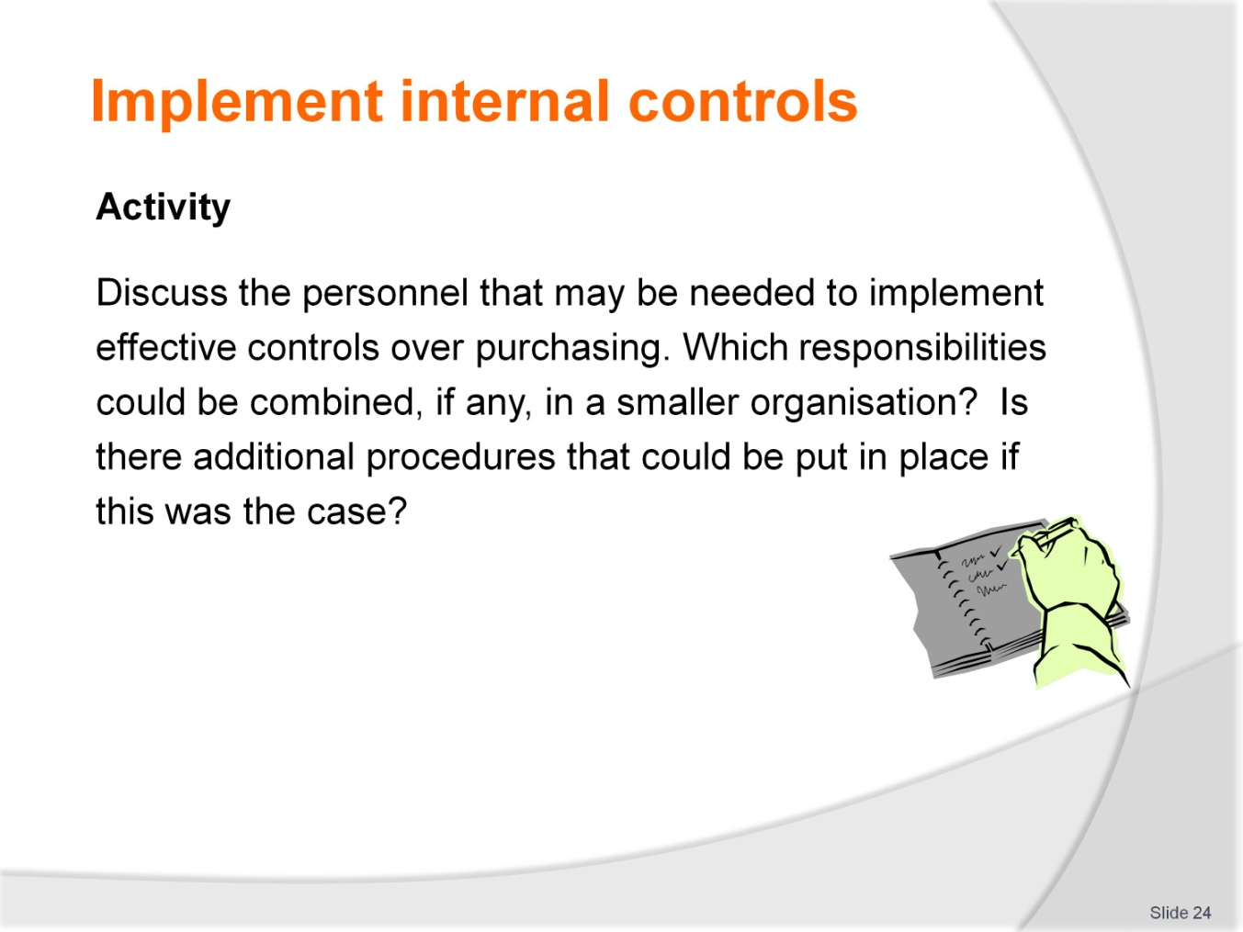
Slide No | Trainer Notes
 | Continued from previous slide.

Slide
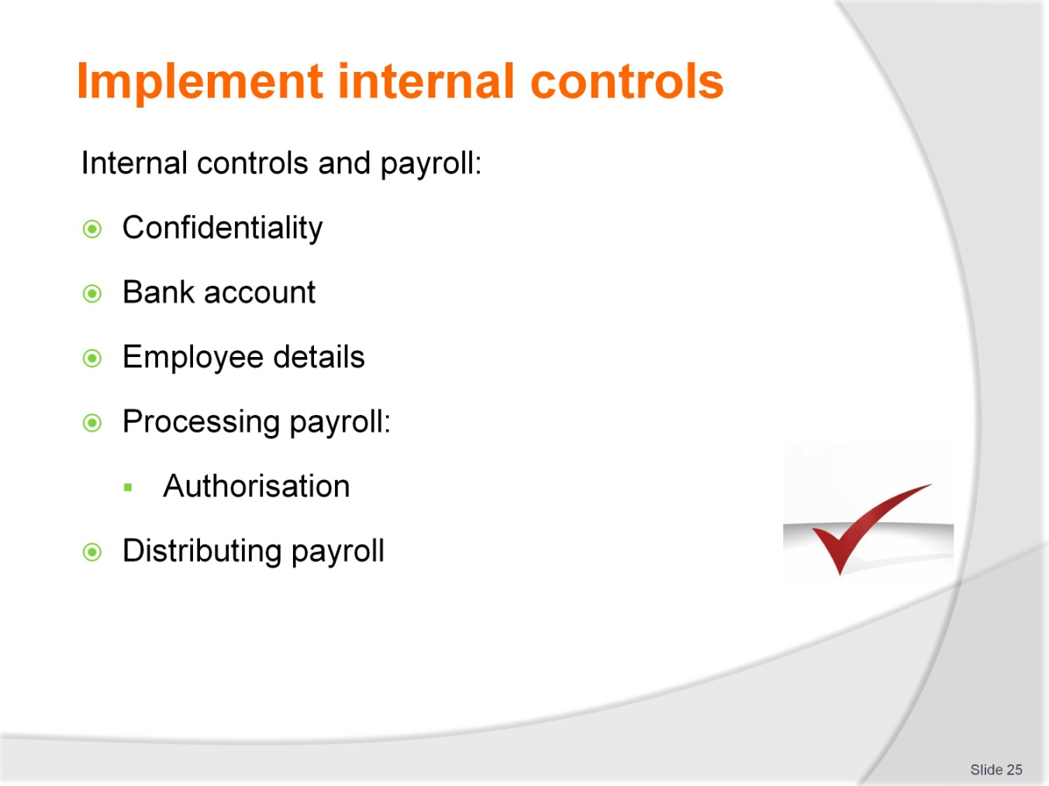
Slide No | Trainer Notes
 | Trainers to ensure that trainees appreciate the need for confidentiality surrounding the payroll process. An activity follows.

Slide
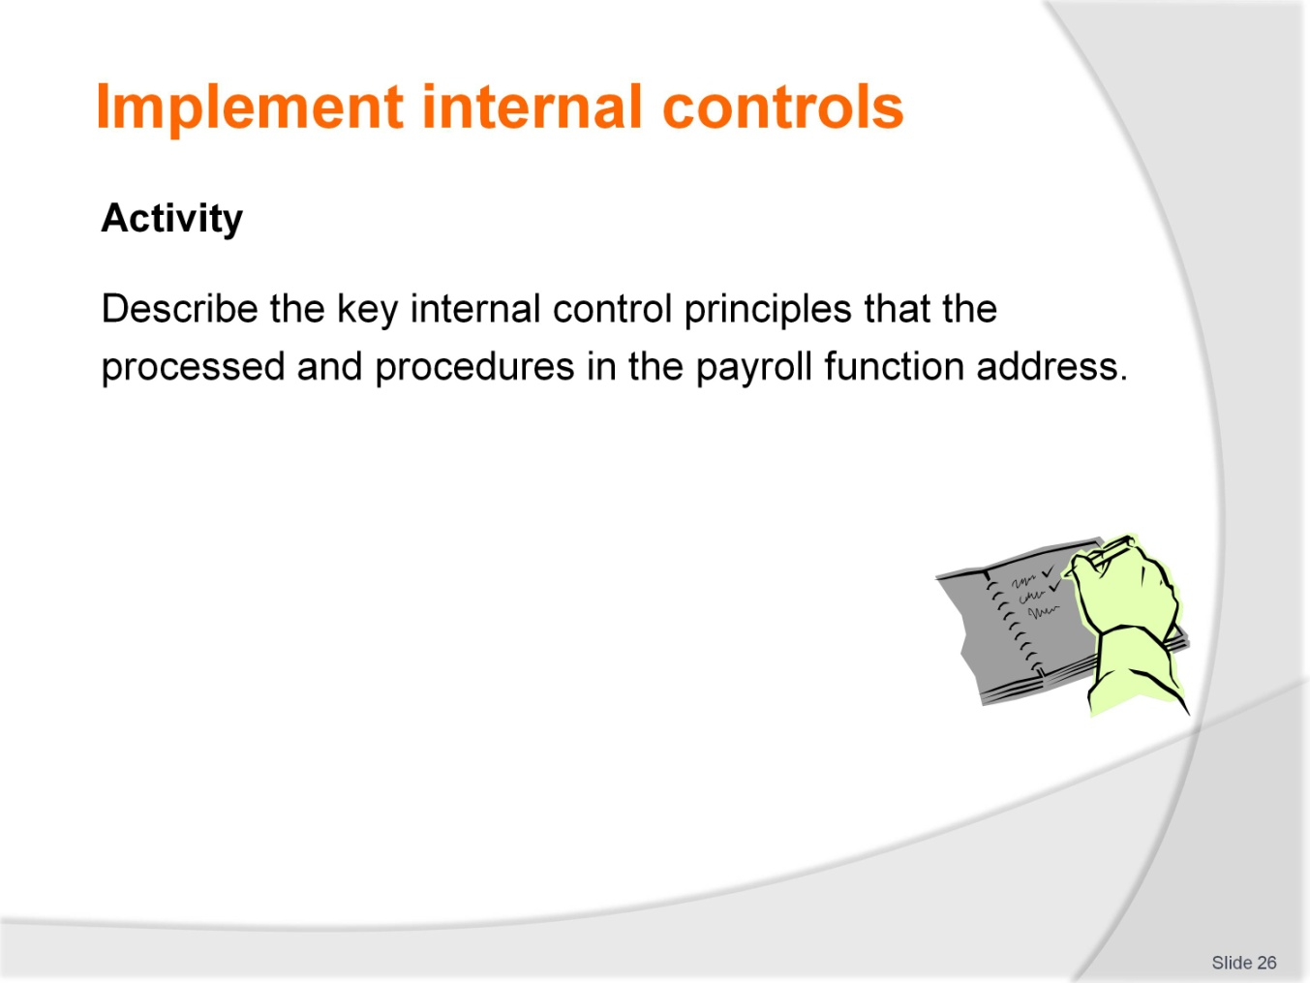
Slide No | Trainer Notes
 | Continued from previous slide.

Slide
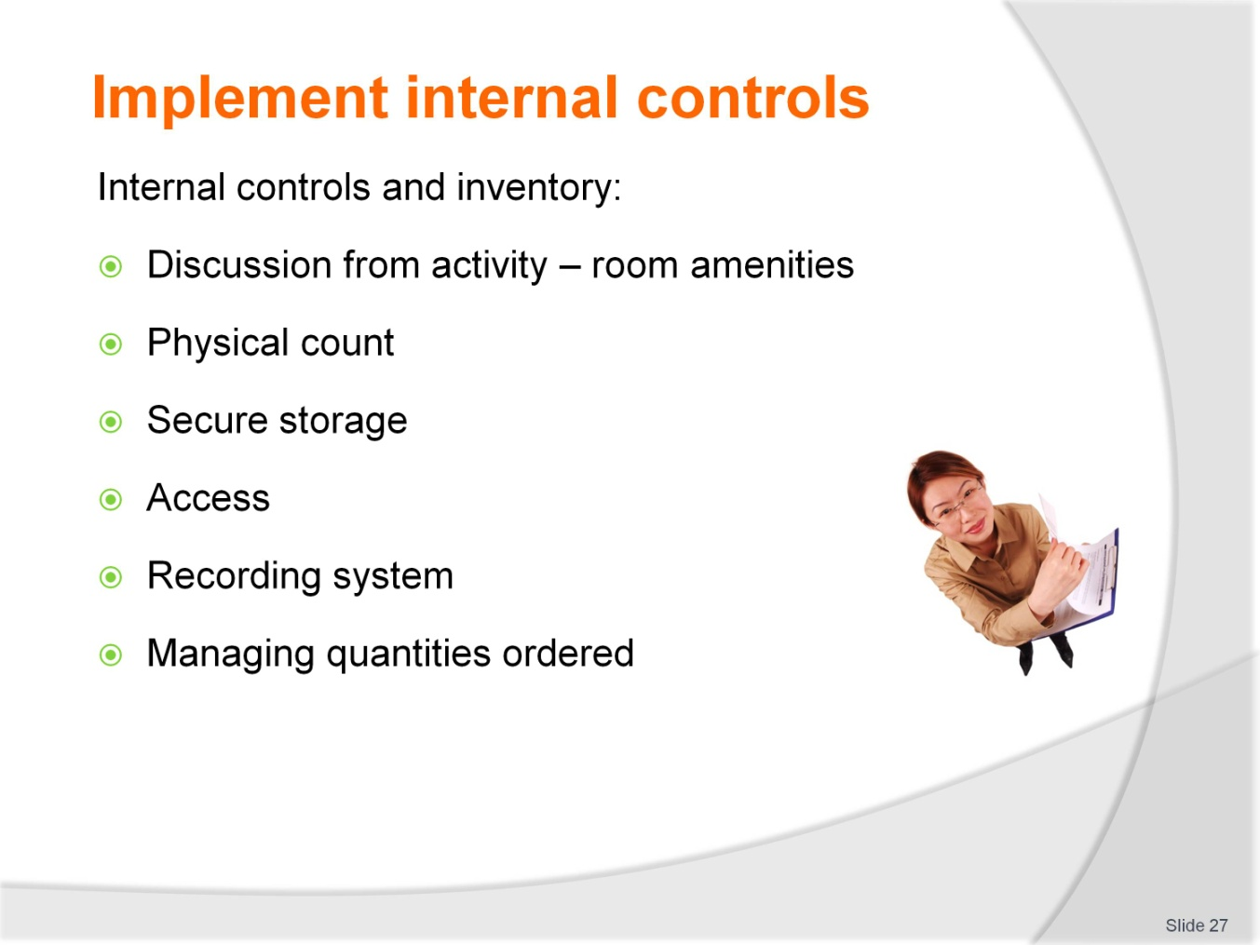
Slide No | Trainer Notes
 | Trainer: Not all hospitality and tourism establishments hold significant levels of inventory. Internal controls should be appropriate to the quantities and value of the stock held. Trainees can provide examples where possible. With regard to quantities ordered, trainees do not need to know the inventory recording systems but that as inventory is received and used it needs to be recorded appropriately.

Slide
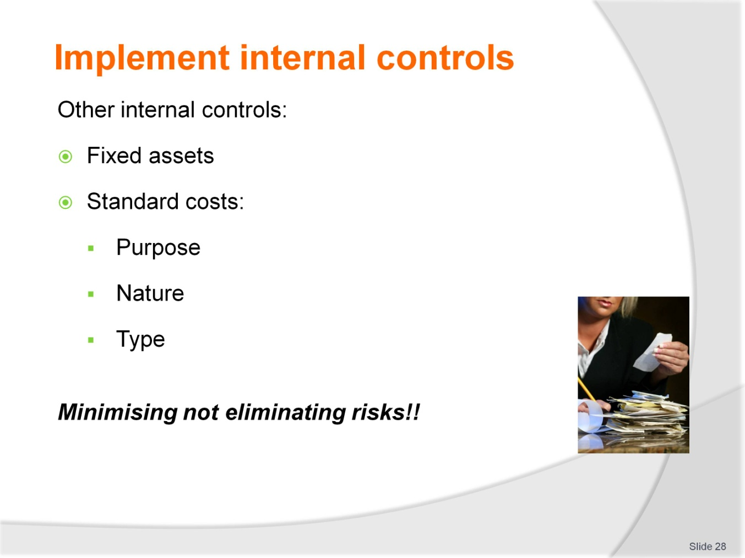
Slide No | Trainer Notes
Trainer: Refer to the training manual for details on the other internal controls trainees should know. Standard costs can be discussed by asking trainees to provide examples of aspects of a business that this internal control may be used. This can be a class activity if appropriate.
Remember that internal controls do not eliminate risks but seek to minimise them.

Slide
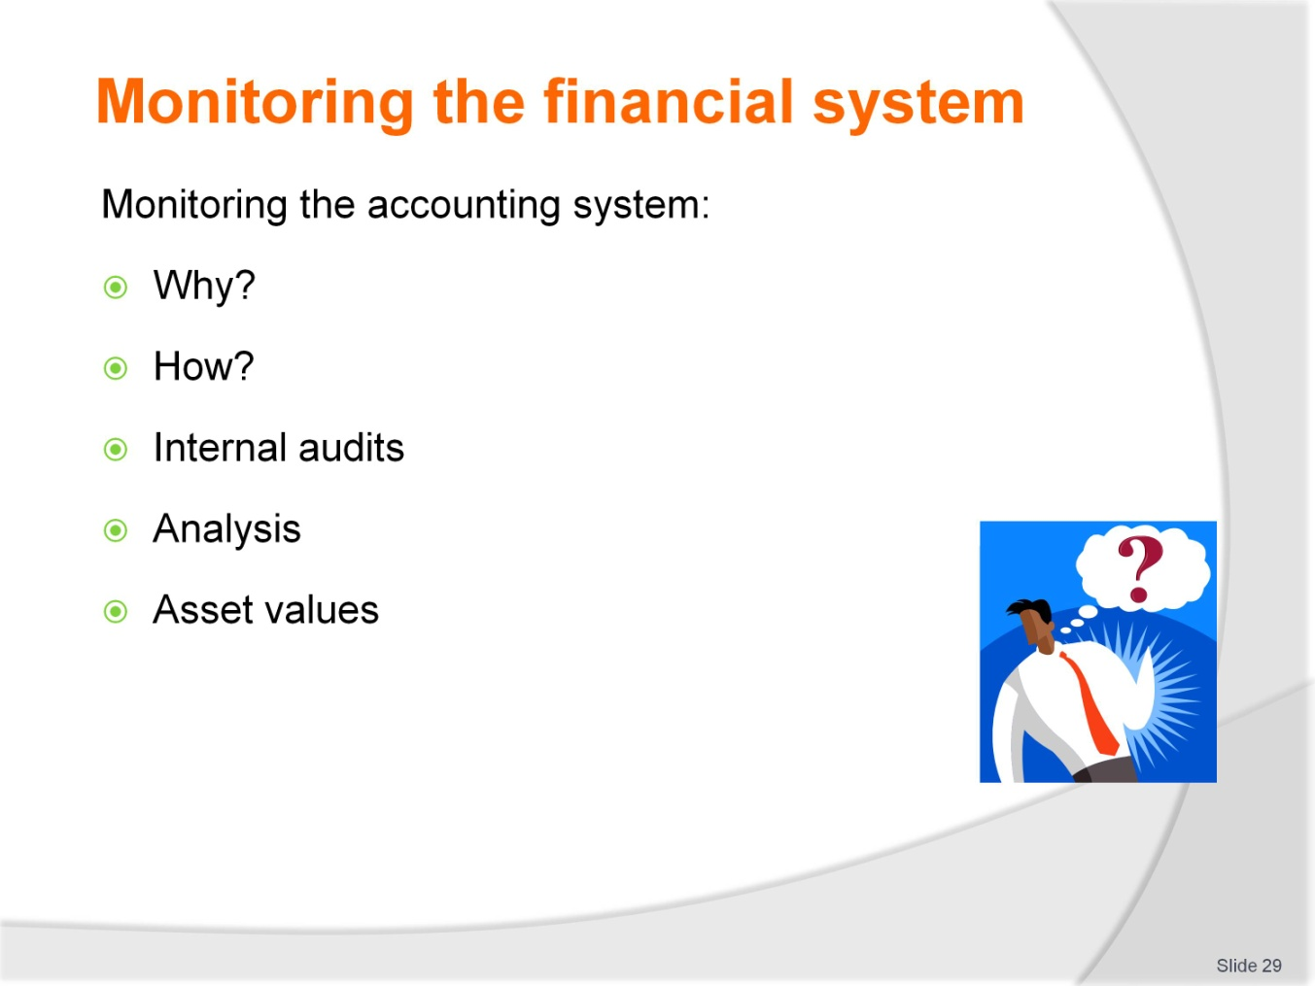
Slide No | Trainer Notes
 | Trainer: When internal controls are implemented, managers need to monitor the accounting system to ensure the objectives of reliability, validity, completeness and accuracy are met. This slide provides an overview for the next series of slides.

Slide
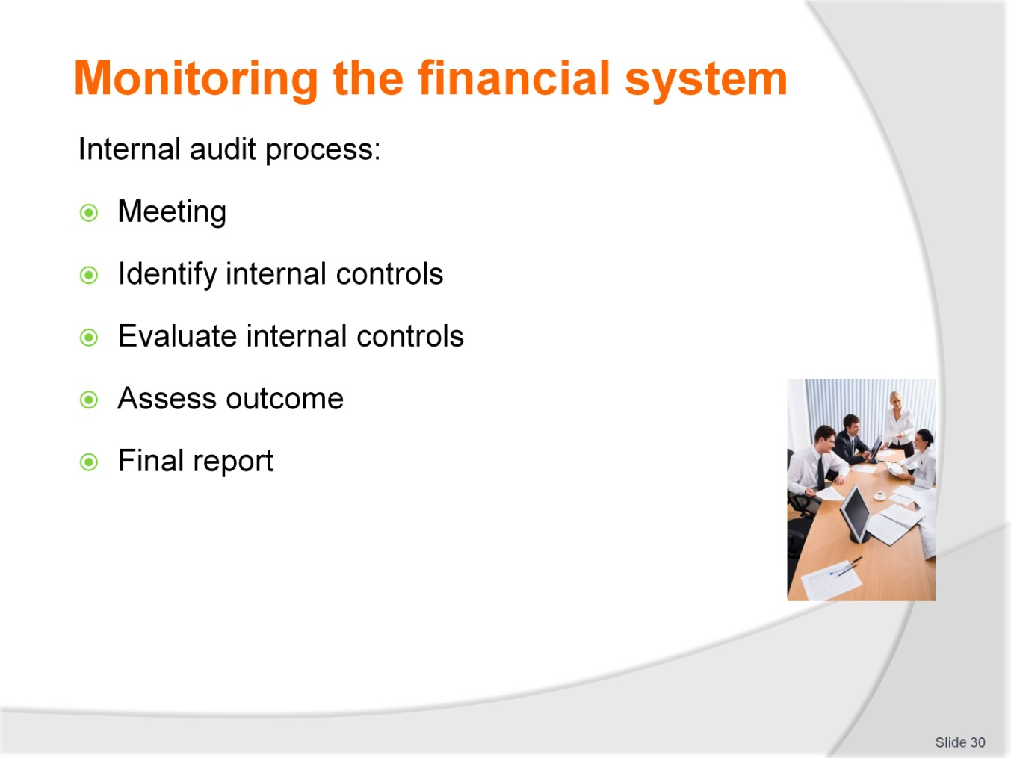
Slide No | Trainer Notes
 | Trainers highlight the variations to internal audits depending on the size of the organisation and should refer to personal or trainees experience if possible.

Slide
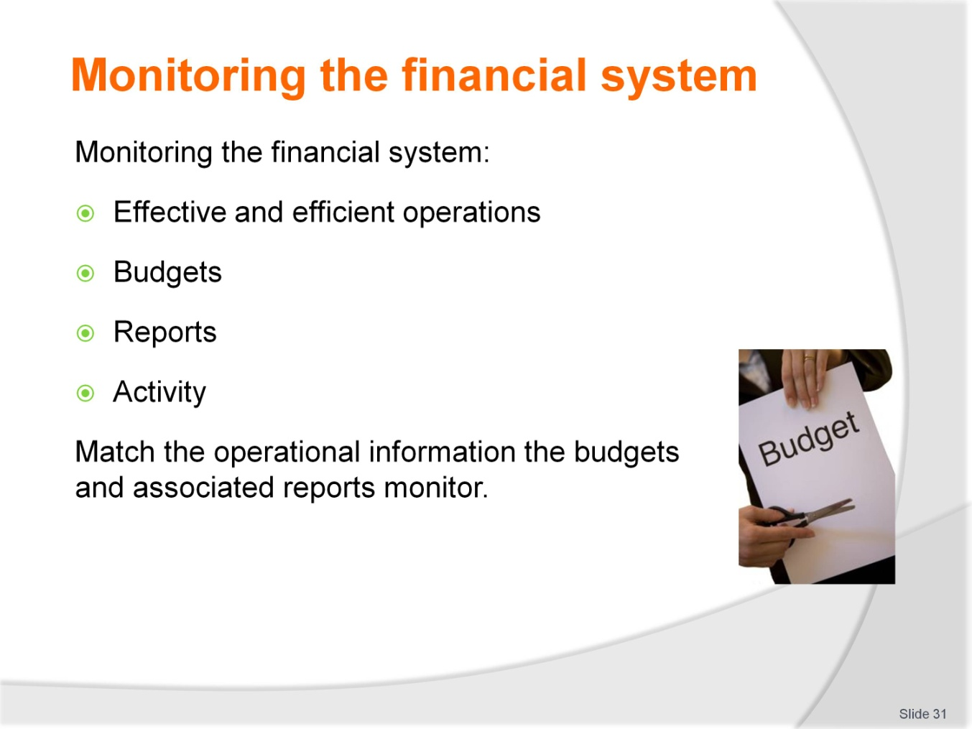
Slide No | Trainer Notes
 | Trainer: Provide trainees with a range of budget names, the training manual can be used as a guide for trainees to discuss the information the budget contains. Trainees can match the budget to the report, also from the training manual.

Slide
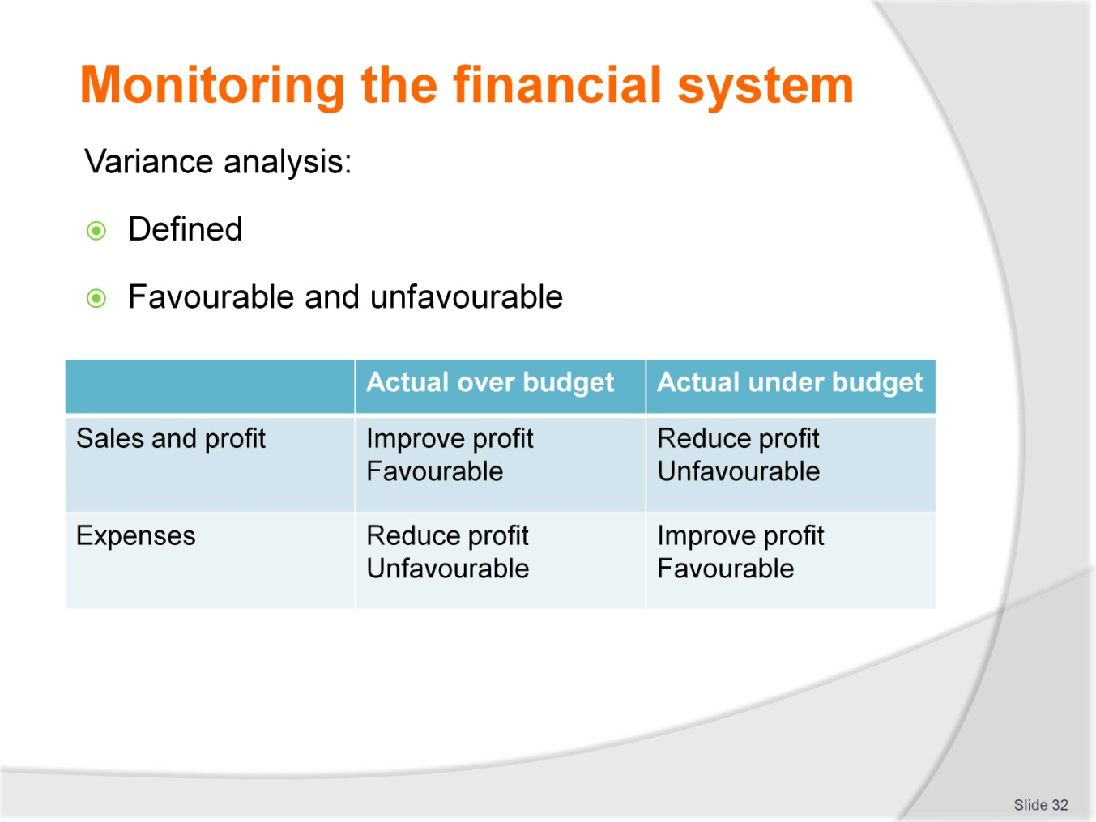
Slide No | Trainer Notes
 | Trainer: It is important that trainees do not think of variances as good or bad but favourable and unfavourable compared to budget.

Slide
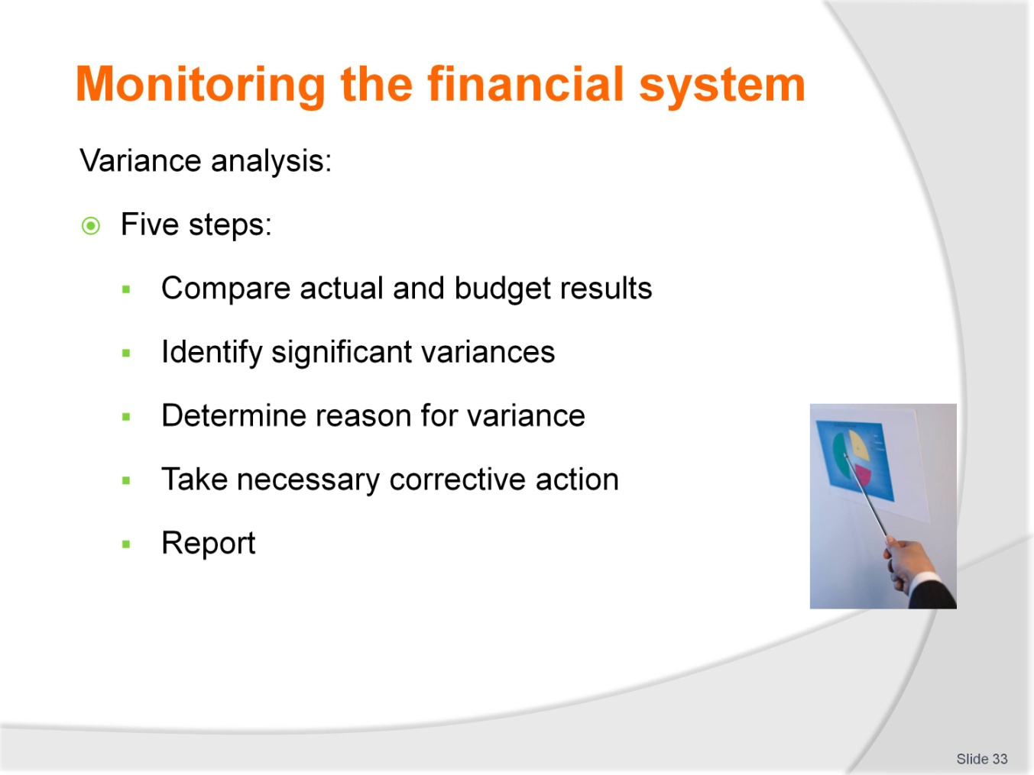
Slide No | Trainer Notes
 | Continued from previous slide.

Slide
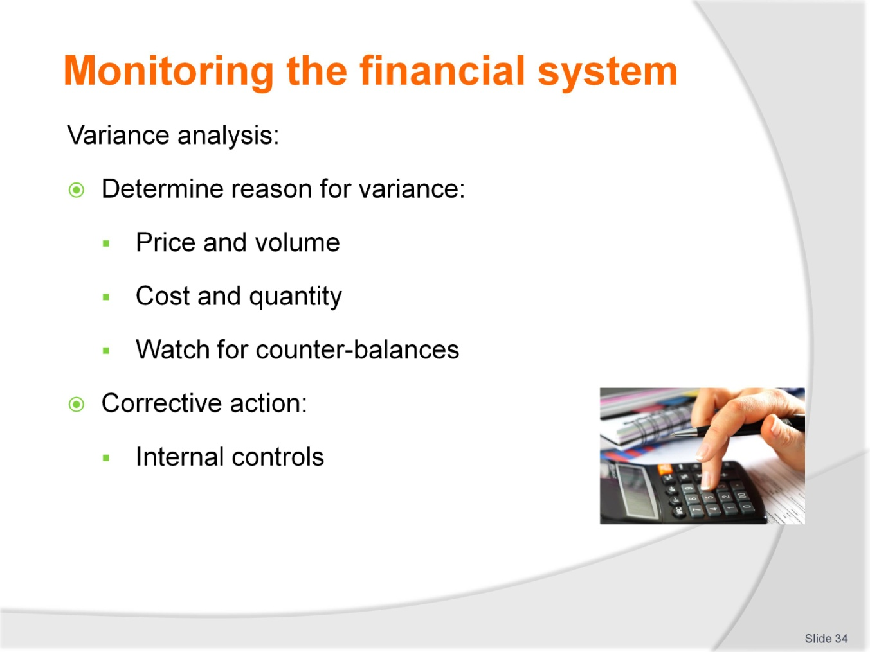
Slide No | Trainer Notes
 | Continued from previous slide.

Slide
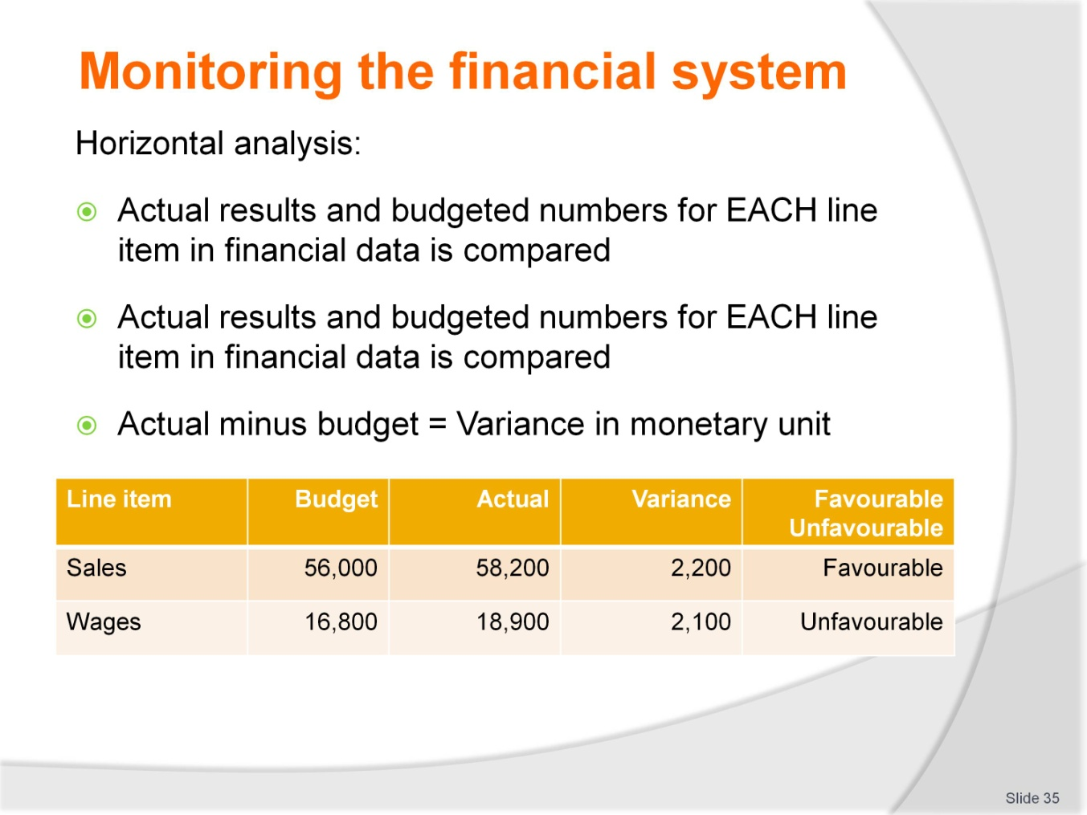
Slide No | Trainer Notes
 | Trainers take trainees through calculations. Note that trainers should source local, relevant examples for exercises for trainees to practice all variance calculations.

Slide
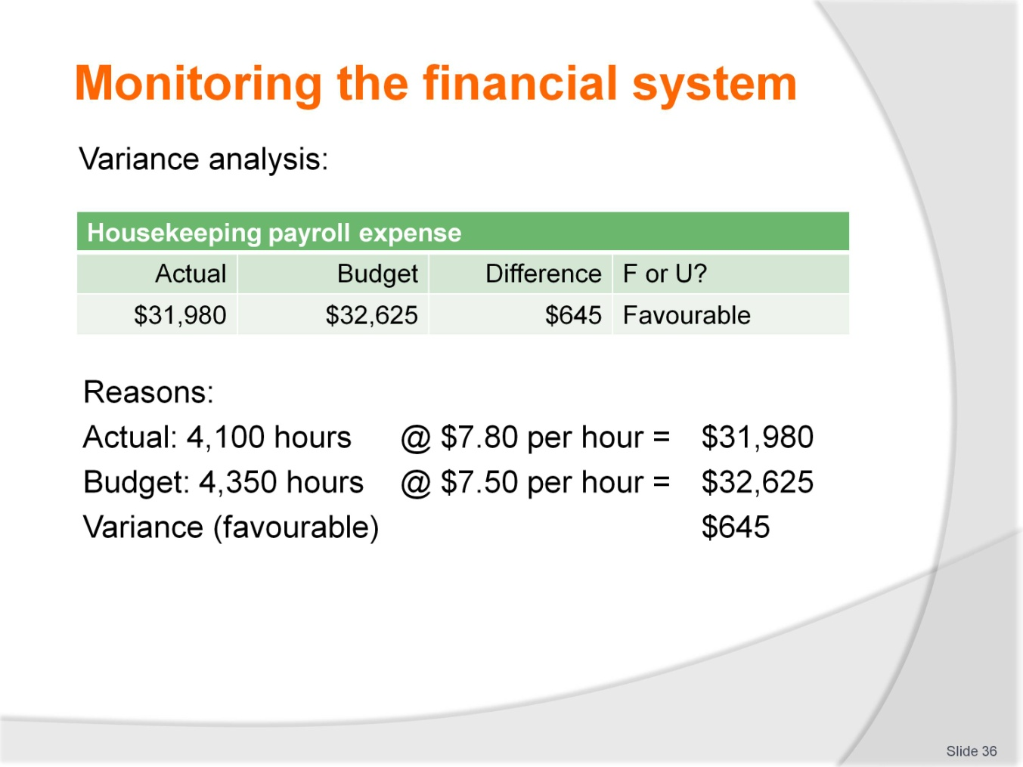
Slide No | Trainer Notes
 | Continued from previous slide.

Slide
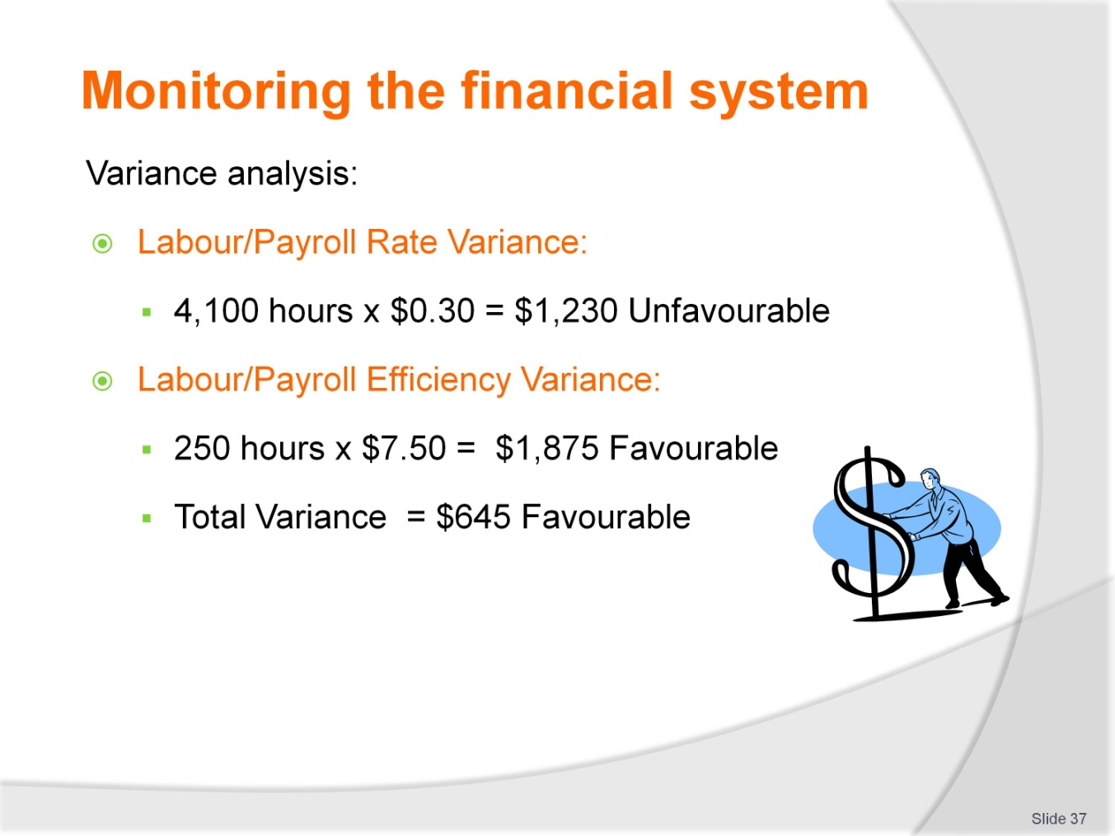
Slide No | Trainer Notes
 | Continued from previous slide - this highlights the two reasons why there may be a payroll variance – the hours worked or the rates of pay.

Slide
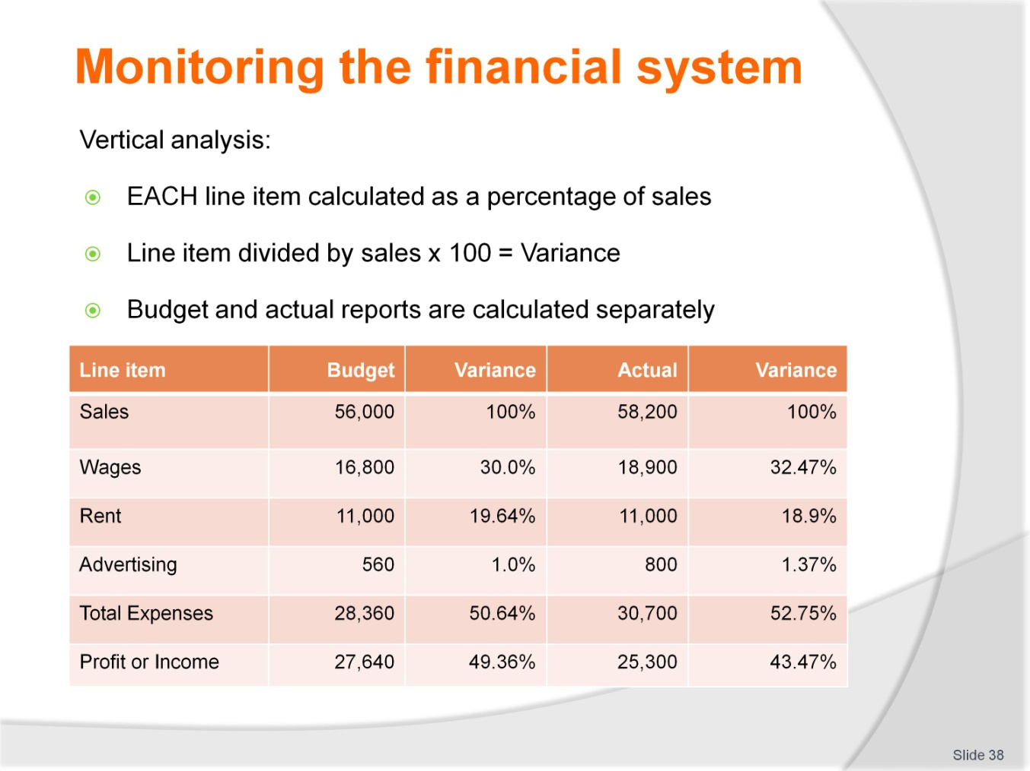
Slide No | Trainer Notes
 | Trainers take trainees through calculations noting that budget line items are divided by budgeted sales and actual line items by actual sales.

Slide
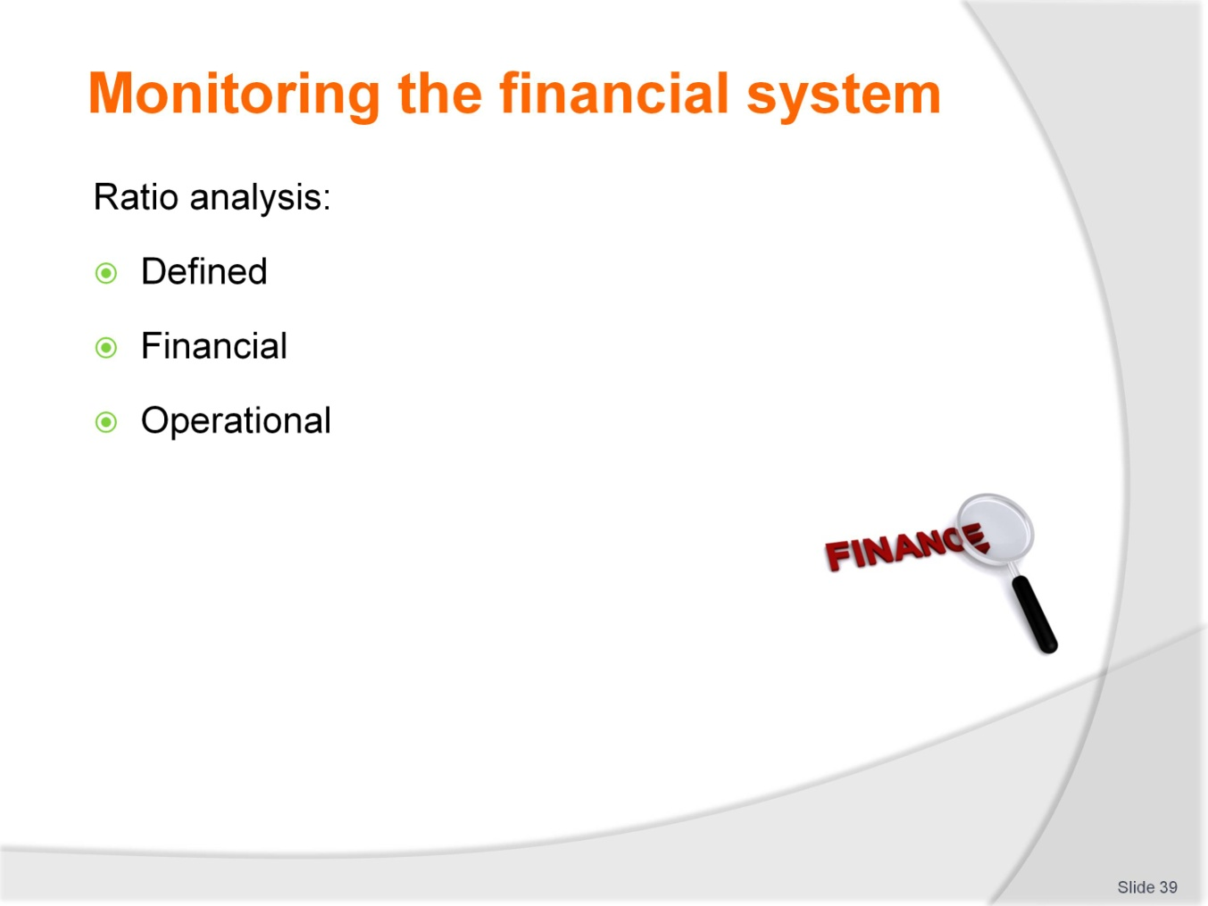
Slide No | Trainer Notes
Trainers: ensure that trainees are aware of the different ways ratios are expressed and that the ratio must have meaning. An explanation as follows might be of assistance:
What is a ratio?
It shows the relative size of two numbers, calculated by dividing one number by the other
For example, if a business has Assets of $500,000 and Liabilities of $350,000, Liabilities divided by Assets shows a ratio of 0.7 to 1
For each $1 of Assets, the business has Liabilities of $0.70
Or if Assets are divided by Liabilities, a ratio of 1.429 results
For each $1 owed to outsiders, the business has $1.43 in Assets.
The distinction between operational and financial ratios for hospitality and tourism establishments can be highlighted by referring to the ratios in the training manual.

Slide
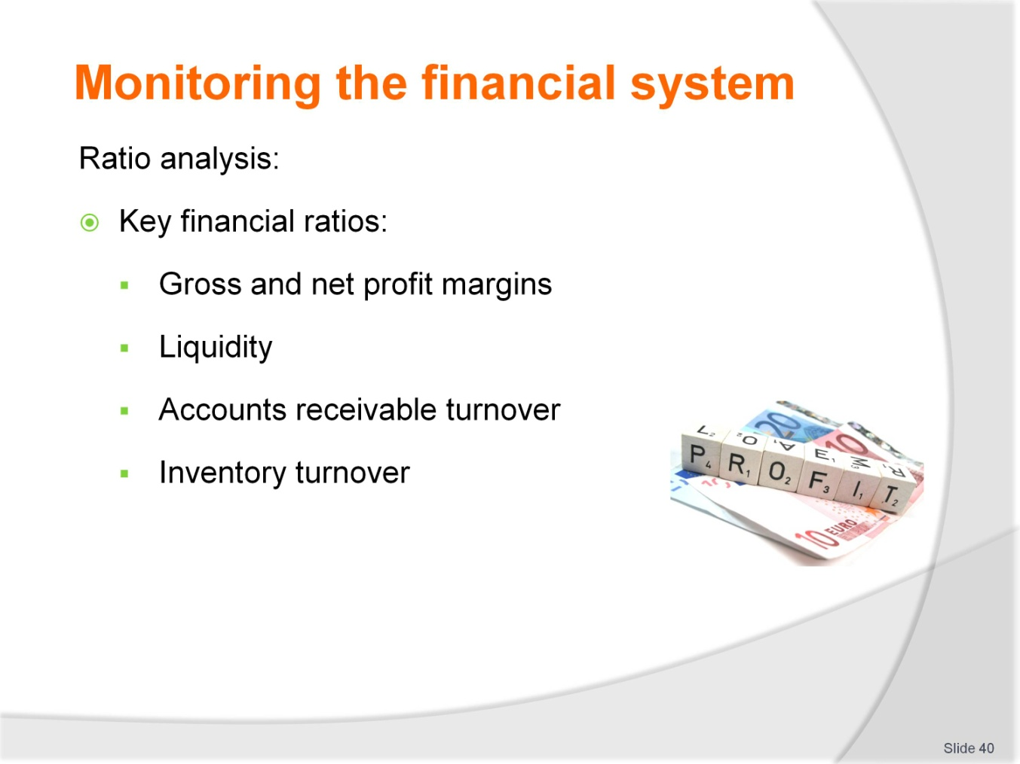
Slide No | Trainer Notes
 | Trainer: at a minimum, trainees should be able to calculate and interpret the ratios listed.

Slide
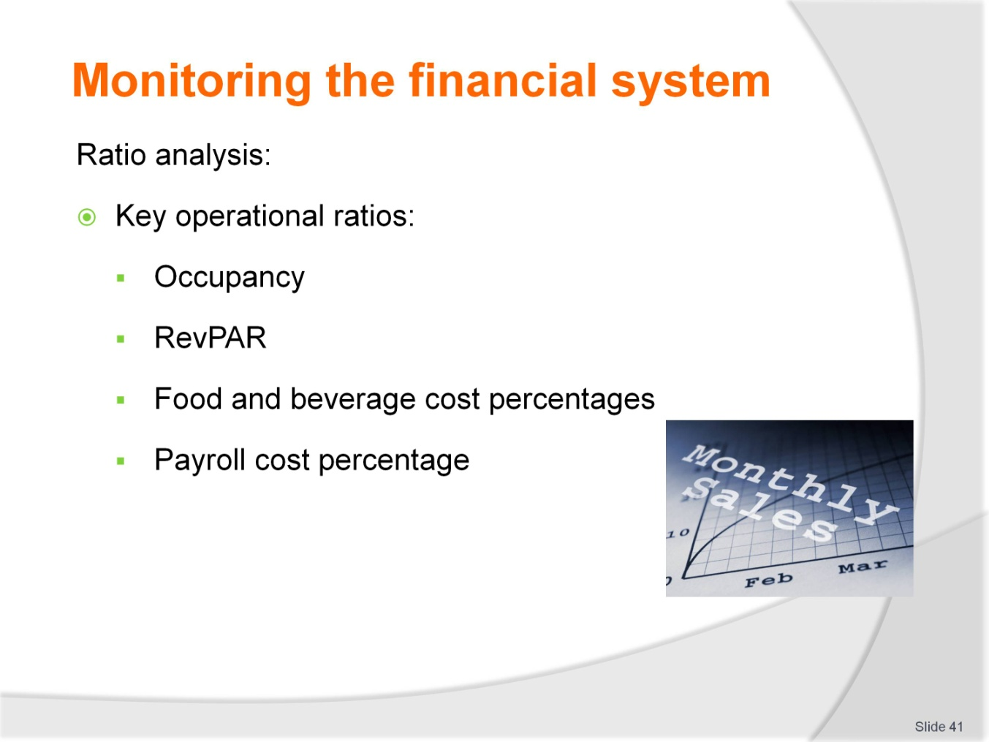
Slide No | Trainer Notes
 | Trainer: at a minimum, trainees should be able to calculate and interpret the ratios listed.

Slide
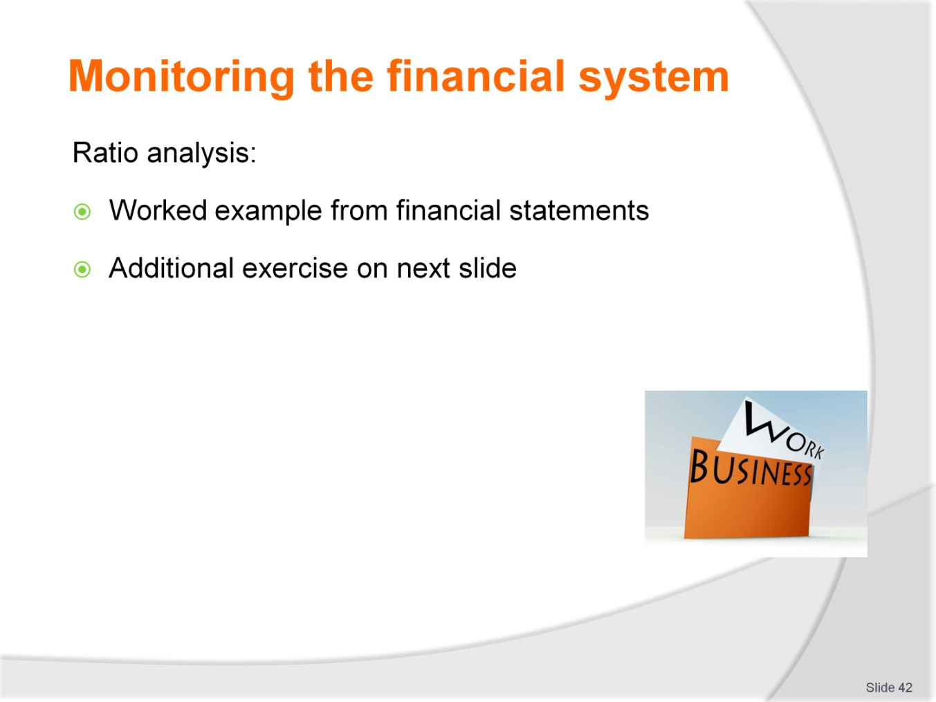
Slide No | Trainer Notes
 | Trainers to source local financial statements and operational data to work through the key ratios and their interpretations with trainees. Formulas and interpretation notes are included in the training manual.

Slide
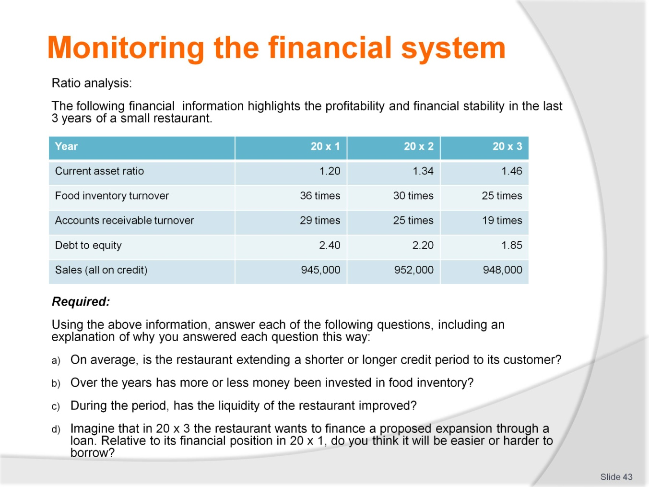
Slide No | Trainer Notes
 | Continued from previous slides.

Slide
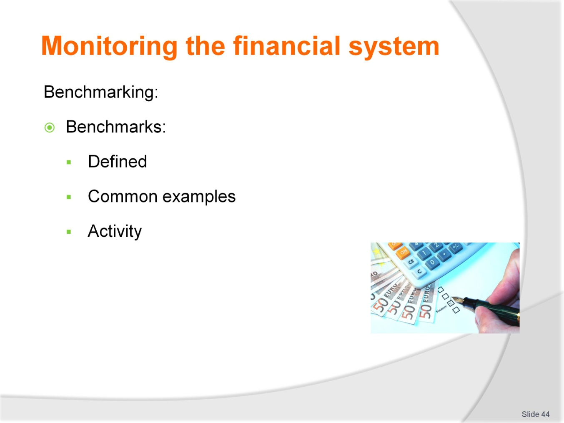
Slide No | Trainer Notes
 | Trainers: source local benchmarks and compare to ratios calculated from the financial statements. Trainees should work in groups to enable discussion and enhance understanding.

Slide
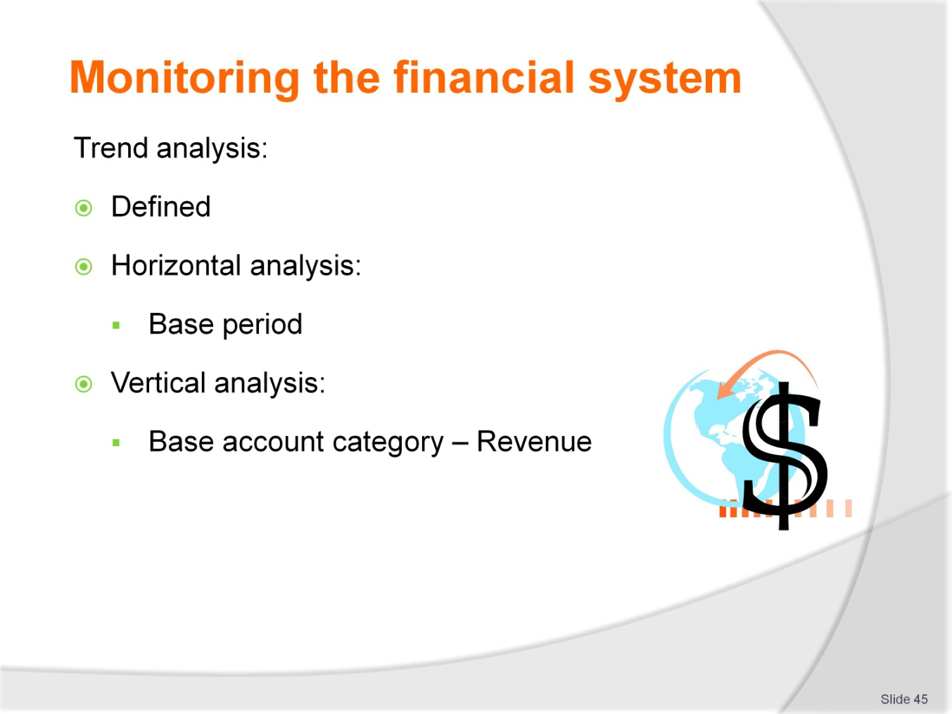
Slide No | Trainer Notes
 | Trainers explain how trends help managers to improve their understanding of operations. An example follows to aid discussions.

Slide
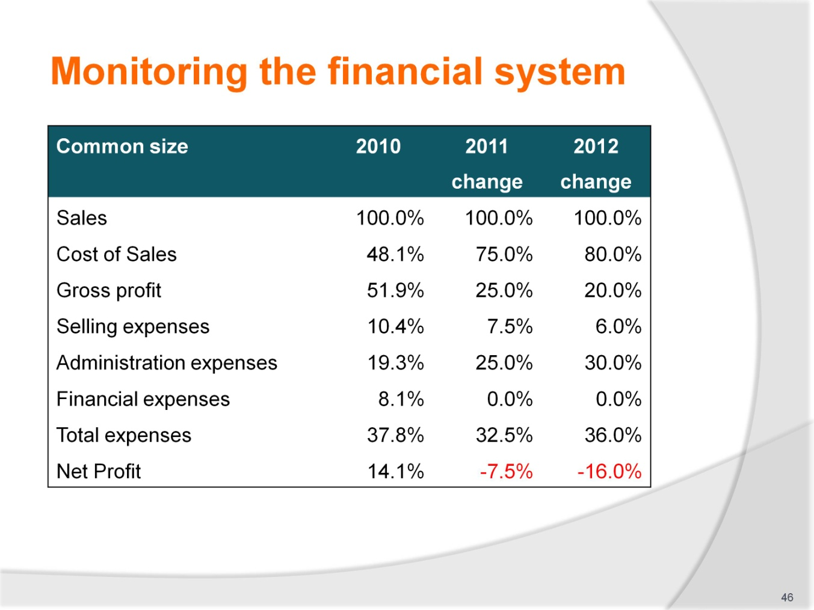
Slide No | Trainer Notes
 | Continued from previous slide.

Slide
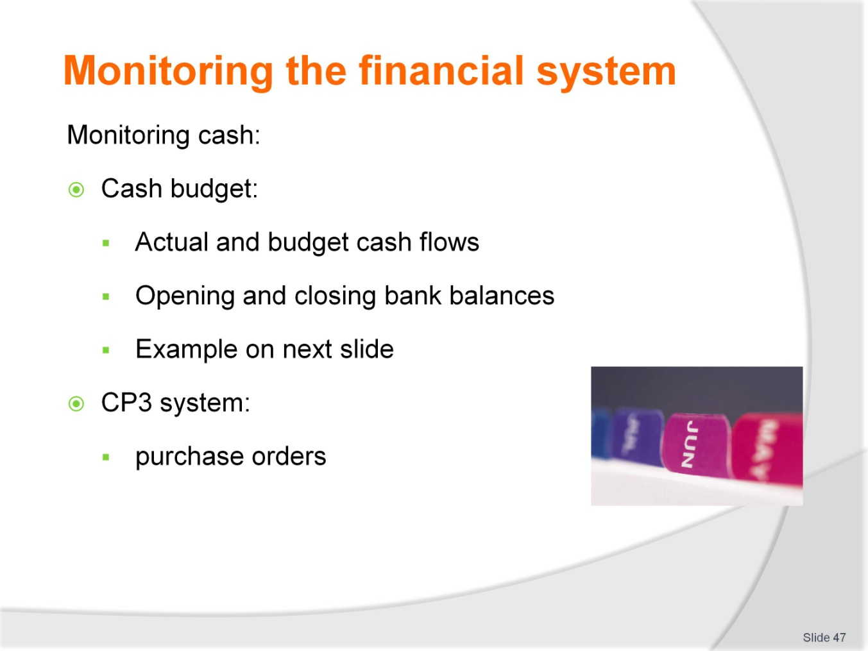
Slide No | Trainer Notes
 | Trainees work through cash budget on next slide, explaining source of information. Relevant, local examples can also be used as activities as appropriate.

Slide
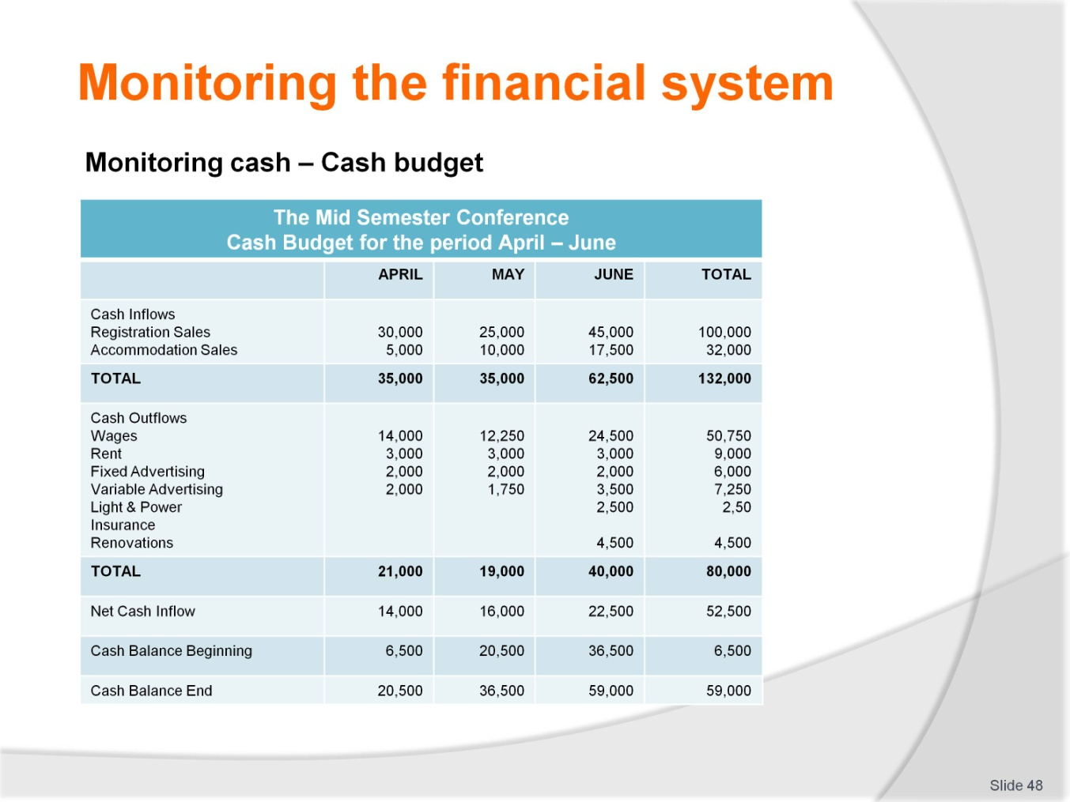
Slide No | Trainer Notes
 | Continued from previous slide.

Slide
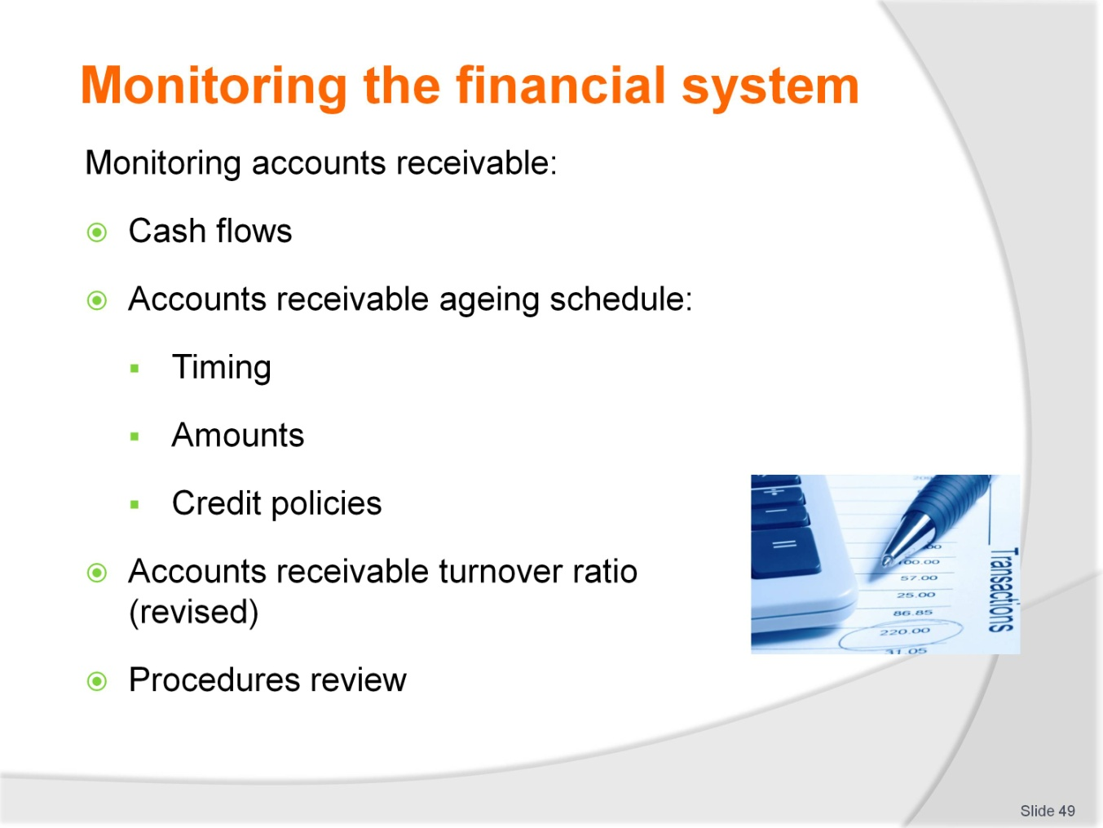
Slide No | Trainer Notes
 | Trainers: highlight cash from accounts receivable as cash inflows and how that relates to budget from previous page. The accounts receivable ageing schedule and turnover ratio together provide the information for managers to monitor. Utilise the ration calculated earlier as an example for this discussion.

Slide
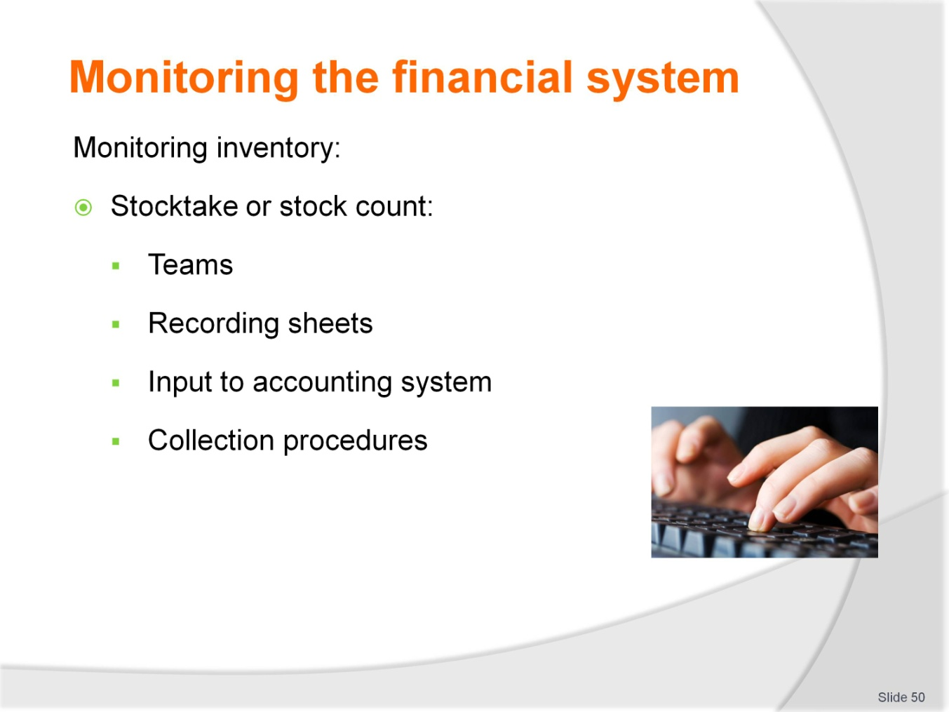
Slide No | Trainer Notes
 | Trainers may wish to organise trainees into small groups to review the training manual and discuss how to monitor inventory to assist with decision making. The ratios calculated earlier can be used as examples for the exercise.

Slide
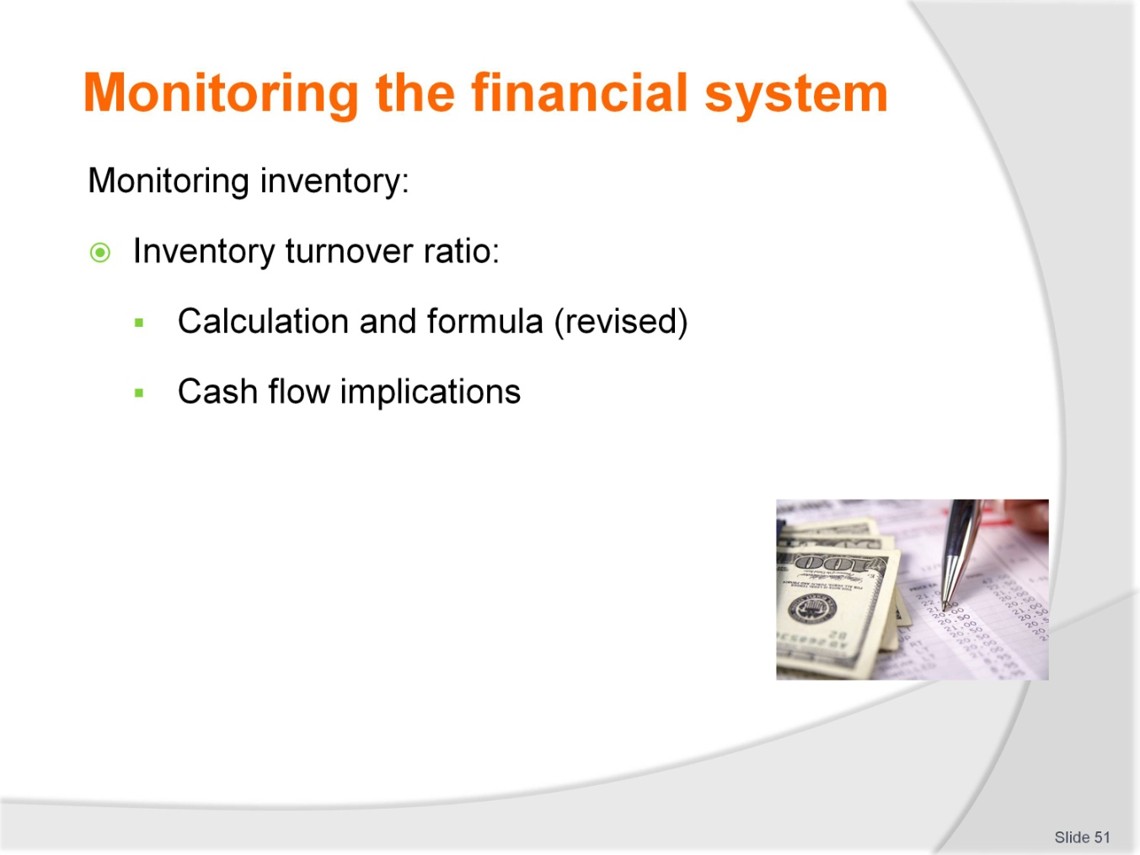
Slide No | Trainer Notes
 | Continued from previous slide.

Slide
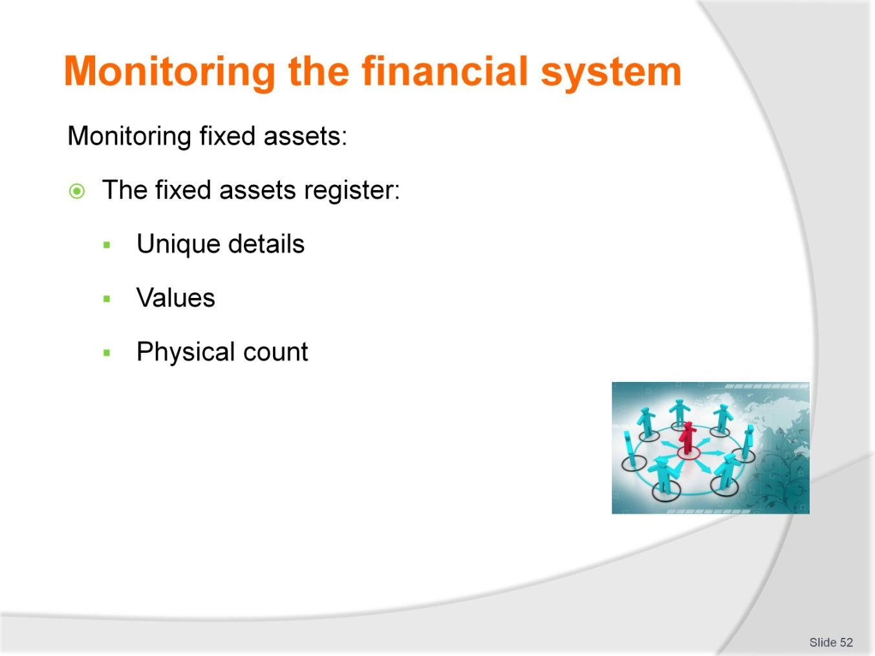
Slide No | Trainer Notes
 | Trainees to understand that it is both the physical presence of fixed assets and the value that management wish to monitor. Refer to the training manual using local examples to enhance discussion.

Slide
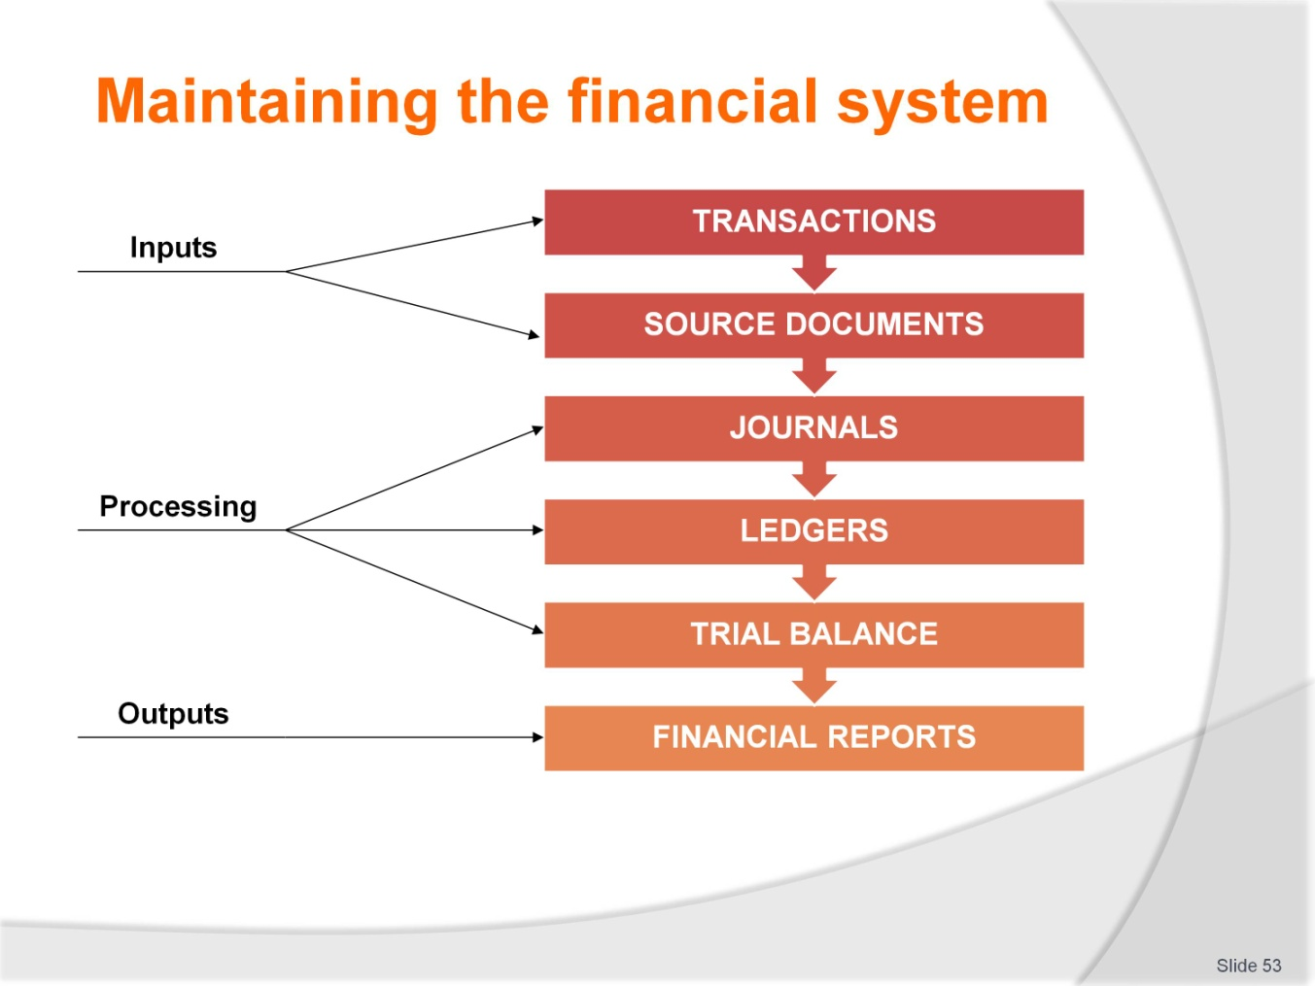
Slide No | Trainer Notes
 | Trainer: The focus for the next series of slides is the input and processing phases in the accounting system.

Slide
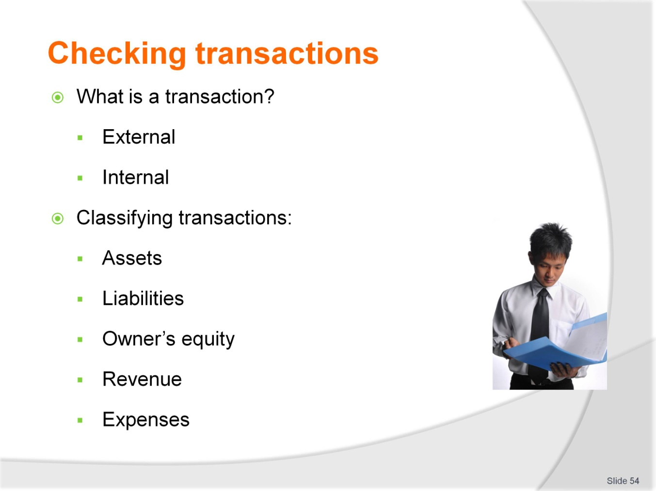
Slide No | Trainer Notes
 | Trainers: explain the difference between internal and external transactions using examples from the normal course of trainees experience. Definitions for the five account categories are found in the training manual.

Slide
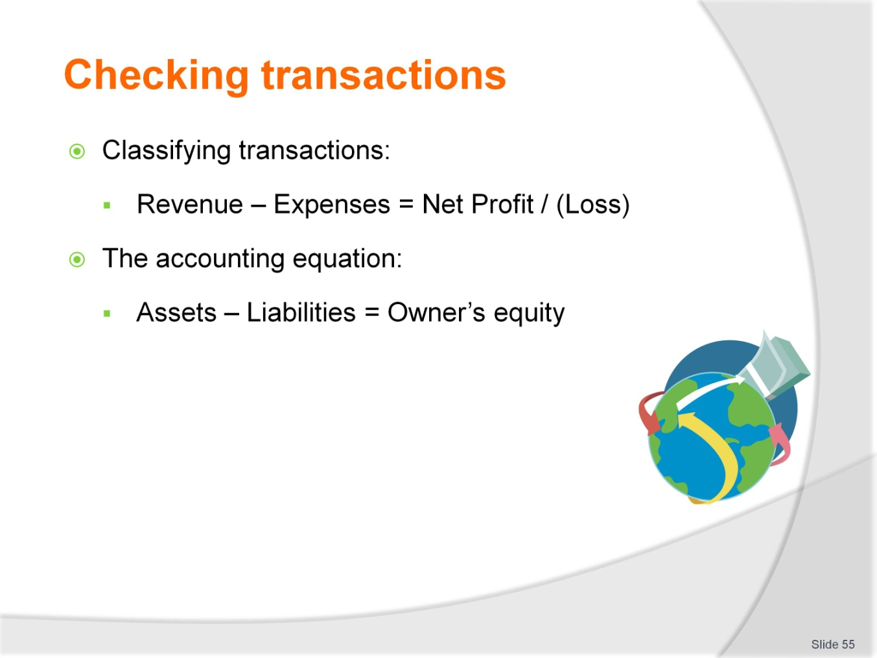
Slide No | Trainer Notes
 | Trainer: Transactions are classified so that they can be reported appropriately. An exercise follows on the next slide.

Slide
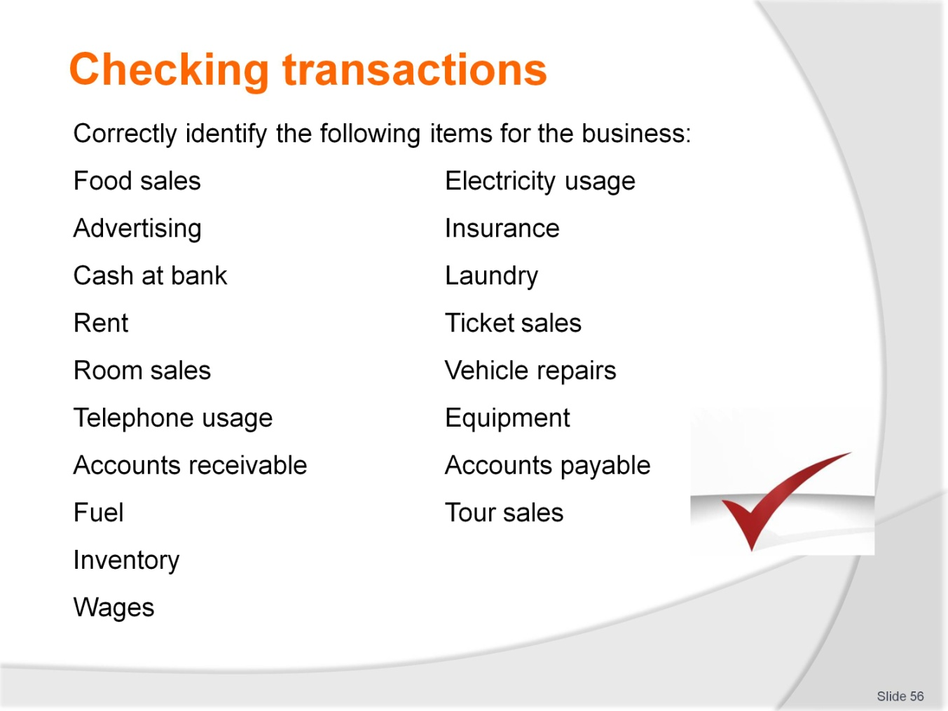
Slide No | Trainer Notes
Trainer: this activity can be completed individually, in small groups or by the entire class led by the trainer. The next slide provides the solutions.
Trainer may like to ask trainees to suggest items for themselves.

Slide
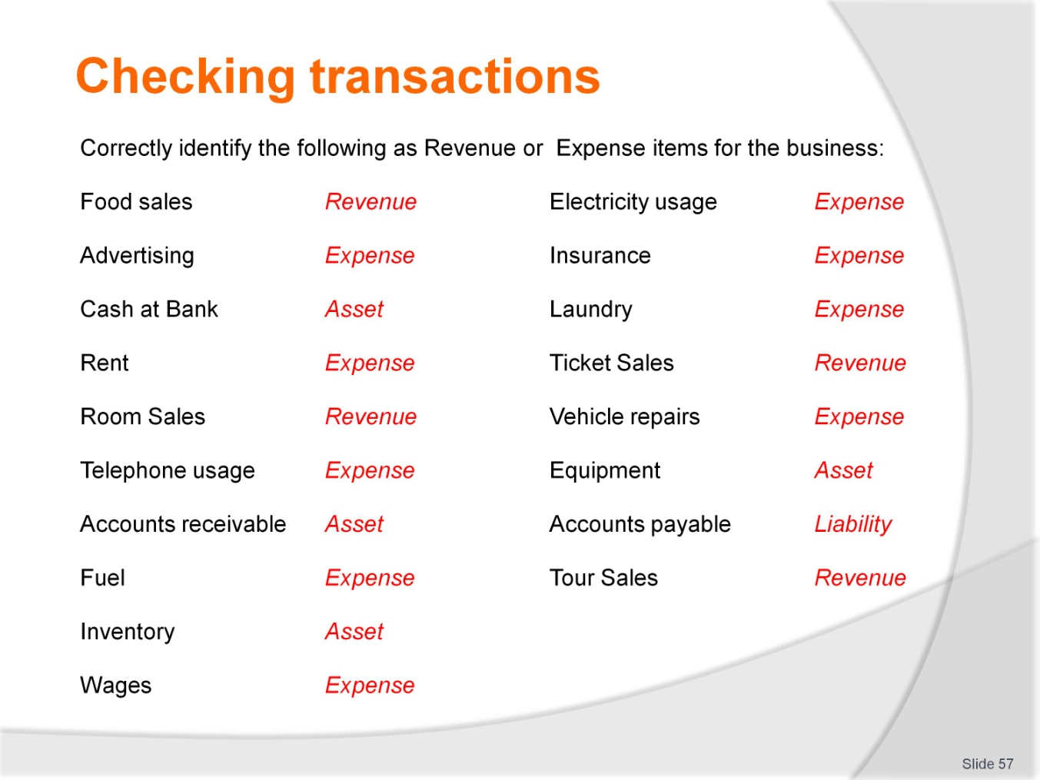
Slide No | Trainer Notes
 | Trainer: Solutions to the activity on the previous slide.

Slide
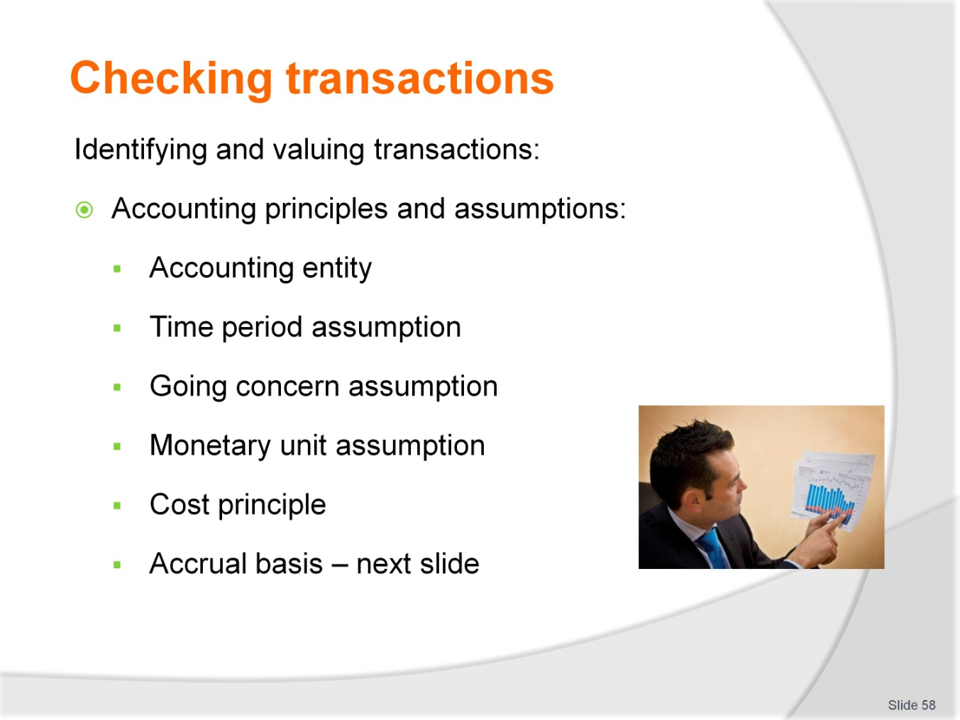
Slide No | Trainer Notes
 | Trainees can form groups and provide their own explanations for each accounting principle and assumptions that are shared and used by the class.

Slide
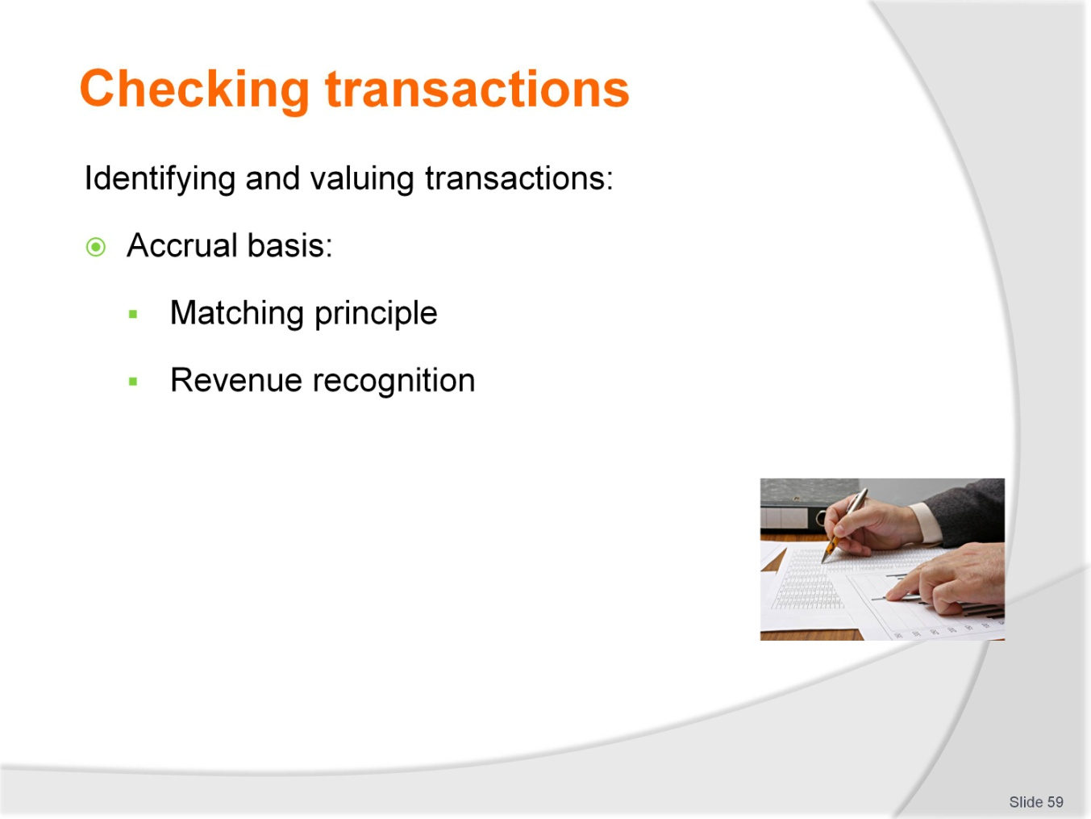
Slide No | Trainer Notes
 | Continued from previous slide.

Slide

Slide No | Trainer Notes
 | Trainer: The diagram on the next slide explains the debit and credit rules and therefore illustrates double entry. Examples are provided in the training manual.

Slide
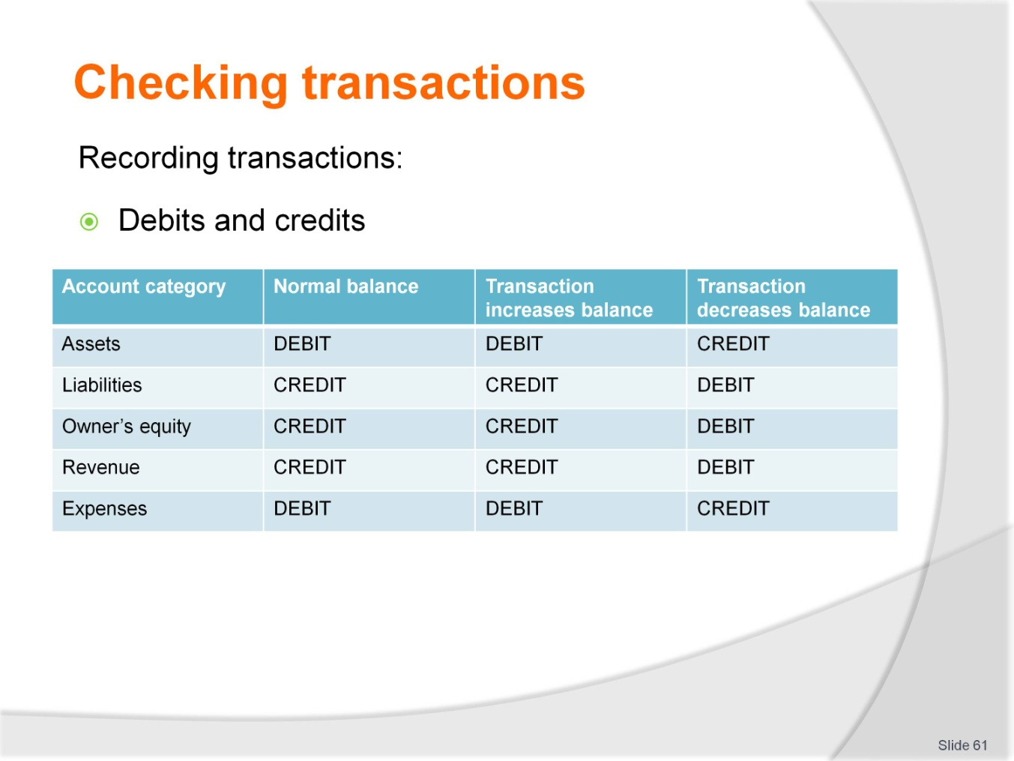
Slide No | Trainer Notes
 | Trainer: Double entry is one of the key principles for entering transactions into the general ledger. Trainers must be sure to make clear to trainees that the words debit and credit have no meaning other than left and right and simply provide and instruction for entering an amount so that the overall account category balance either increases or decreases.

Slide

Slide No | Trainer Notes
 | Trainer: Journals are used in a manual accounting system to record the details of all transactions from source documents. A computerised system may not necessarily display journals in this manner. Examples of cash journals follow.

Slide
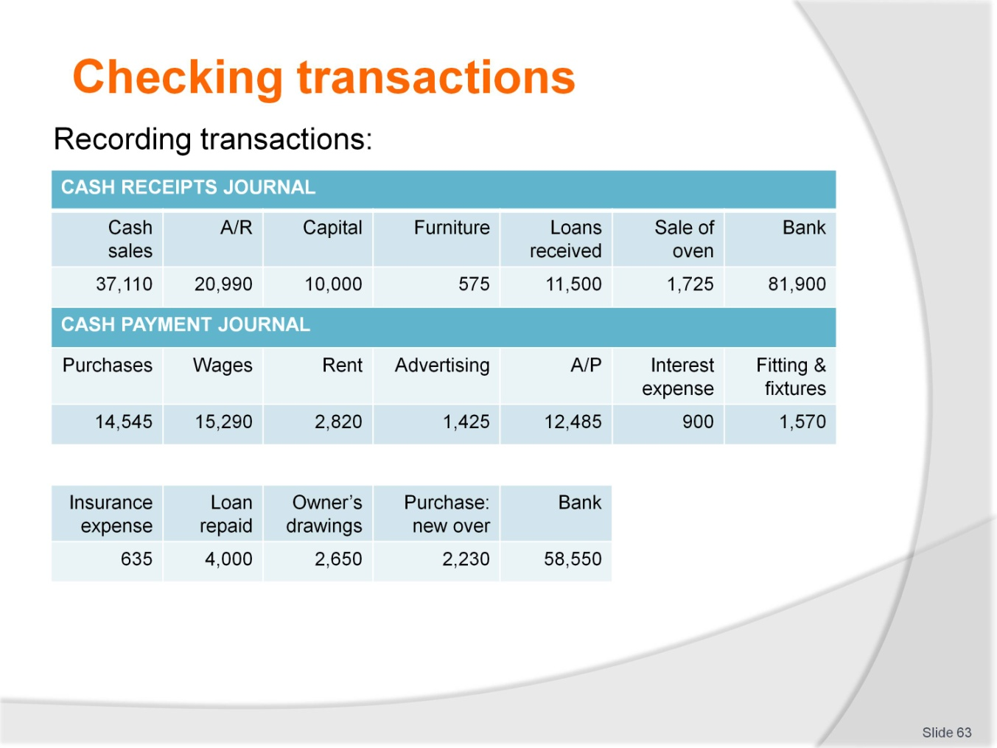
Slide No | Trainer Notes
 | Continued from previous slide.

Slide

Slide No | Trainer Notes
 | Trainers refer to personal experience and experience from the trainees to describe the process of checking transactions for accuracy and completeness. Refer back to managers responsibilities with regard to accounting information and how this process fulfils that responsibility.

Slide
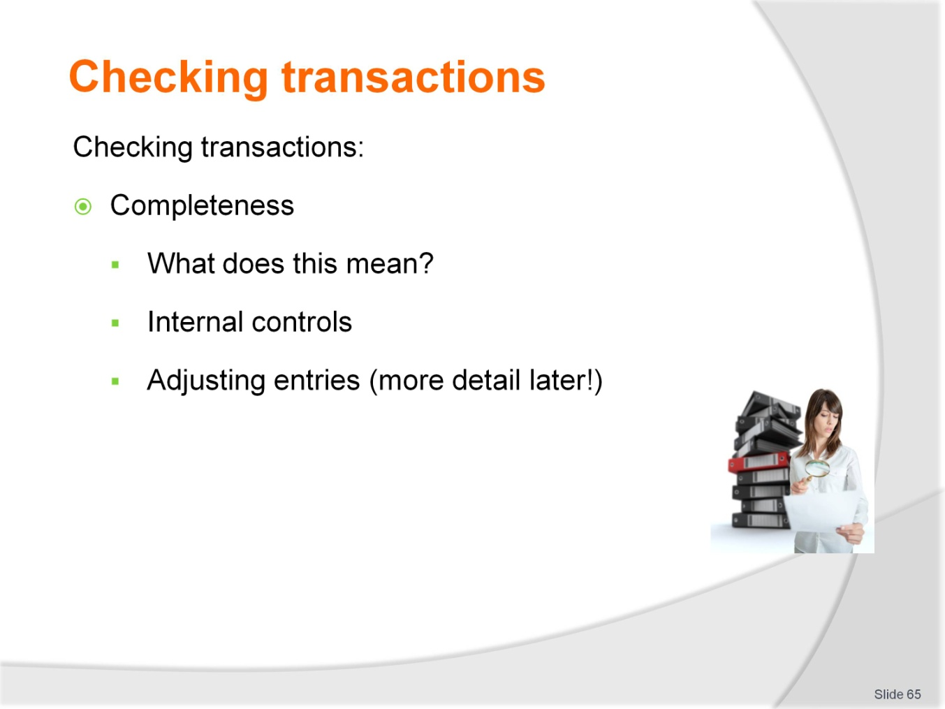
Slide No | Trainer Notes
 | Continued from previous slide.

Slide
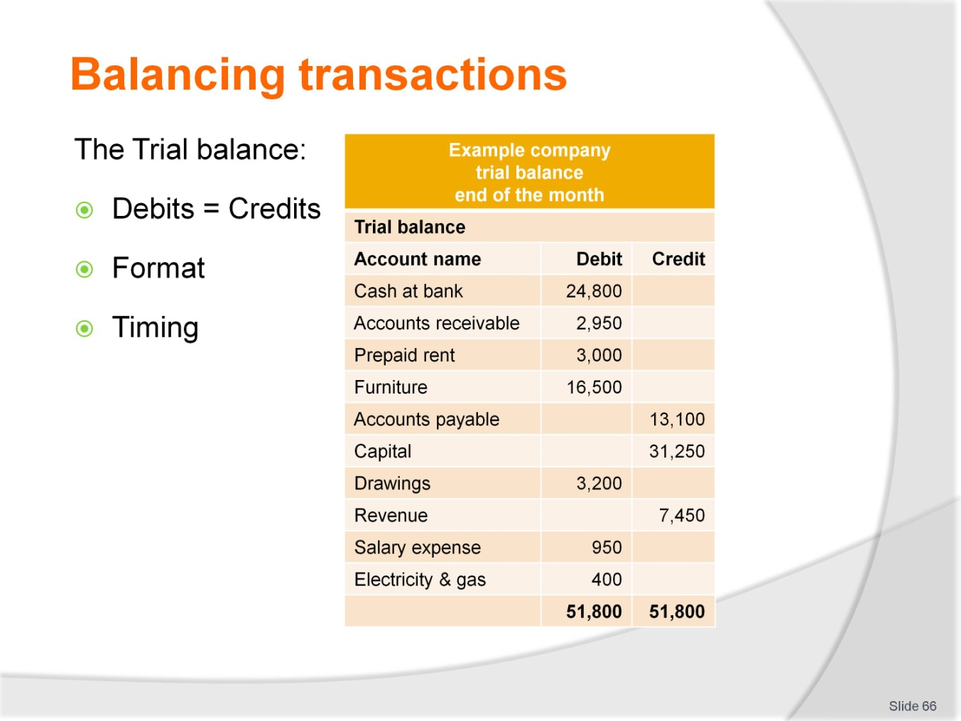
Slide No | Trainer Notes
 | Trainer: Provide the trial balance that was used to create the financial statements that were analysed earlier if possible otherwise source a relevant, local example.

Slide
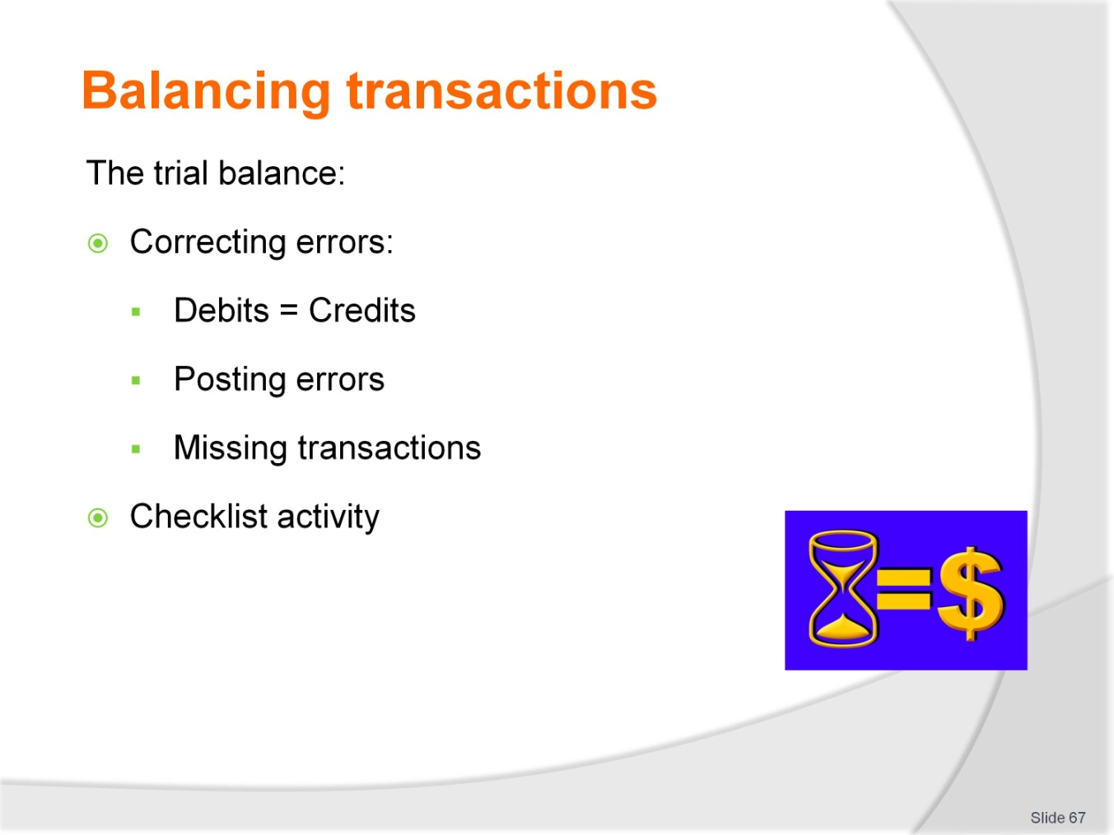
Slide No | Trainer Notes
 | Continued from previous slide. Trainees to write up a checklist for preparing an accurate trial balance.

Slide
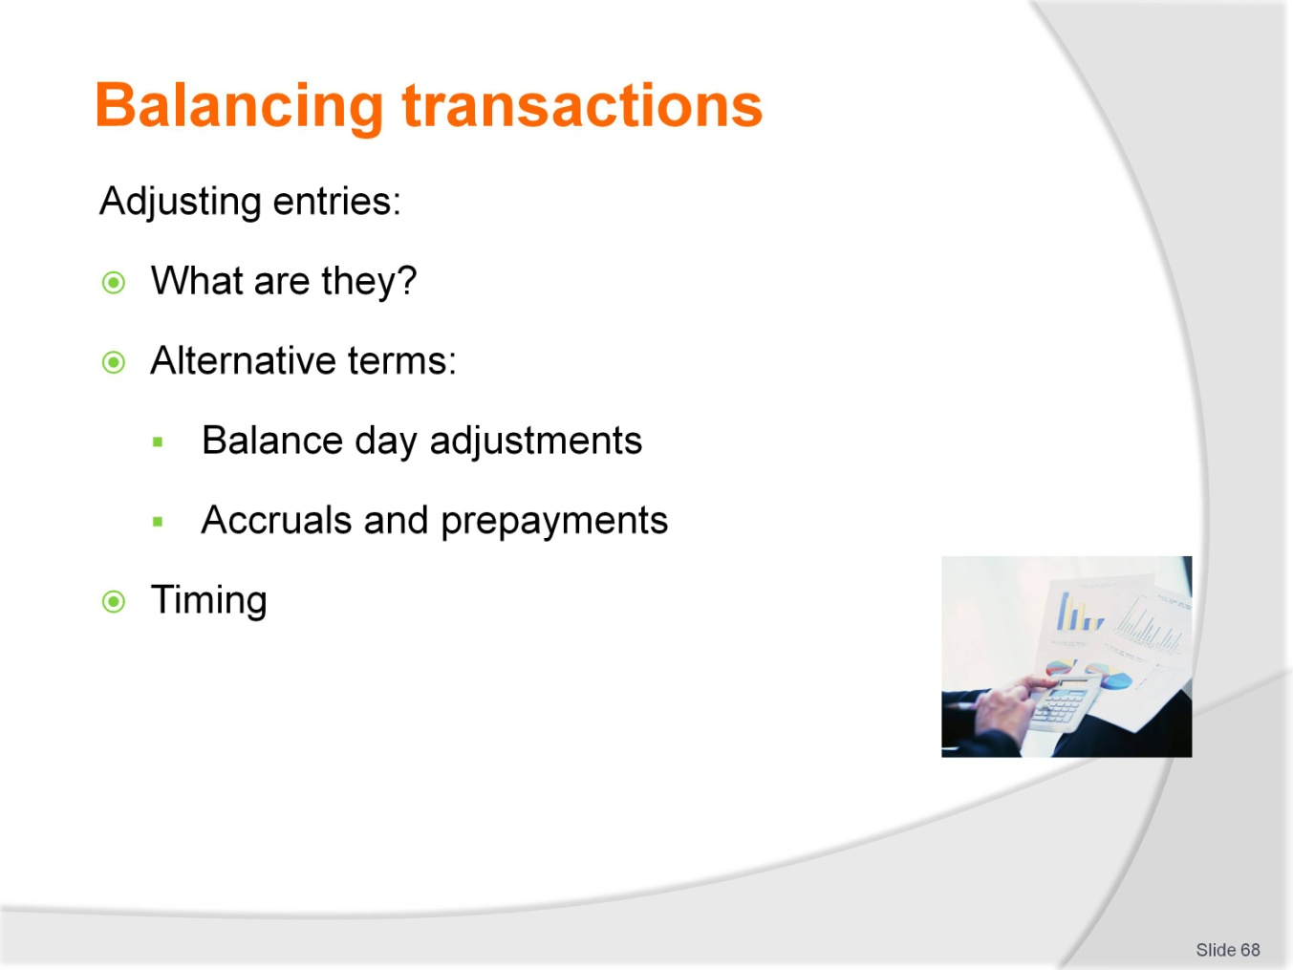
Slide No | Trainer Notes
 | Trainer: Each of the adjusting entries that are common to hospitality and tourism organisations will be reviewed in the next series of slides. Details are provided in the training manual.

Slide
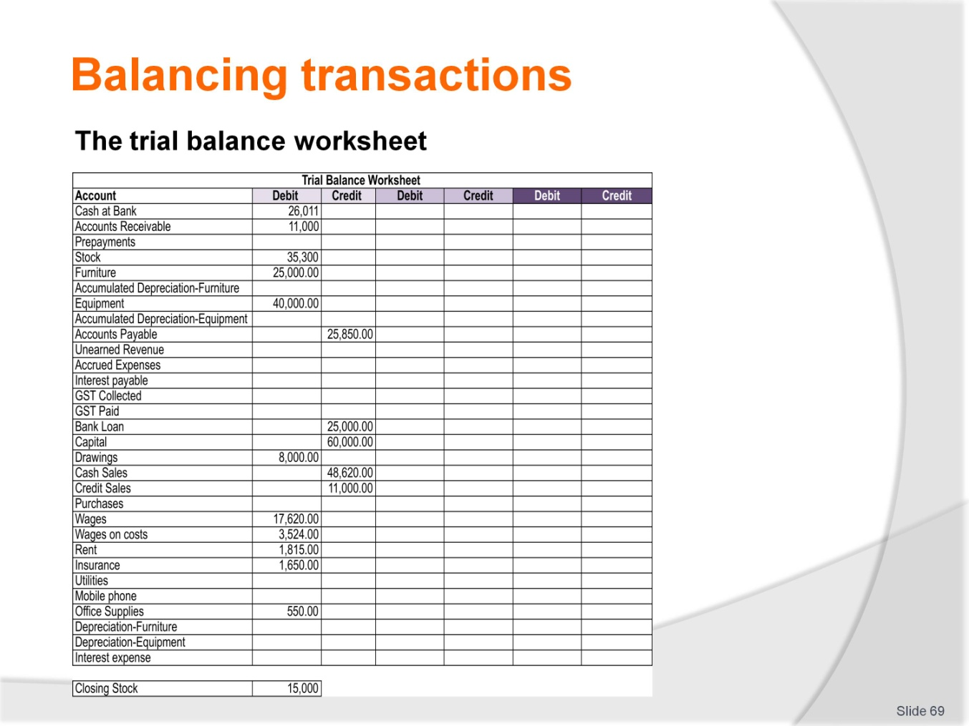
Slide No | Trainer Notes
 | Trainers can demonstrate where the draft, adjustments and final entries are entered when a worksheet is used.

Slide
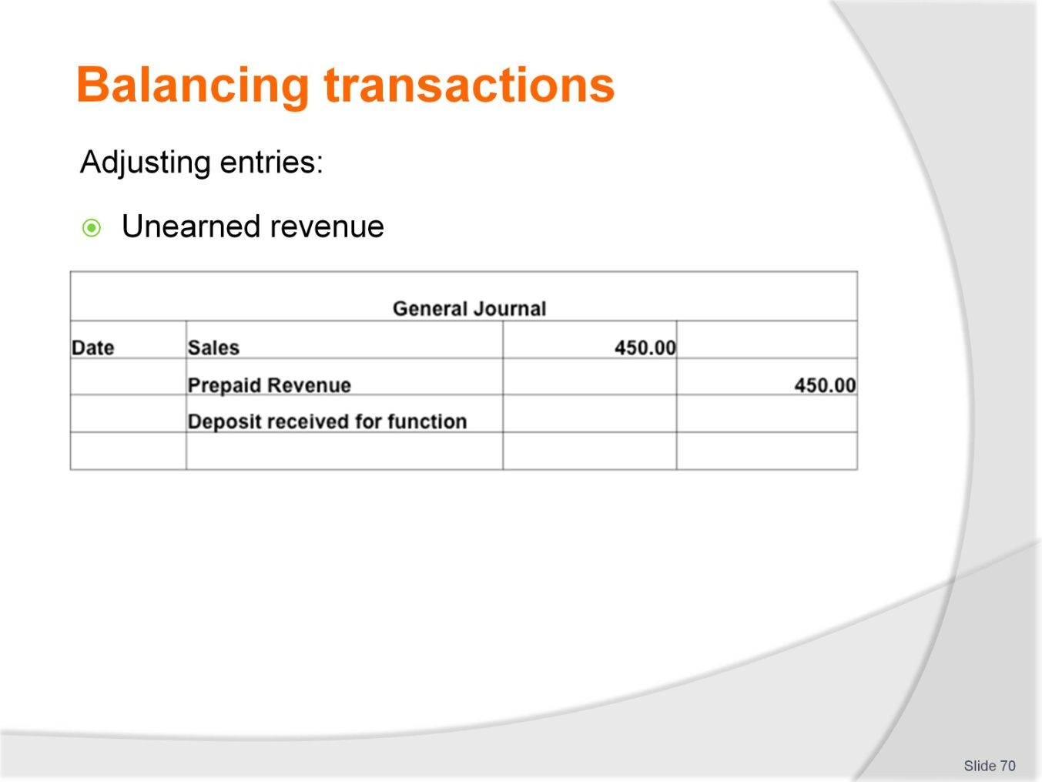
Slide No | Trainer Notes
 | Trainers refer to training manual for more information.

Slide
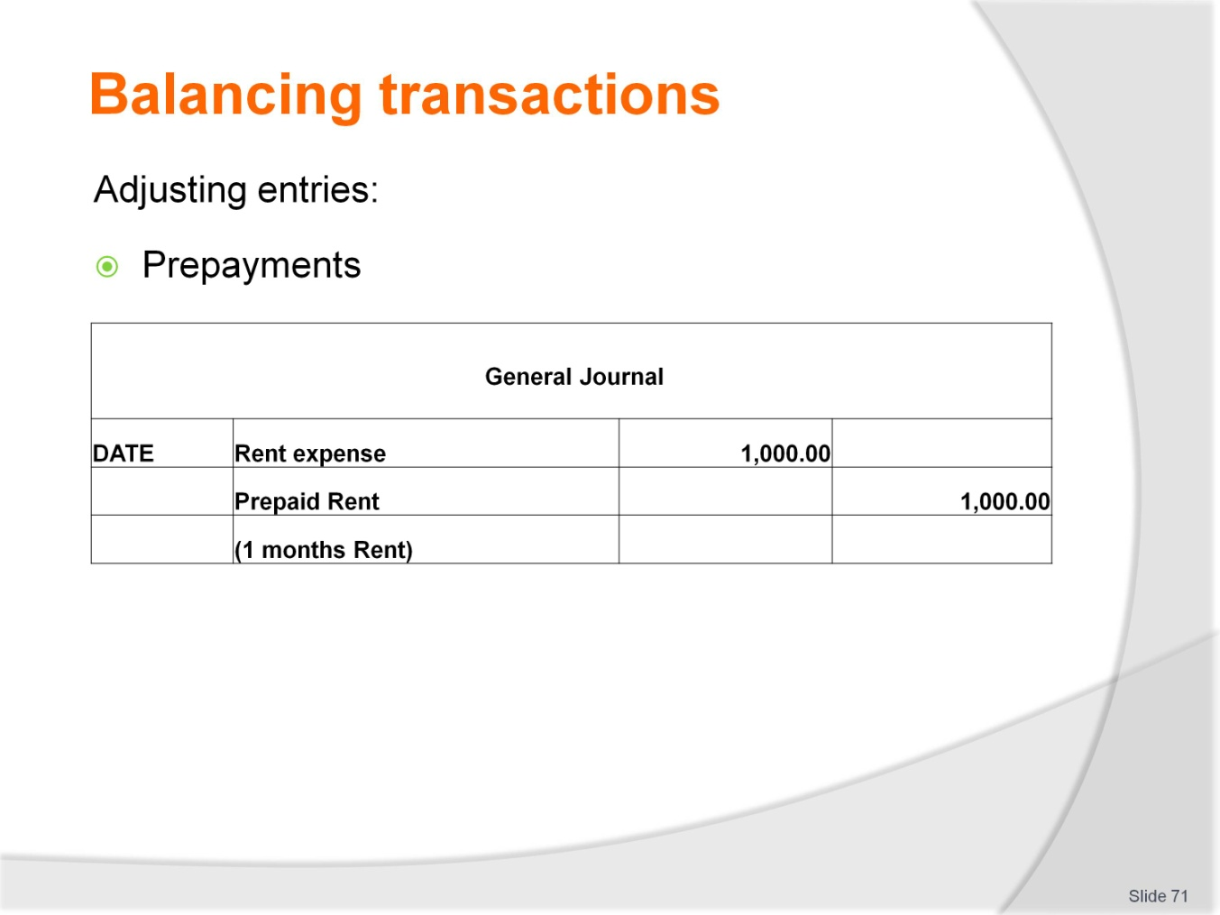
Slide No | Trainer Notes
 | Trainers refer to training manual for more information.

Slide
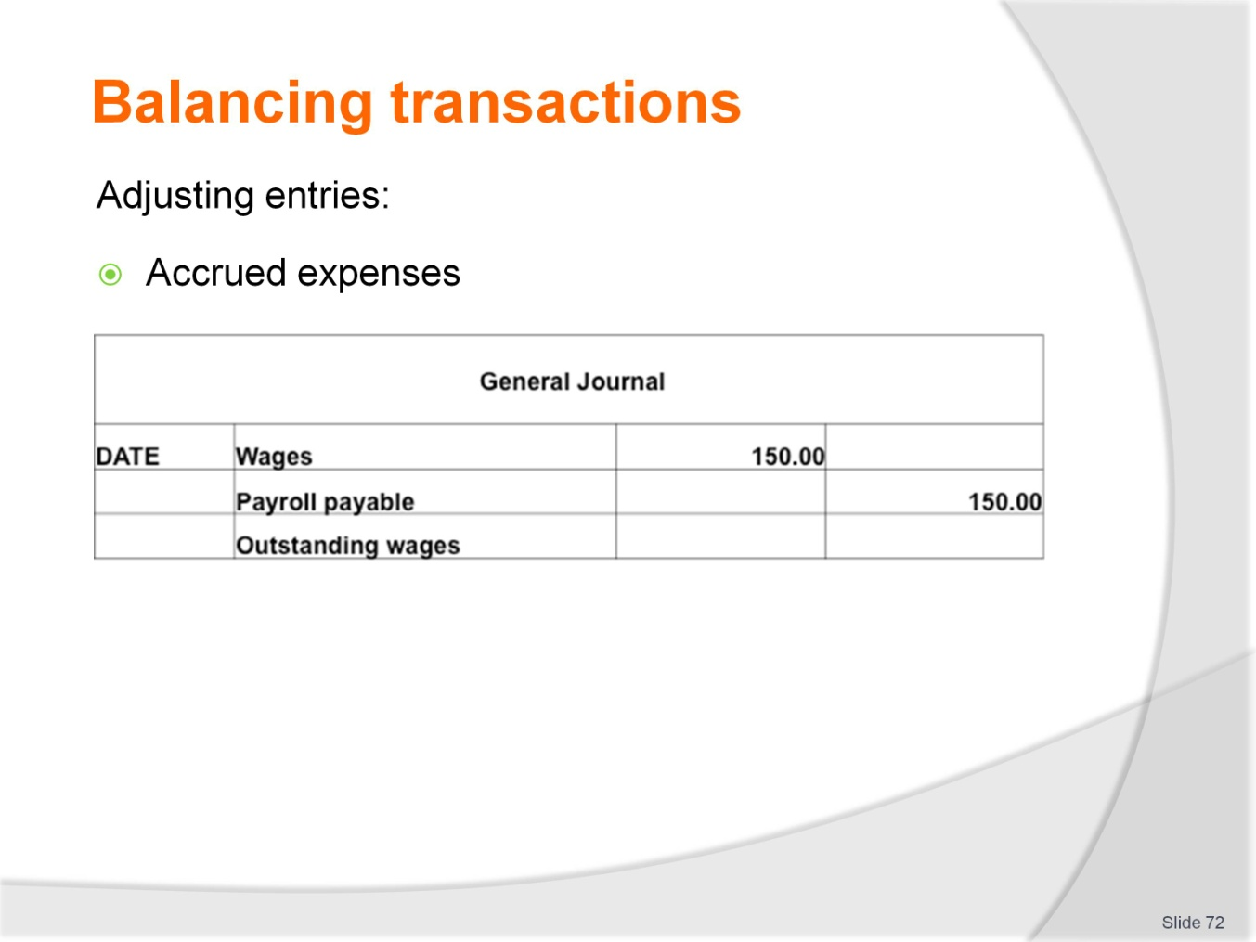
Slide No | Trainer Notes
 | Trainers refer to training manual for more information.

Slide
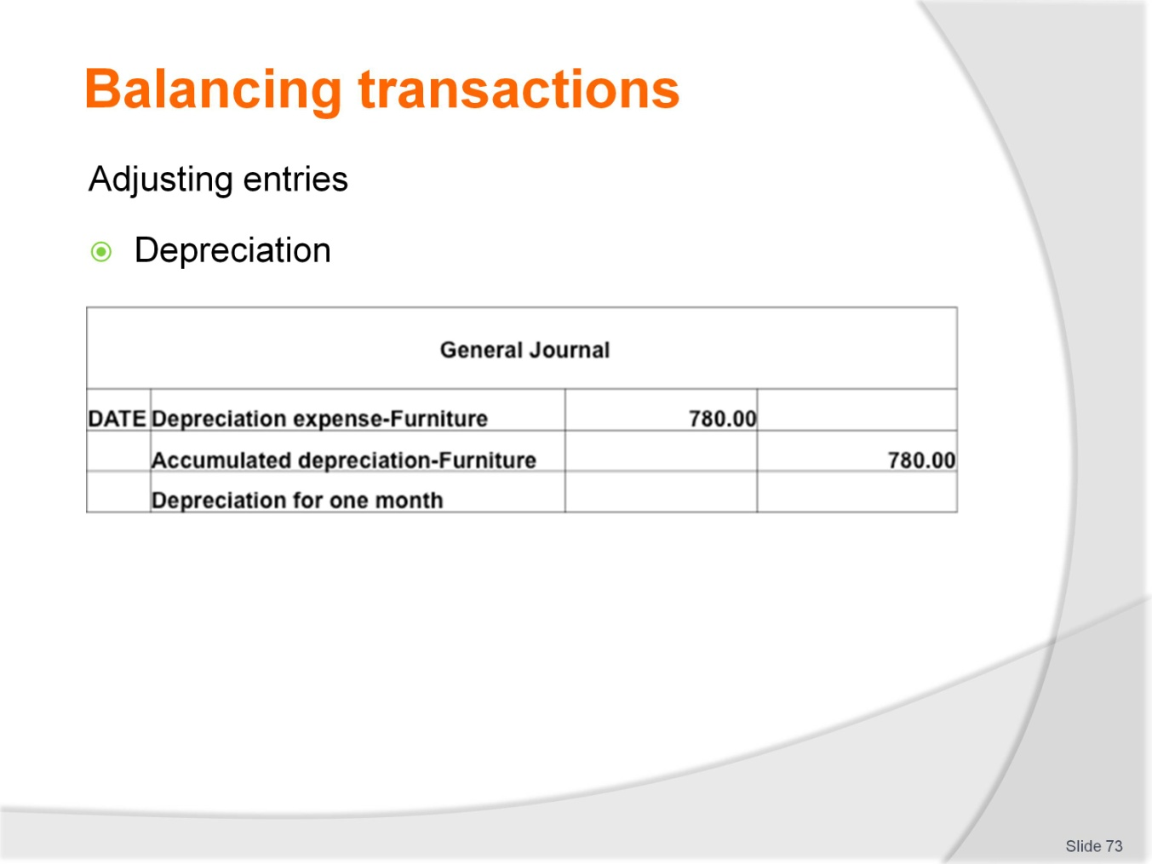
Slide No | Trainer Notes
 | Trainers refer to training manual for more information.

Slide
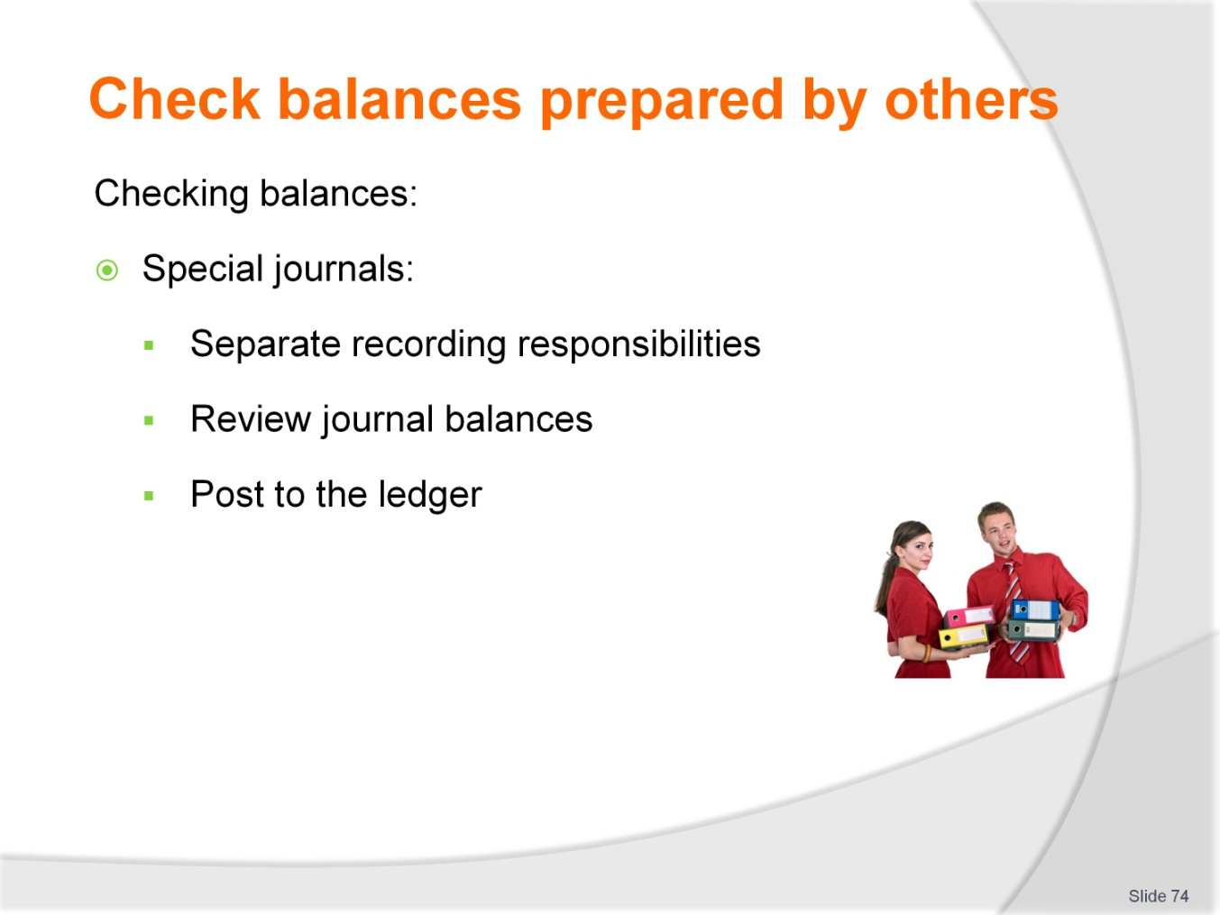
Slide No | Trainer Notes
 | Trainer: the processes that enable the efficient input and processing of transactions also provide an inbuilt check on balances prepared by others as duties are usually separated as required by internal controls.

Slide
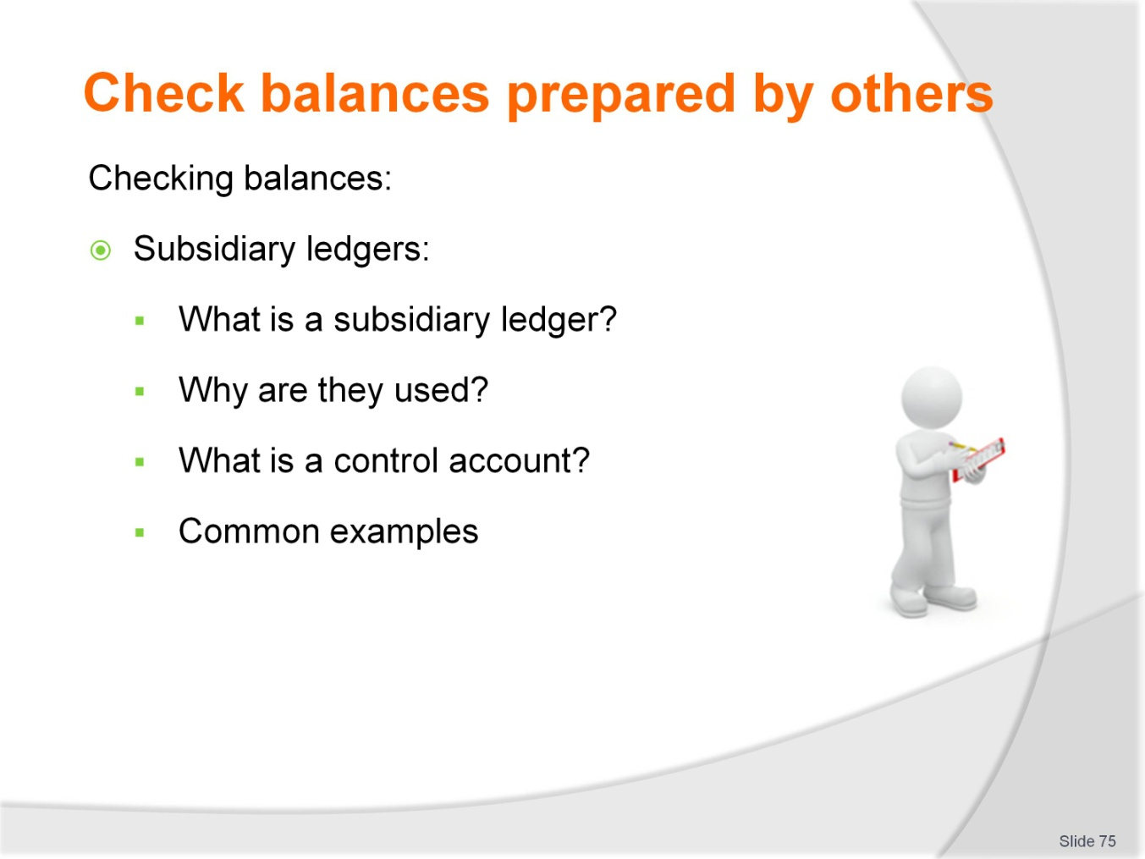
Slide No | Trainer Notes
 | Trainees should be aware of subsidiary ledgers used in the tourism and hospitality industry and that the details of transactions are not recorded in control accounts. The reconciliation between the two recording documents provides the checks on balances.

Slide
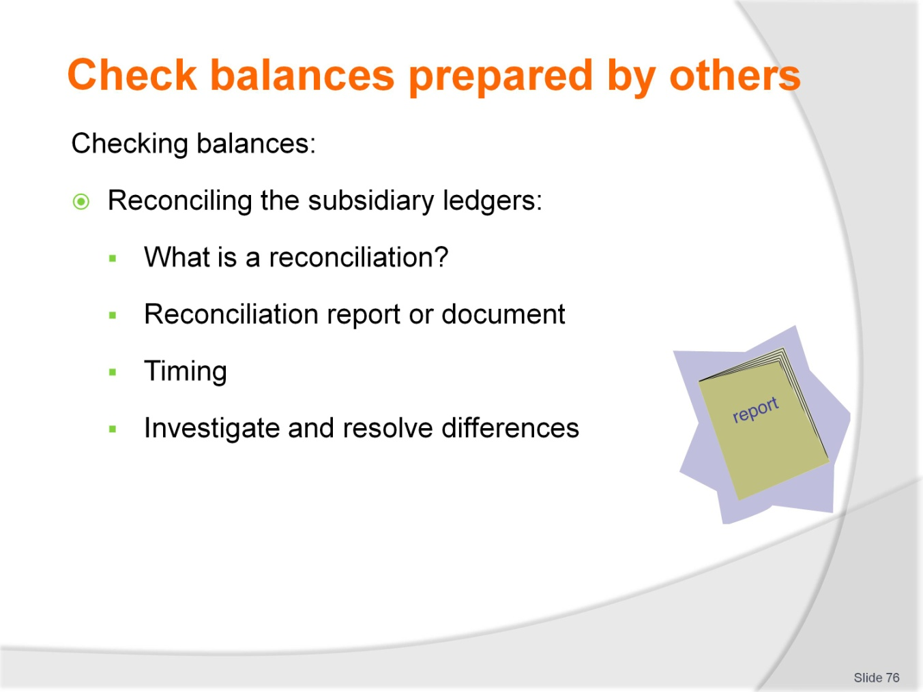
Slide No | Trainer Notes
 | Trainers work through the process of a reconciliation. Usually reconciliations are recorded on standard documents and reviewed, provided further checks on balances prepared by others. Each subsidiary ledger is reviewed in the next slides.

Slide
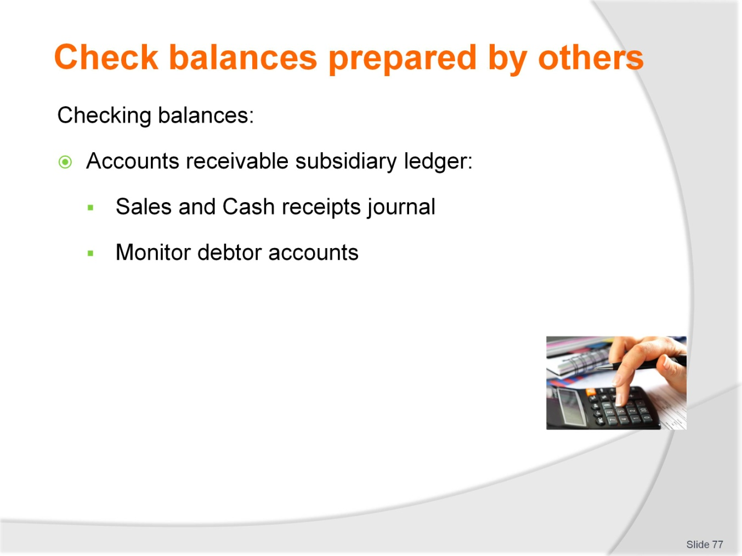
Slide No | Trainer Notes
 | Continued from previous slide.

Slide
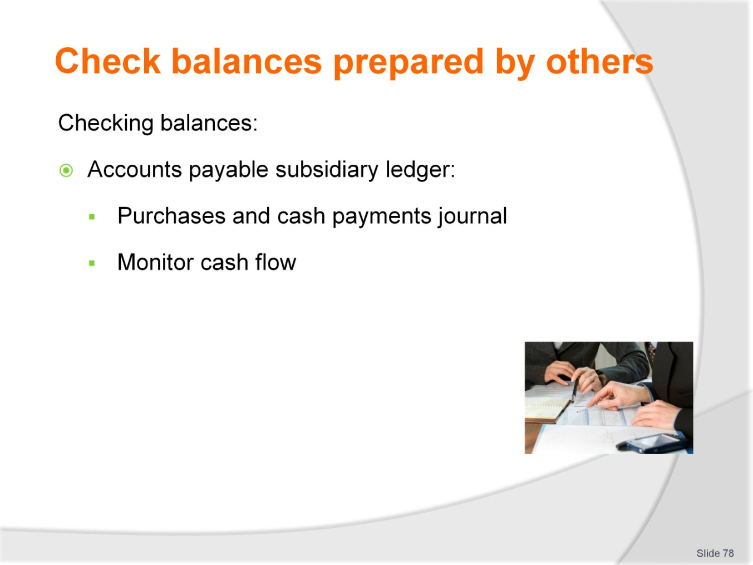
Slide No | Trainer Notes
 | Continued from previous slide.

Slide
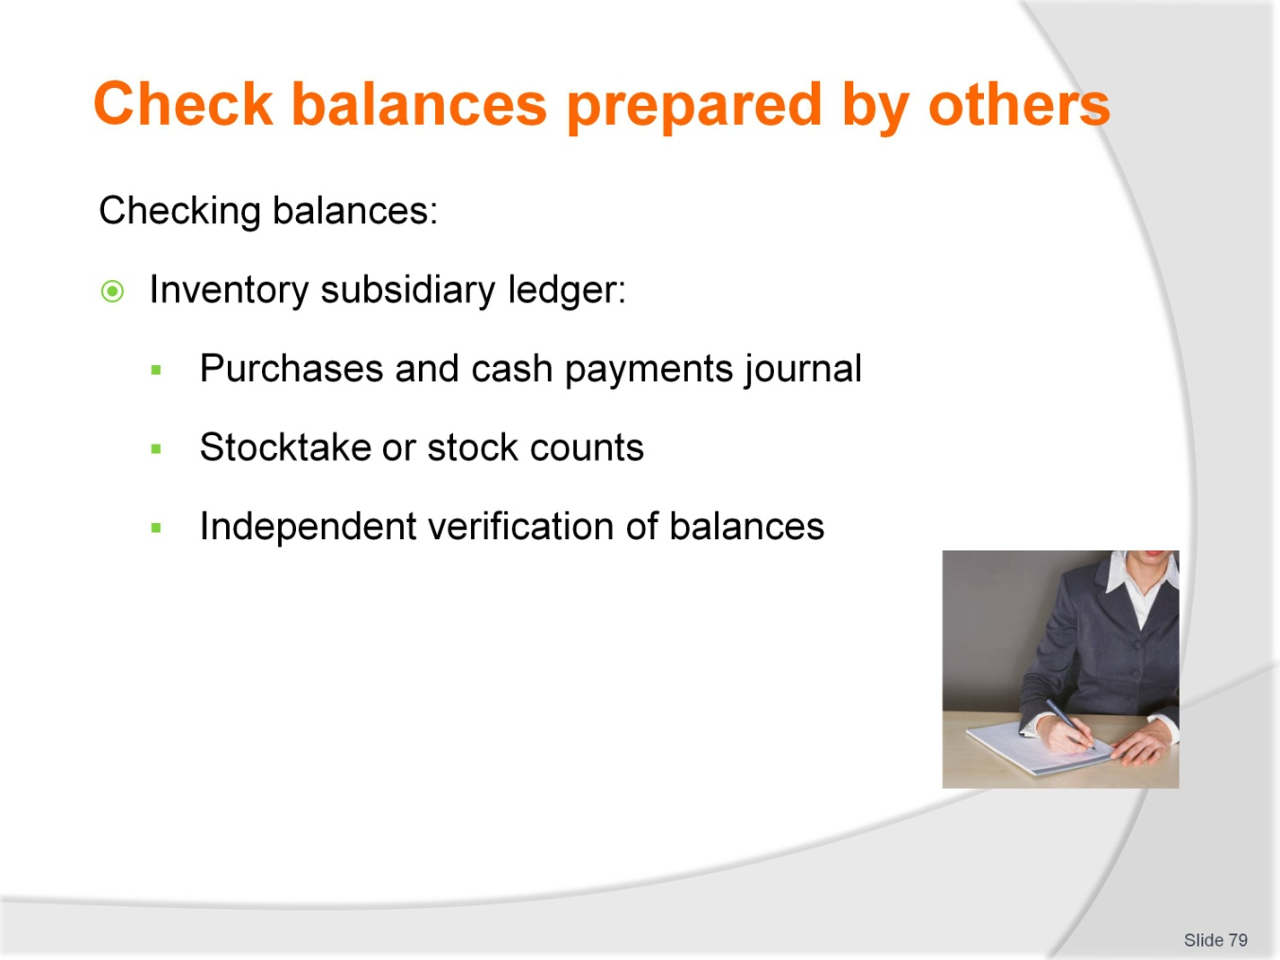
Slide No | Trainer Notes
 | Continued from previous slide.

Slide
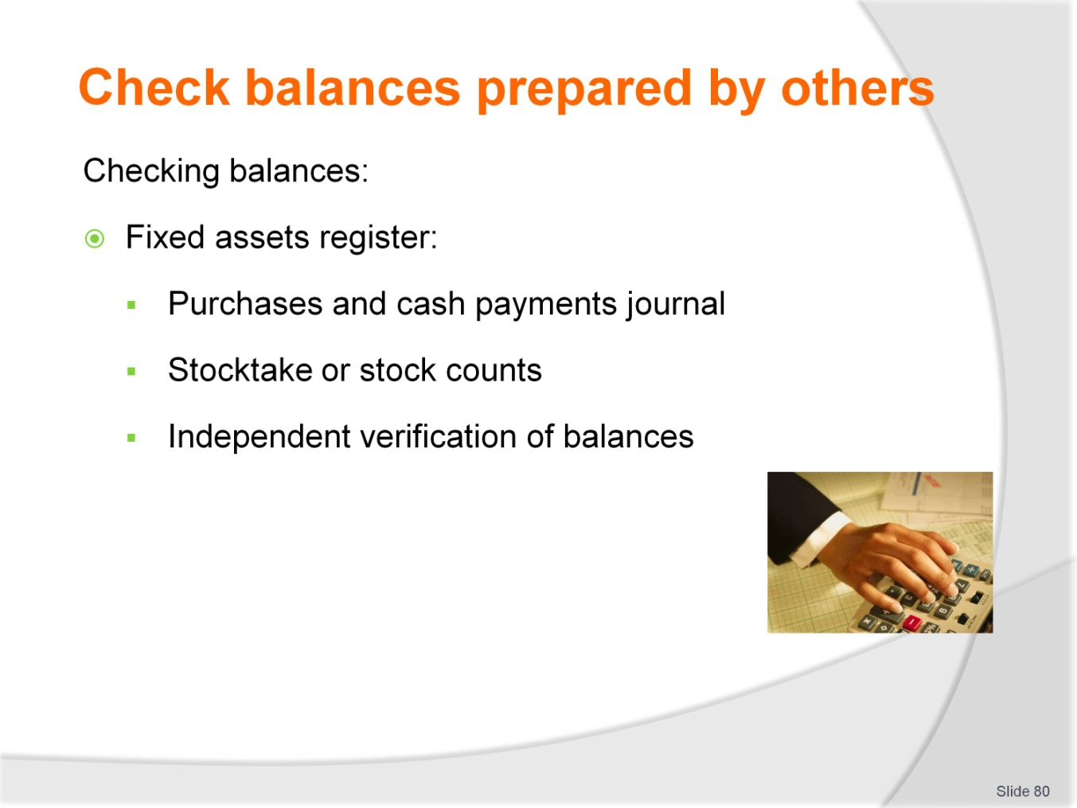
Slide No | Trainer Notes
 | Continued from previous slide.

Slide
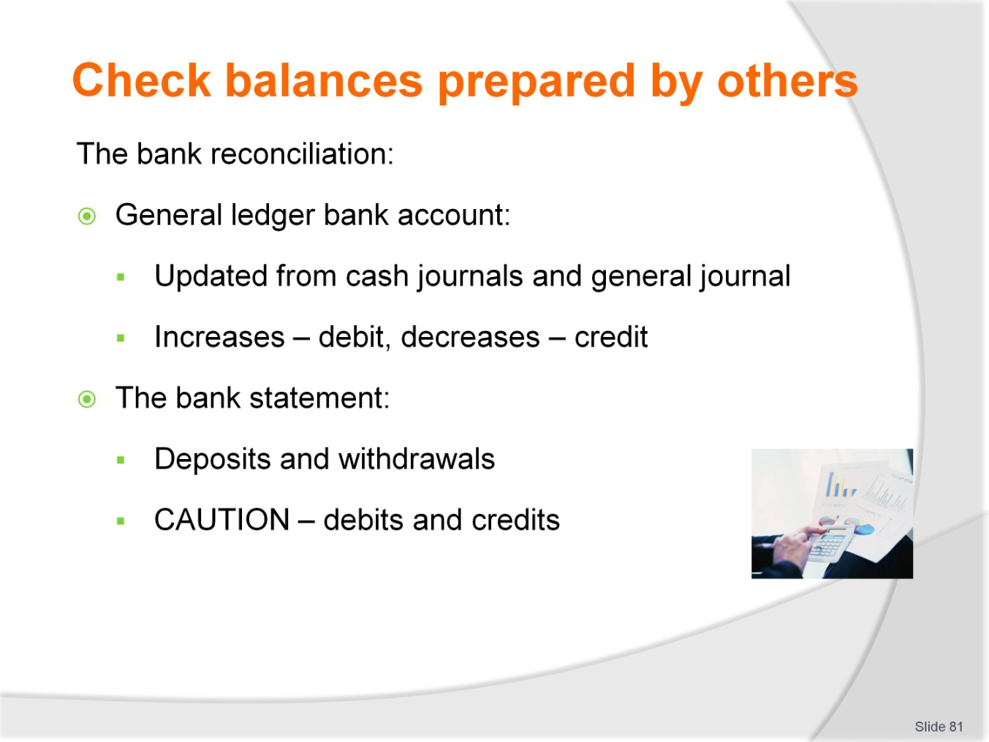
Slide No | Trainer Notes
It is important that trainees understand the definition of cash as encompassing all forms of payment received from customers, guests and other third parties and made to suppliers, staff and other parties. Internal controls safeguarding cash must be strict, especially in the tourism and hospitality industry as there are often large volumes of cash across multiple locations. Trainers may wish to draw upon the experiences of the group for local relevant examples or provide their own.
Trainer: Discuss the detail included in the general ledger bank account and the bank account as well as the source of the information. Reiterate what debit and credit entries represent.

Slide
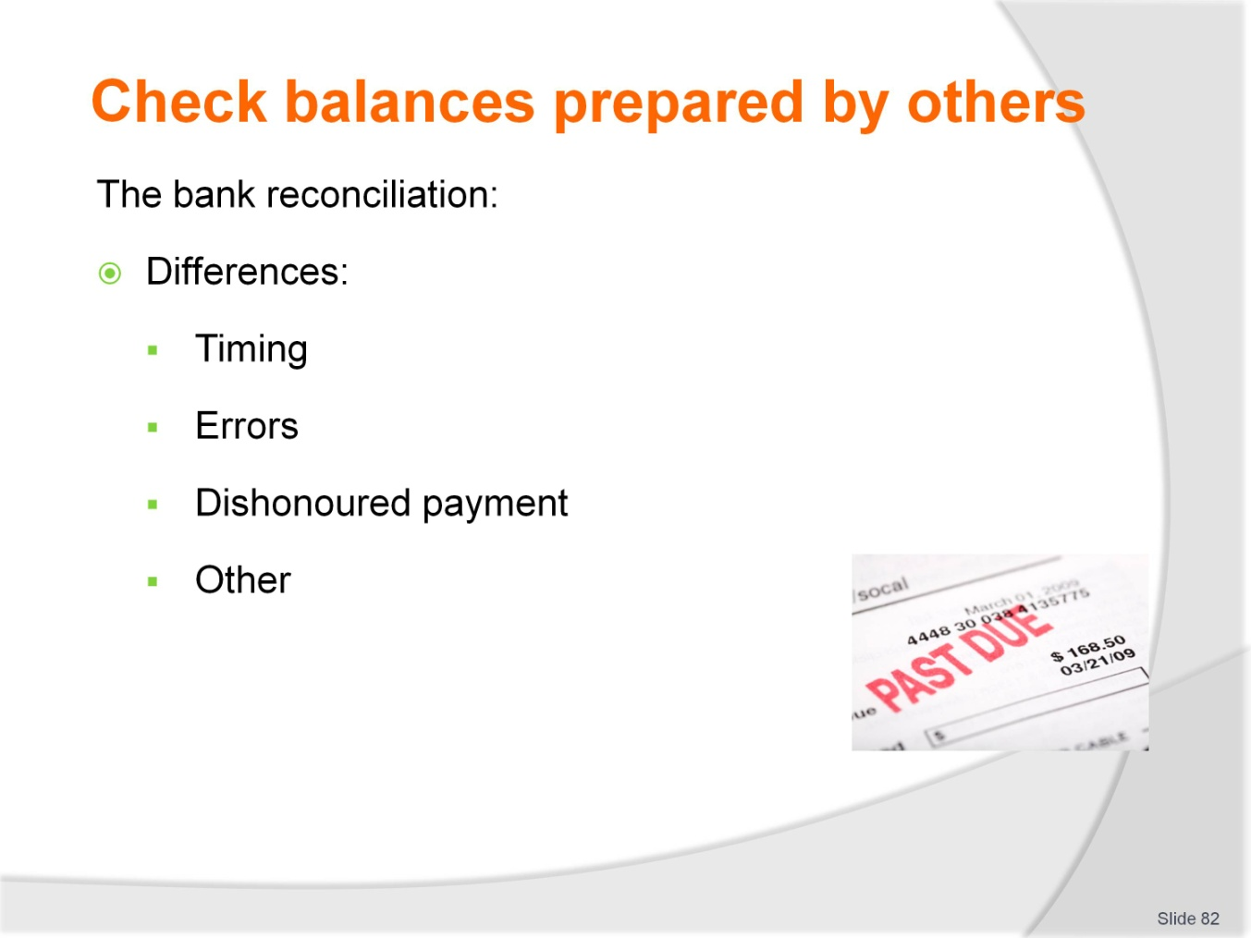
Slide No | Trainer Notes
 | Trainer: The bank reconciliation is the means by which the general ledger account balance and the bank account balance are verified. Trainees may be able to draw on their own experiences for recognising some of the differences.

Slide
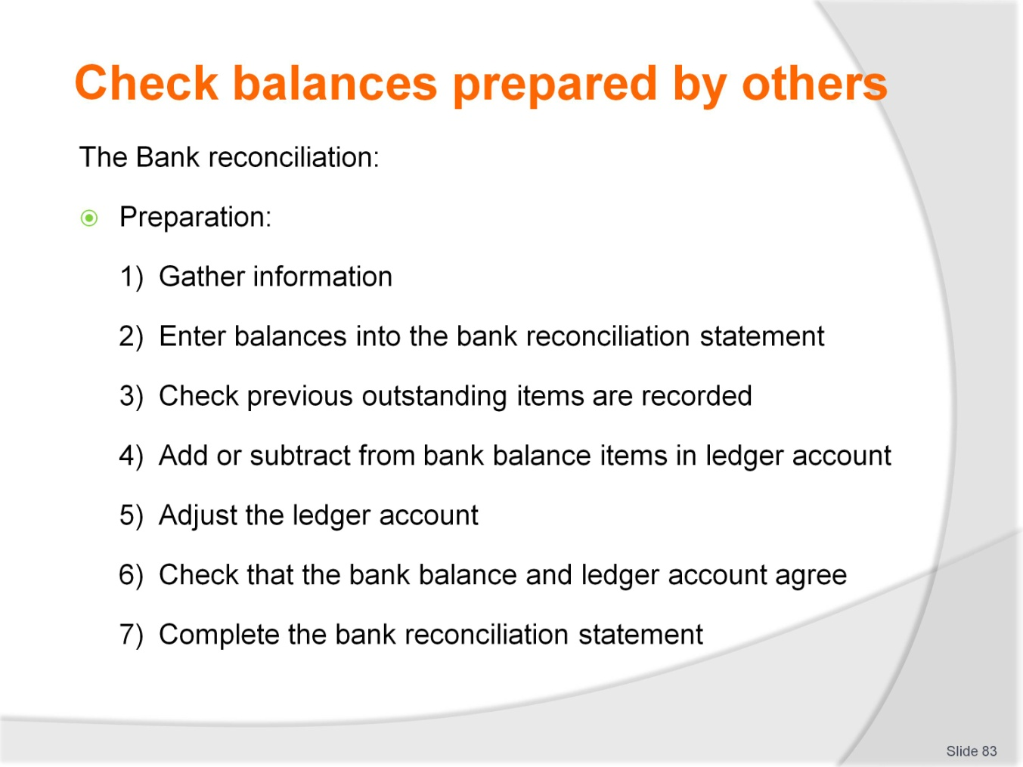
Slide No | Trainer Notes
 | Trainer: refer to the training manual for detail.

Slide
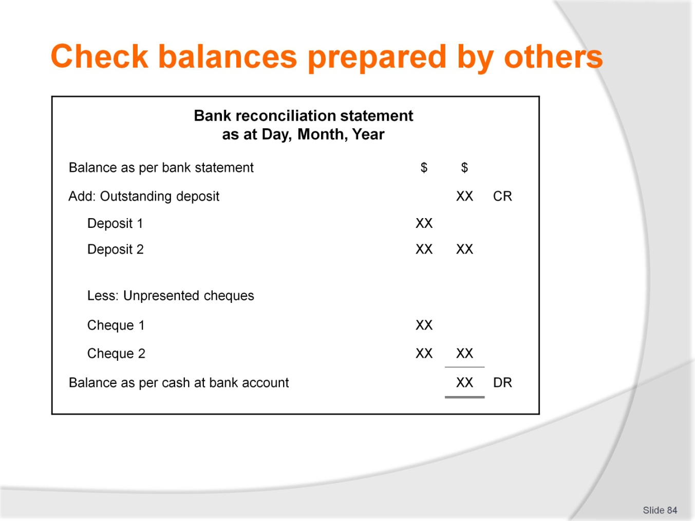
Slide No | Trainer Notes
 | Trainers can use this diagram to discuss the elements of the bank statement from the notes provided in the training manual. The following slide summarises the key points.

Slide
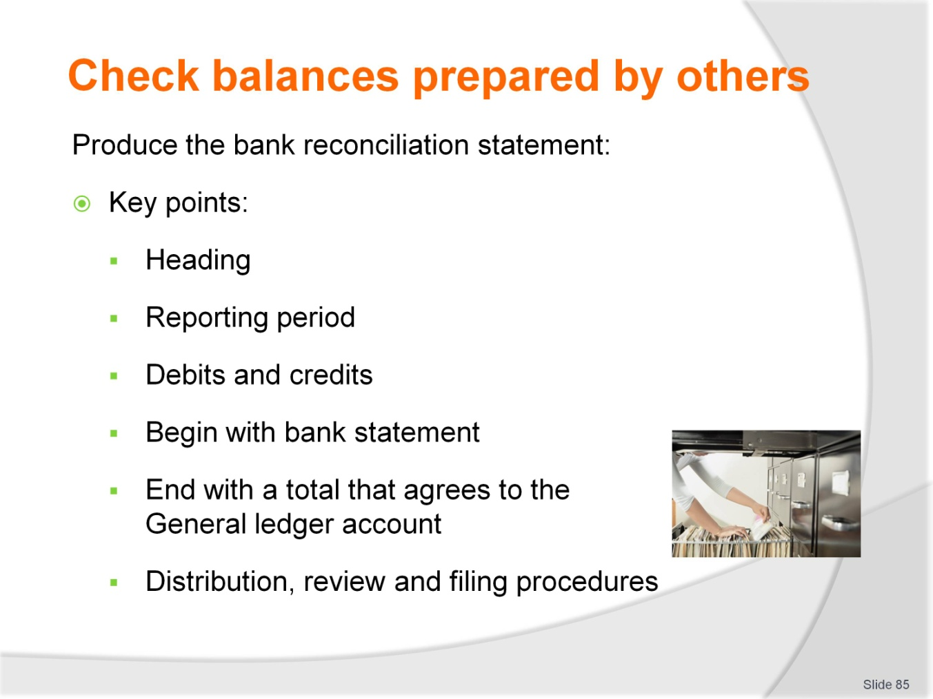
Slide No | Trainer Notes
 | Continued from previous slide. Examples of missing entries can be taken from training manual.

Slide
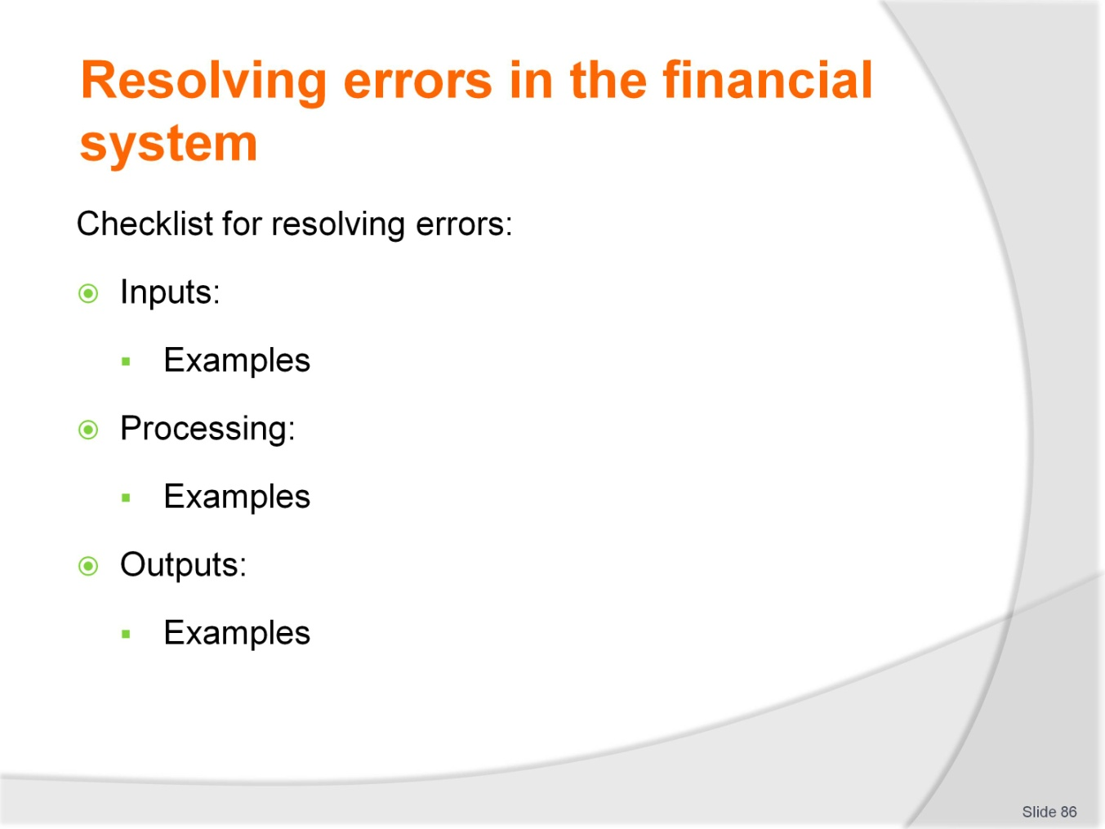
Slide No | Trainer Notes
 | Trainers: Errors and discrepancies have been discussed throughout the slides so far. This is a review or reminder of what to do when an error is found.

Slide
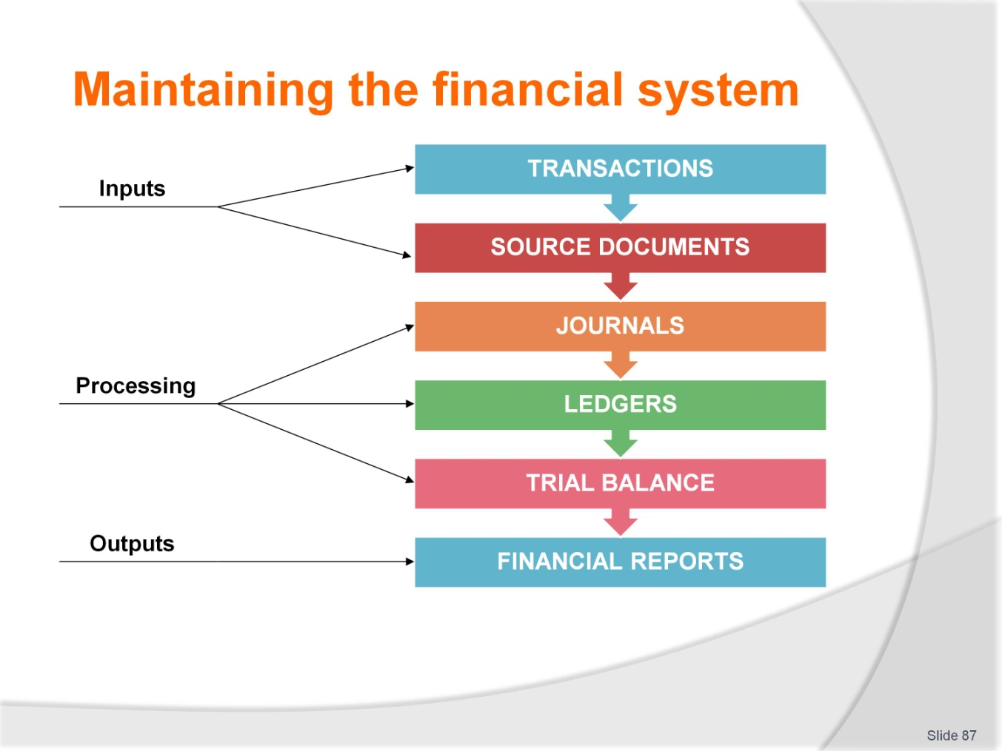
Slide No | Trainer Notes
 | Trainer: The focus for the next series of slides is the outputs phase of the accounting system.

Slide
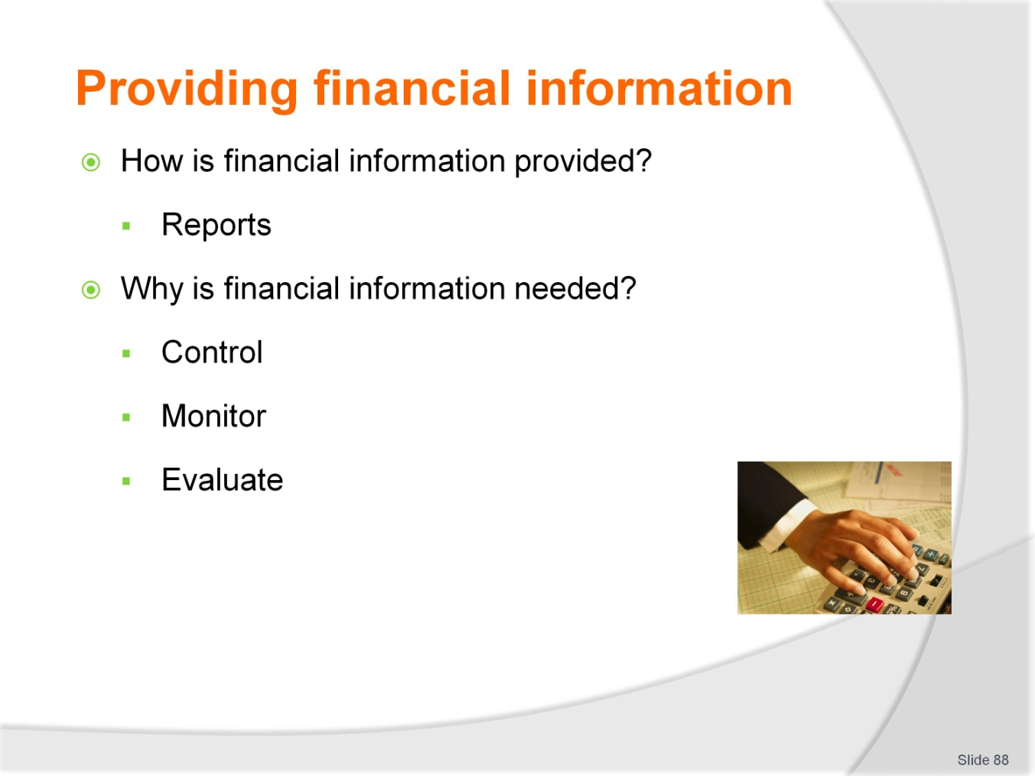
Slide No | Trainer Notes
 | Trainers focus on the need for management to gather information that allows them to control, monitor and evaluate operations. Operations are considered in terms of two related cycles, the business cycle and the revenue cycle. This is detailed on the next two slides. Reports are discussed in terms of the cycle of operations.

Slide
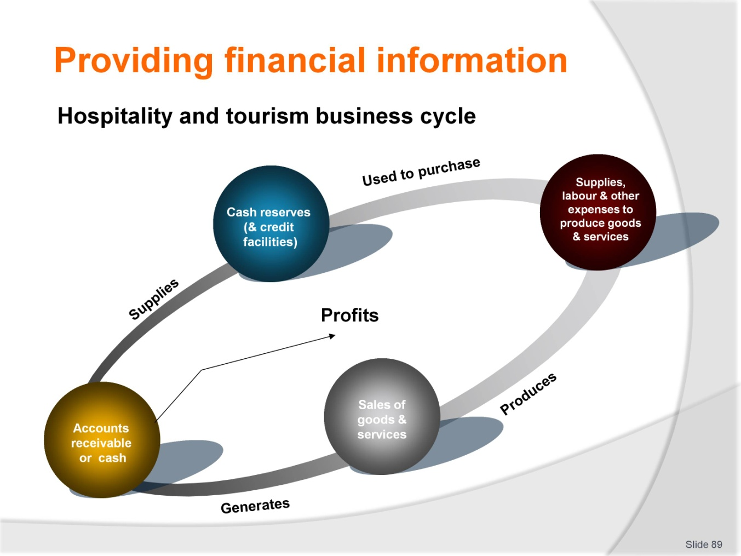
Slide No | Trainer Notes
 | Continued from previous slide.

Slide
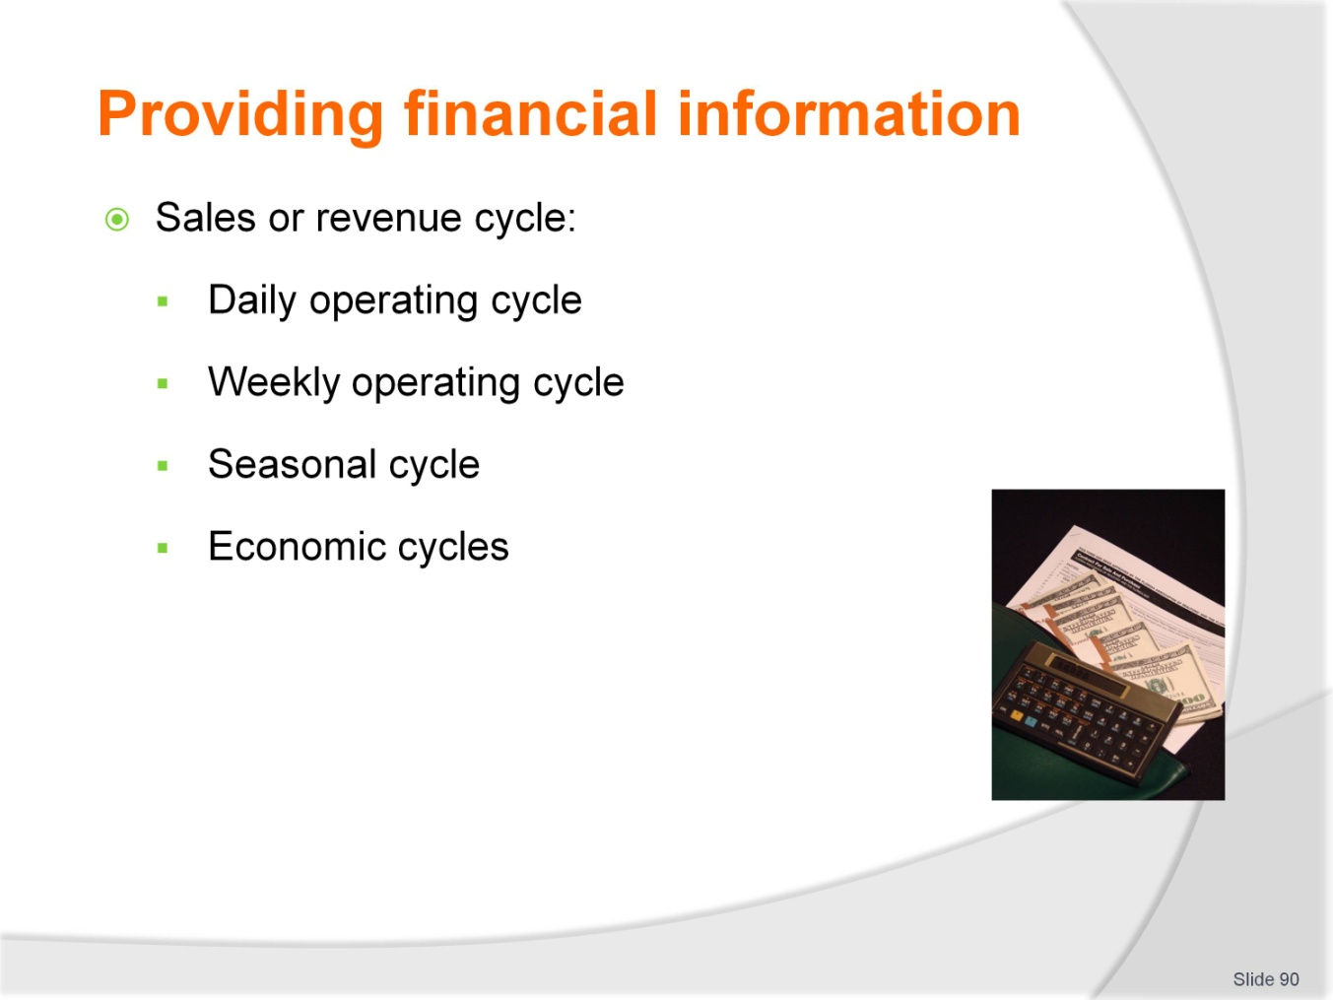
Slide No | Trainer Notes
 | Continued from previous slide.

Slide
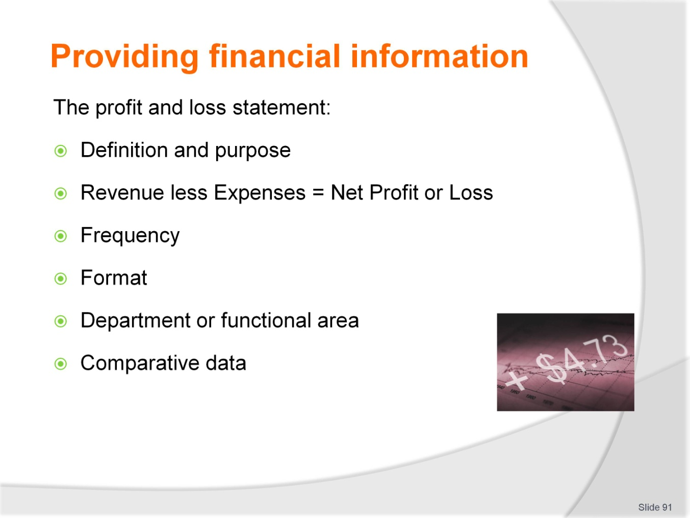
Slide No | Trainer Notes
Trainers: Note that the rest of the slides provide examples of the different reports that are produced in hospitality and tourism establishments. Report formats, frequency and the nature of information is unique to each type of business, the region and management requirements. Therefore trainers must be prepared to source relevant, local examples so trainees are aware of the format used in their local areas.
All report data is sourced from ledger accounts.

Slide
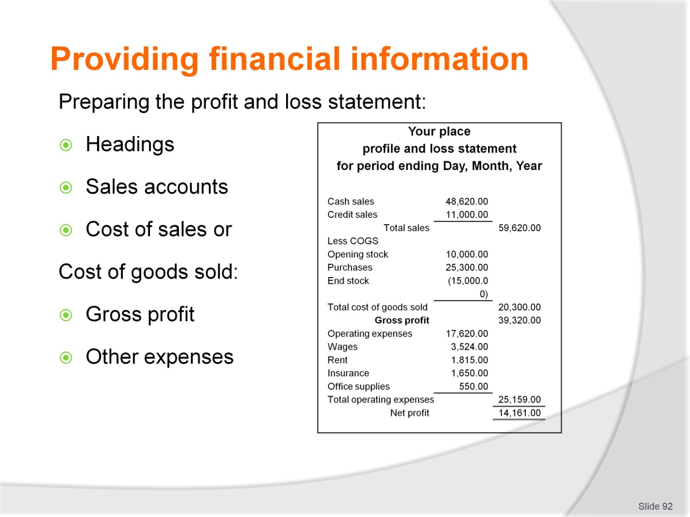
Slide No | Trainer Notes
 | Continued from previous slide.

Slide
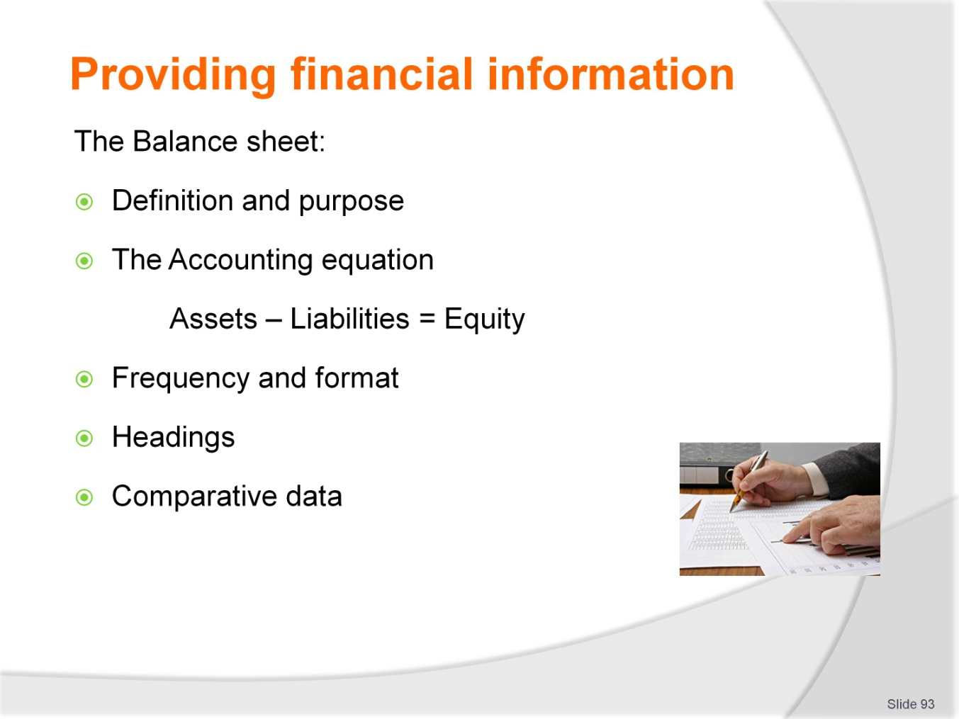
Slide No | Trainer Notes
 | Trainers refer to the training manual for details on preparing the balance sheet and are encouraged to use relevant local examples.

Slide
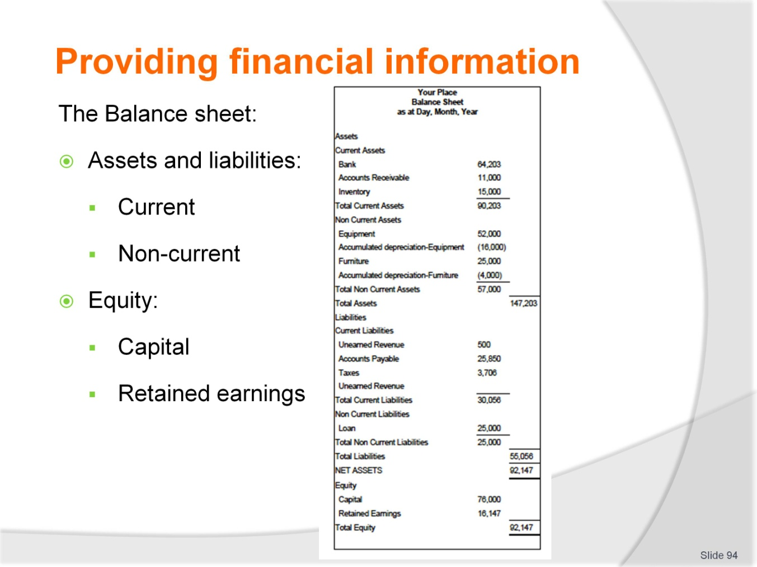
Slide No | Trainer Notes
 | Continued from previous slide.

Slide

Slide No | Trainer Notes
 | Trainers refer to the training manual for details and the following slide for a sample cash flow statement. Trainers are encouraged to use relevant local examples.

Slide
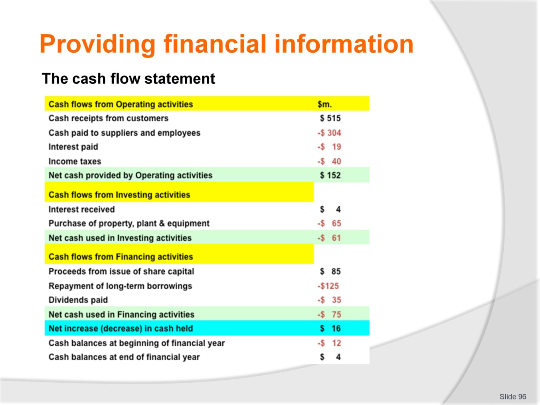
Slide No | Trainer Notes
 | Trainers refer to the training manual for details and the following slide for a sample revenue report. Trainers are encouraged to use relevant local examples.

Slide
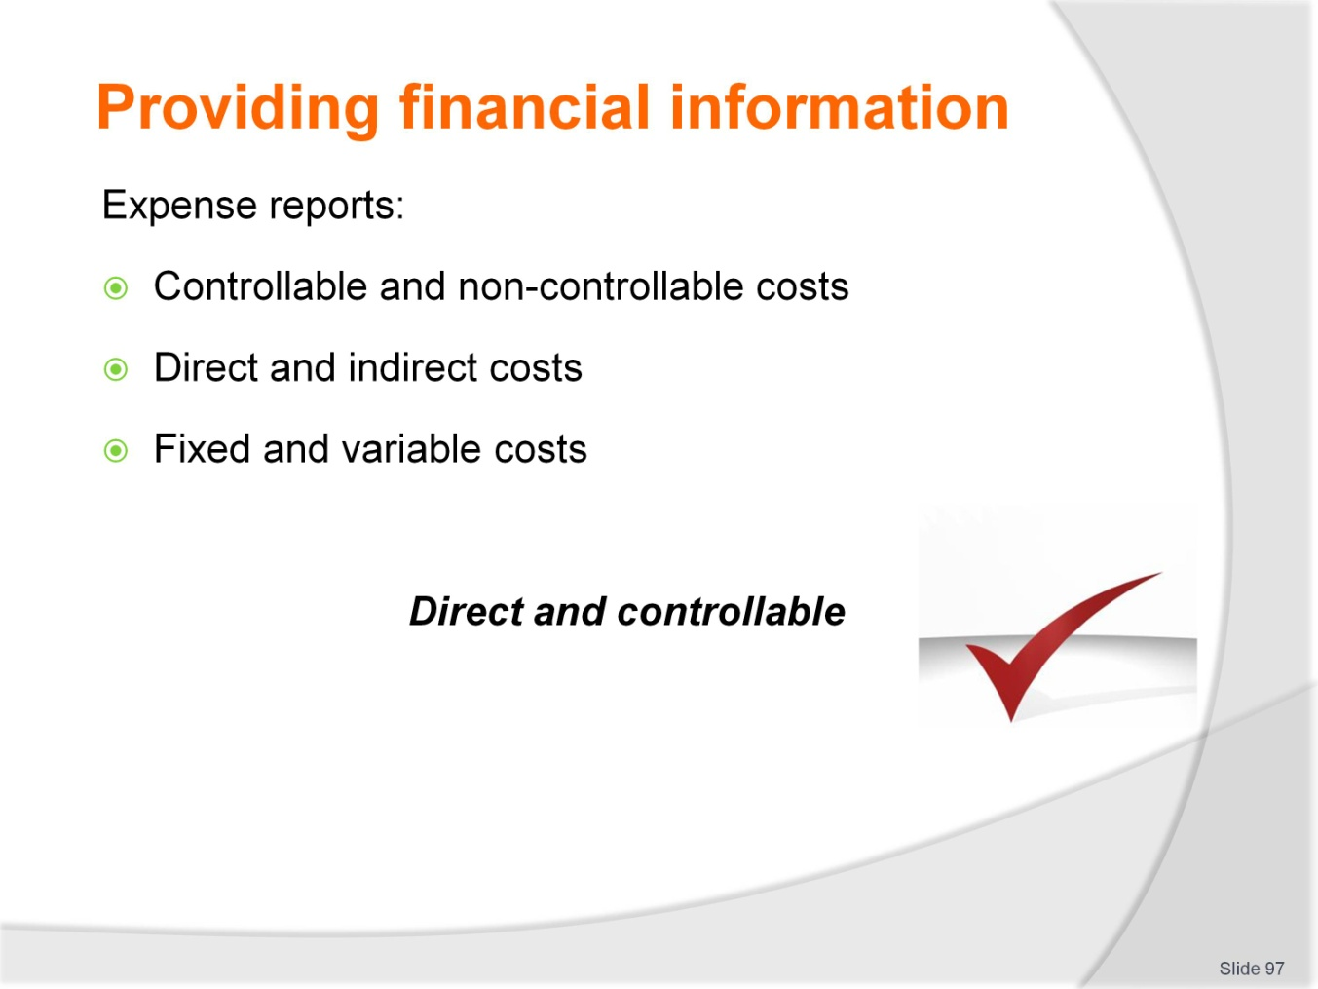
Slide No | Trainer Notes
 | Trainers refer to the training manual for details and local examples.

Slide

Slide No | Trainer Notes
 | Trainers refer to the training manual for details and provide local examples.

Slide
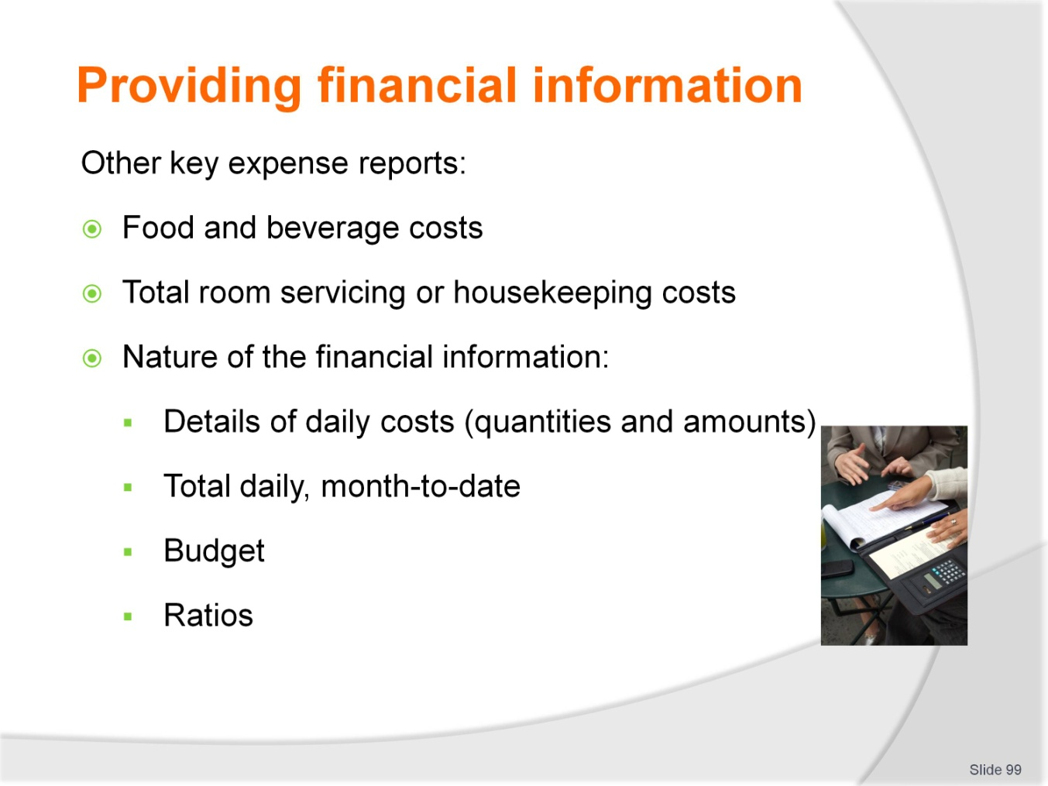
Slide No | Trainer Notes
 | Trainers refer to the training manual for details and the following slide for a sample revenue report. Trainers are encouraged to use relevant local examples.

Slide
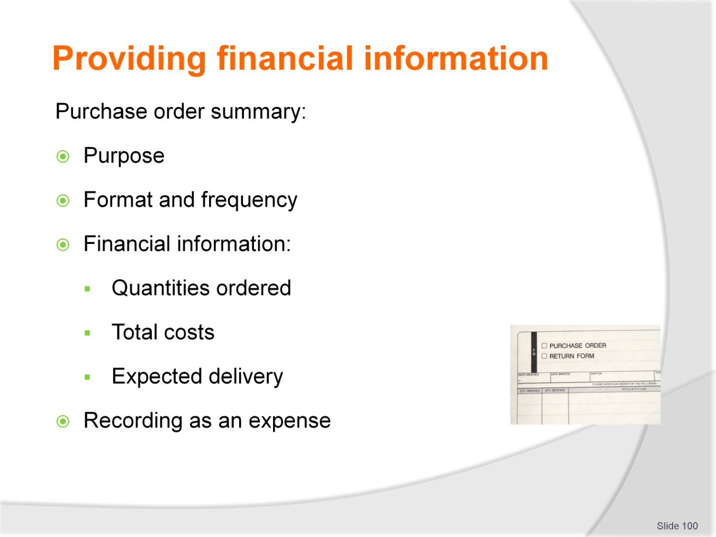
Slide No | Trainer Notes
 | Trainers refer to the training manual for details and provide local examples.

Slide
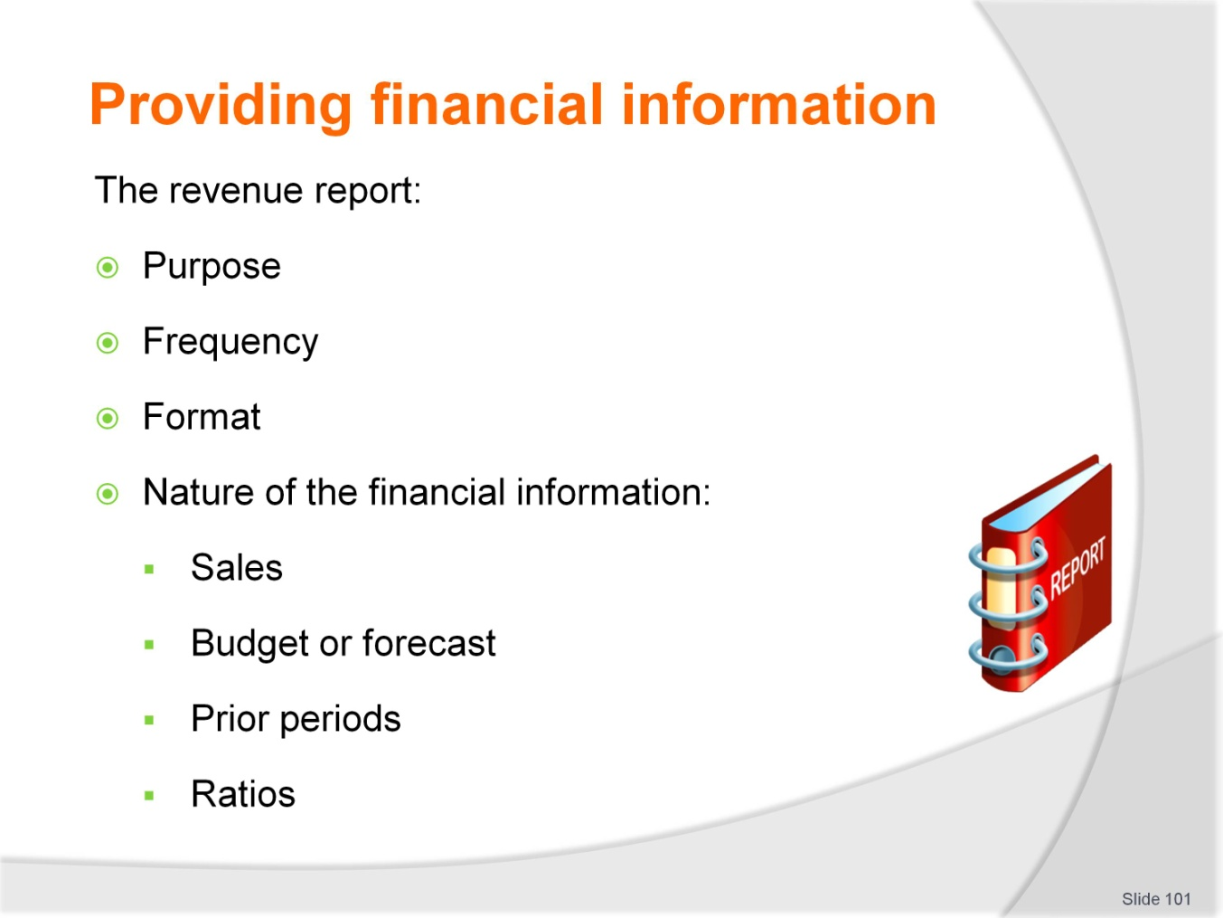
Slide No | Trainer Notes
 | Trainers refer to the training manual for details and the following slide for a sample revenue report. Trainers are encouraged to use relevant local examples.

Slide
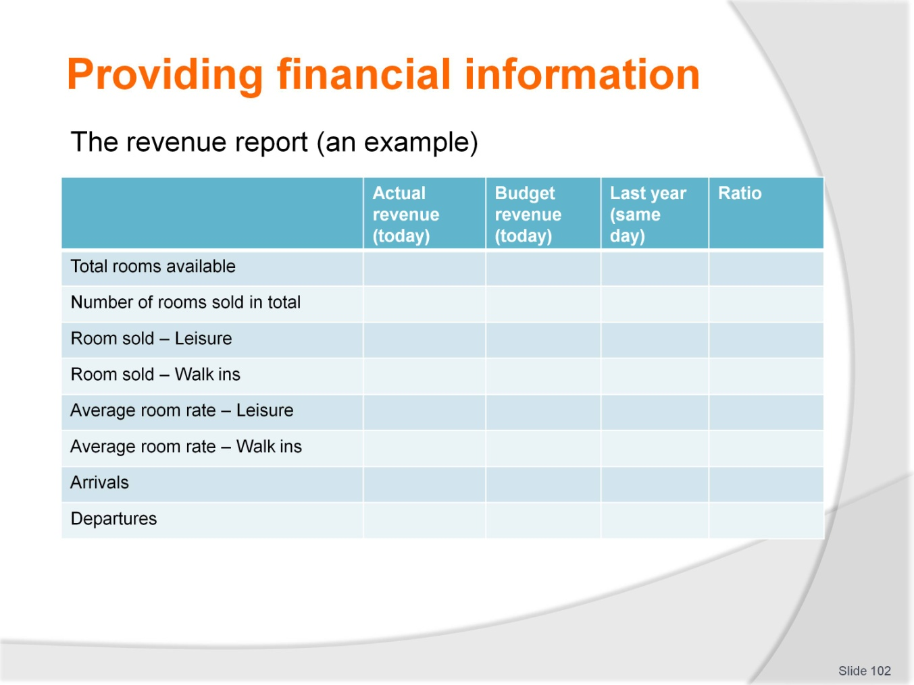
Slide No | Trainer Notes
 | Continued from previous slide.

Slide
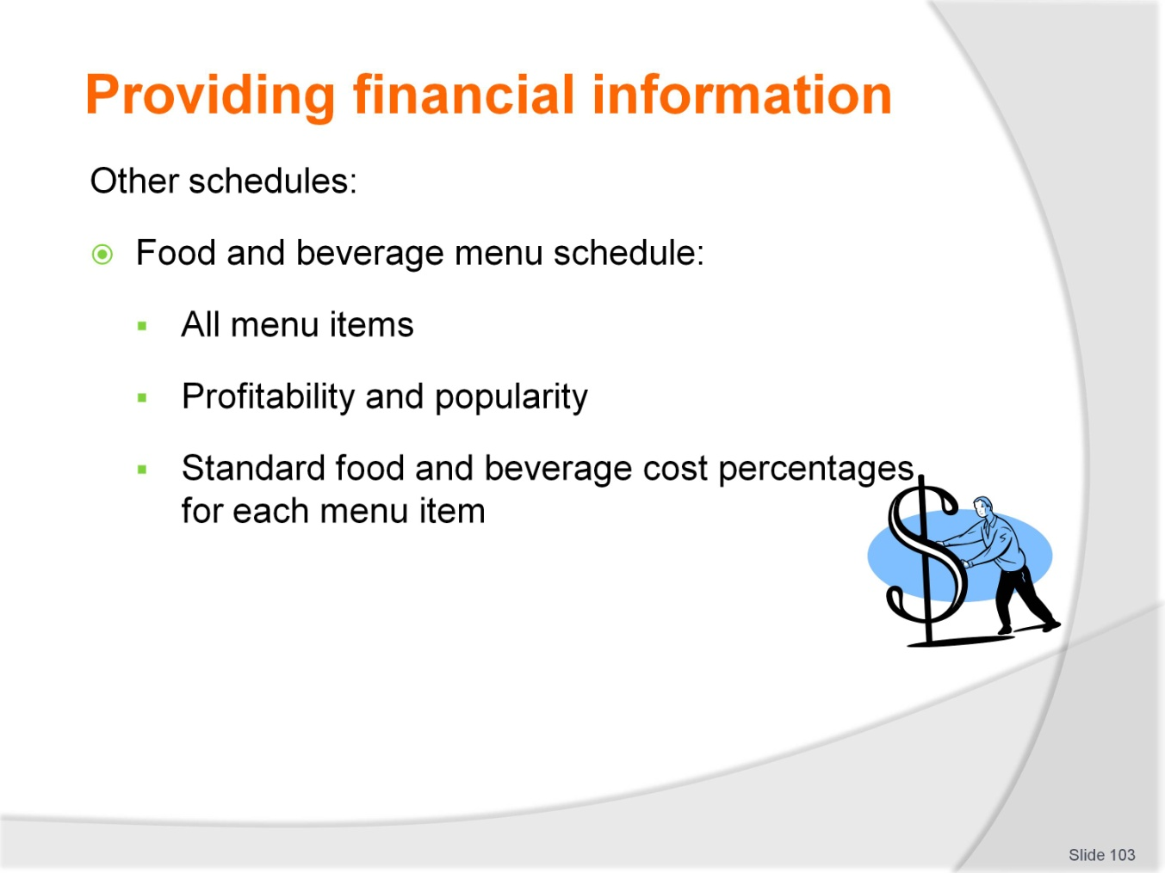
Slide No | Trainer Notes
 | Trainers refer to the training manual for details and the following slide for a sample revenue report. Trainers are encouraged to use relevant local examples.

Slide

Slide No | Trainer Notes
 | Trainers refer to the training manual for details and provide local examples.

Slide
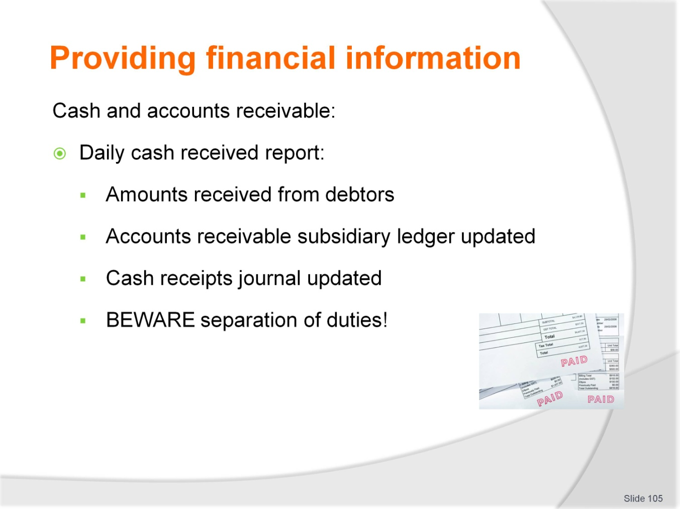
Slide No | Trainer Notes
 | Trainers refer to the training manual for details and provide local examples.

Slide
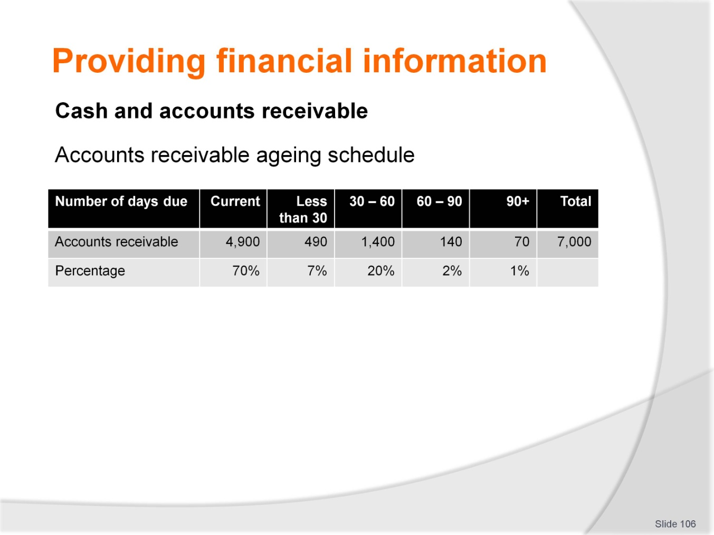
Slide No | Trainer Notes
 | Trainers refer to the training manual for details and the following slide for a sample revenue report. Trainers are encouraged to use relevant local examples.

Slide
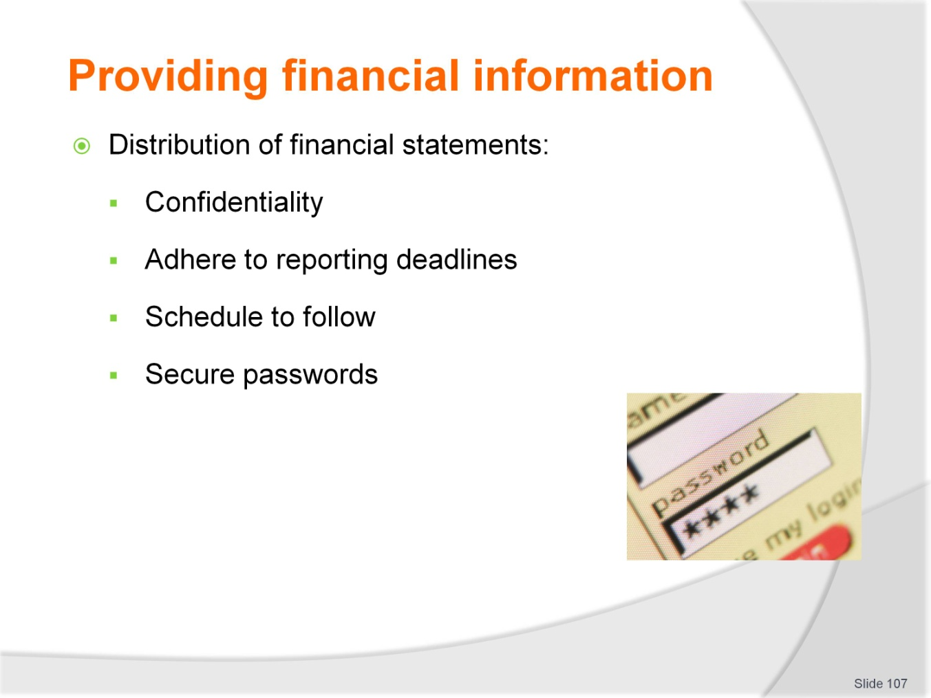
Slide No | Trainer Notes
 | Trainers guide trainees through the steps to distribute financial statements which are mostly administrative tasks. At all times, financial statements should be treated securely and confidentiality maintained.

Recommended training equipment
- Whiteboard or similar display tool
- Internet access if possible
- Calculator,
- Pens
- Paper.

Instructions for Trainers for using
PowerPoint – Presenter View
Connect your laptop or computer to your projector equipment as per manufacturers’ instructions.
In PowerPoint, on the Slide Show menu, click Set Up Show.
Under Multiple monitors, select the Show Presenter View check box.
In the Display slide show on list, click the monitor you want the slide show presentation to appear on.
Source: http://office.microsoft.com
Note:
In Presenter View:
You see your notes and have full control of the presentation
Your trainees only see the slide projected on to the screen
More Information
You can obtain more information on how to use PowerPoint from the Microsoft Online Help Centre, available at: http://office.microsoft.com/training/training.aspx?AssetID=RC011298761033
Note Regarding Currency of URLs
Please note that where references have been made to URLs in these training resources trainers will need to verify that the resource or document referred to is still current on the internet. Trainers should endeavour, where possible, to source similar alternative examples of material where it is found that either the website or the document in question is no longer available online.

Appendix – ASEAN acronyms
AADCP | ASEAN – Australia Development Cooperation Program.
ACCSTP | ASEAN Common Competency Standards for Tourism Professionals.
AEC | ASEAN Economic Community.
AMS | ASEAN Member States.
ASEAN | Association of Southeast Asian Nations.
ASEC | ASEAN Secretariat.
ATM | ASEAN Tourism Ministers.
ATPMC | ASEAN Tourism Professionals Monitoring Committee.
ATPRS | ASEAN Tourism Professional Registration System.
ATFTMD | ASEAN Task Force on Tourism Manpower Development.
CATC | Common ASEAN Tourism Curriculum.
MRA | Mutual Recognition Arrangement.
MTCO | Mekong Tourism Coordinating office.
NTO | National Tourism Organisation.
NTPB | National Tourism Professional Board.
RQFSRS | Regional Qualifications Framework and Skills Recognition System.
TPCB | Tourism Professional Certification Board.







